Dear Sir/Maam,
Greetings!
I am writing to express my interest for applying as a Staff Nurse in your company. Having obtained all required subjects of Bachelor of Science in Nursing at Capitol University, I wish to bring my knowledge and skills and commitment to excellence to the company’s innovative environment.
I have become equipped with the necessary knowledge that come with experience in different hospitals and have attended trainings and seminars related to my work. I also identify and prioritize the needs of my patients and perform my duty as a nurse in an efficient way.
I looked up for advice and mentorship with respect to my seniors and colleagues for a better relationship and performance at work. I can vouch my dedication and sincerity for my work. And I will do my best to ensure all expectations set forth.
For additional details regarding my qualification and expertise, please review my attached resume. Thank you for taking the time to consider this application and I look forward to hearing from you.

Sincerely,

Glenn Christian M. Chua
Balulang, Cagayan de Oro City, Misamis Oriental, Philippines 9000
0935-856-5064
glennmchua2021@gmail.com

Glenn Christian M. Chua 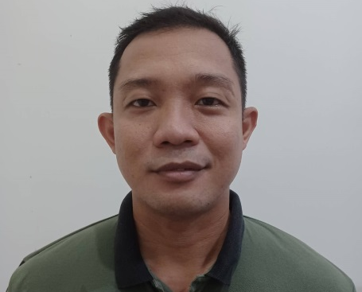
Balulang, Cagayan de Oro City
Misamis Oriental, Philippines 9000
Mobile No.: (+63)935-856-5064
Email: glennmchua2021@gmail.com

PROFESSIONAL SUMMARY
Passionate and motivated nurse with extensive experience in patient care and hospital administrative functions. Person with strong skills with ability to evaluate and advocate for patient needs.

EDUCATIONAL ATTAINMENT
Bachelor of Science in Nursing
Capitol University
Corrales Extension, Cagayan de Oro City
SY 2008-2009

SKILLS
- Can easily adapt to the environment
- Patient privacy
- Responding to emergencies
- Patient management
- Identifies and prioritizes nursing needs of patients
- Patient management
- Plans, renders and evaluates nursing care
- Reports assessment and observations to the physician

WORK HISTORY
February 2011 –July 2011 J.R Borja General Hospital
J.V. Seriña St., Carmen, Cagayan de Oro City
Misamis Oriental, Philippines 9000
(Assigned in Medical Isolation Ward and OB/GYNE/Surgical Ward-Staff Nurse)
November 2011-December 2012 Northern Mindanao Medical Center
Capitol Ground, Cagayan de Oro City
(Staff Nurse)
January 2013-October 2013 Camp Phillips Memorial Hospital
Camp Phillips, Bukidnon
(Staff Nurse)
November 2013-June 2015 Del Monte Philippines-Plantation
Camp Phillips, Bukidnon
(Truck Operator)
July 2015- Present Bureau of Fire and Protection
Capt. Roa Vicente, Roa St., Cagayan de Oro City
(Operation and Inspection)

SEMINARS ATTENDED
July 25-31, 2005 Basic Life Support Training- Capitol University, Corrales Extension, Cagayan de Oro City
May 18, 2013 The Beauty of M.I.S(Minimally Invasive Surgery)
Capitol University, Corrales Extension, Cagayan de Oro City

REFERENCES
Lanie O. Capinpuyan, RN, MAN
Chief Nurse-Nursing Services Department
J.R. Borja General Hospital, Carmen, Cagayan de Oro City
(+63)926-887-0471

Jose C. Chan, M.D
Medical Center Chief II
Northern Mindanao Medical Center
Capitol Grounds, Cagayan de Oro City
(08822)726-362

