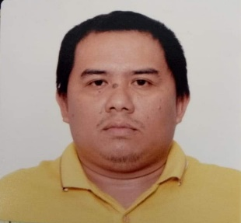
GEOVANNI N. FACTES
Address: Barangay Cawayanan, Miagao, Iloilo
Contact No.: +63 9085161661 / +63 9452360291
E-mail: factesgeovanni25@gmail.com

OBJECTIVE

Seeking a challenging opportunity where I will be able to utilize my strong skills experience and educational background and ability to work well with people which will allow me to grow personally and professionally.

ACADEMIC BACKGROUND

Tertiary : Bachelor of Secondary Education
Major in Technology and Livelihood Education
Specialize in Shielded Metal Arc Welding
Iloilo Science and Technology University (Miagao Campus)
S.Y. 2007-2008

Secondary : St. Louise de Marillac School of Miagao
Miagao, Iloilo
S.Y. 2002-2003

Primary : Jesus Nievales Memorial Elementary School
Brgy. Igbugo, Miagao, Iloilo
S.Y. 1999-1999

WORK EXPERIENCE

- Teacher/TVET Trainer
Miagao National High School
Brgy. Igtuba, Miagao, Iloilo
2011 – Present

SKILLS

- Shielded Metal Arc Welding NC I and II
- Carpentry NC II
- Masonry NC II
- Driving NC II
- Accredited Driving Instructor (Land Transportation Office)

