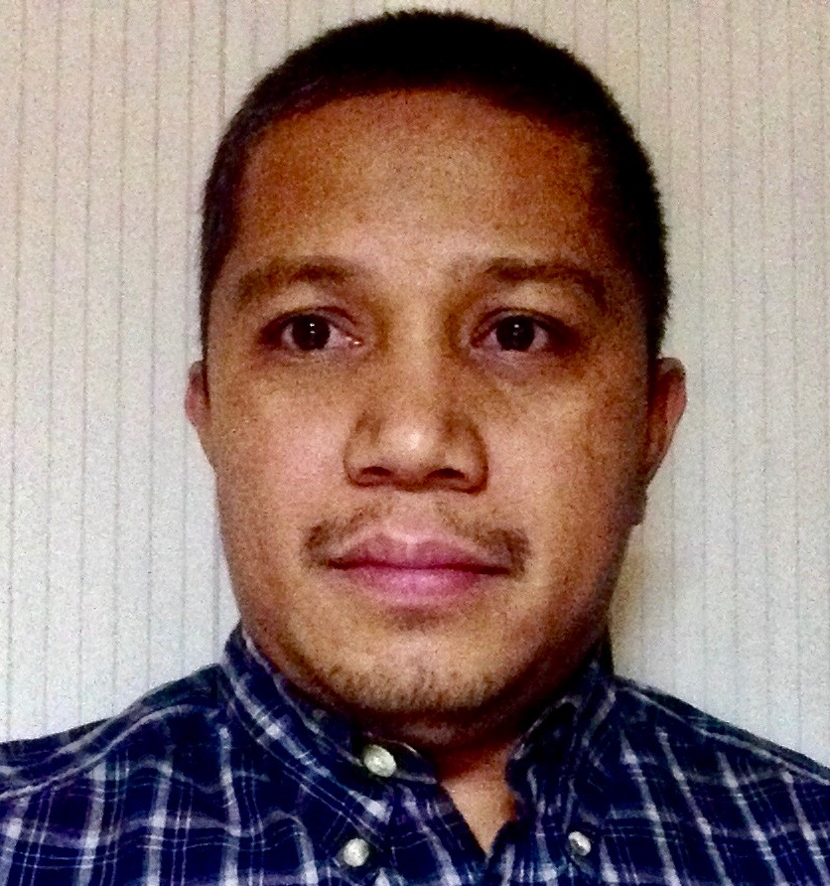
Jowey C. Yorac

17 Bonifacio St. Kingking, Pantukan Phone: +(63) 9772195334 (mobile)
Davao de Oro, 8809 + (63) 9055906325 (Home)
Philippines Email: yoracj@gmail.com
_________________________________________________________________________________________________

Objectives:

Heating Ventilation Airconditioning Technician
Appliance Maintenance Technician

An experienced Heating, Ventilation Air Conditioning Technician with extensive experience in Trouble shooting & Repair, Servicing and Installing various types of Heating, Air Conditioning and Refrigeration equipment, laundry equipment such as Washers and Dryers, Kitchen Equipment such as Gas Range, Boiler, Brat Pan, Convection Oven, etc.

Summary of Qualification:

- More than 20 years of work Experience
- Thorough practices in Installing, Maintaining and Repairing of Heating, Ventilation & Air Conditioning Equipment
- Hands on experience, ability to diagnose, repair, and maintain heating, refrigeration and air conditioning systems.
- Knowledge in Siemens Building Automation System (BAS) operation.
- Knowledge in reading blue prints and schematic diagrams
- Ability to diagnose, repair and maintain Laundry equipment such as Washers and Dryers.
- Excellent communication and human relations skills
- Highly skilled in the proper use and Maintenance of HVAC tools

Certifications:

By Mainstream Engineering

Type 608 Universal Certification
Type 609 MVAC Certification
HVAC/R Preventive Maintenance Certification
Indoor Air Quality Certification
Green HVAC/R Technician Certification
HFC-410A Handling, Use and Recovery Certification
HC/HFO Certification

Work Experiences:

May 17, 2017 to 15 August 2021
PAE Govt. Services
American Embassy, Kabul, Afghanistan

HVAC Technician/ Appliance Maintenance Technician

Duties and Responsibilities:

- Troubleshooting, repair and maintenance of HVAC system, Humidifiers
- Operation and troubleshooting through Siemens Building Automation System (BAS)
- Troubleshooting, repair and maintenance of Walk in Freezers, Chillers, Display Cabinet Chillers, Food Warmer and etc.
- Troubleshooting, repair and maintenance of Kitchen equipment such as Dish washer, Food Warmer, Bean Marie, Boiler, Deep Fat Fryer, Griddle Top, LP Gas Stove, and other Kitchen Equipment.
- Troubleshooting, repair and maintenance of Wilms Direct-fired Heaters
- Troubleshooting, repair and maintenance of laundry equipment such as clothes Washers and Dryers.

Nov. 2007 to April 2016
DynCorp International DoS Air Wing, Contract/ Camp Alvarado Kabul, Afghanistan

Facilities Technician HVAC/ Appliance Maintenance

Duties and Responsibilities:

- Installation, Servicing, Troubleshooting and repair of HVAC systems.
- Troubleshooting, repair and maintenance of walk-in freezers and chillers refrigeration units.
- Troubleshooting, repair and maintenance of Wilms Direct-fired Heaters
- Troubleshooting, repair and maintenance of Laundry equipment such as clothes Washers and Dryers.
- Trouble shooting and repair of Kitchen equipment such as Dish Washer, Food Warmer, Bean Marie, Deep fat Fryer, Griddle top and LP Gas stoves.
- Order spare parts needed for inoperative equipment
- Review incoming and completed work orders and maintains related records.
- Performed other duties as assigned

September 2003 to November 2007
PAE Govt. Services (Construction Dept.)
Kabul, Kandahar, Bagram Afghanistan Site Projects

HVAC Technician/ Electrician

Duties and Responsibilities:

- Installation of Split type AC units
- Trouble shooting repair and Maintenance of Air Conditioning, Heating units.
- Trouble shooting repair and maintenance of Laundry equipment
- Electrical wiring and termination from Generator unit to Main Distribution Board to Sub Distribution Panel and to individual conex

March 2001 to April 2003
Red Sea Housing Services Company Ltd.
Dubai, United Arab Emirates

AC Technician

Duties and Responsibilities:

- Installation of Air conditioning equipment
- Installation of Refrigeration equipment
- Servicing of Air conditioning units
- Troubleshooting repair and maintenance of Refrigeration and Air conditioning equipment
- Troubleshooting repair and maintenance of power tools such as power/ cordless drills, angle grinders, chop saws.
- Troubleshooting repair and maintenance of Pneumatic tools such as Nailer, Brad nailer, staplers.

September 1998 to August 2000
Red Sea Housing Services
Desert Palms Compound
Jubail, Saudi Arabia

AC Technician/ Appliance Maintenance Technician

Duties and Responsibilities:

- Trouble shooting, repair and maintenance of Laundry equipment
- Servicing of Air conditioning units
- Trouble shooting, repair and maintenance of Air conditioning units
- Trouble shooting and repair of Kitchen equipment such as Food Warmer, Bean Marie, Electric Stoves, Gas Stoves, Deep Fat Fryer and Dish Washer.

March 1995 to February 1998
Northern Aircon & Refrigeration Services
Tagum City, Philippines

Refrigeration and Air Conditioning Tech.

Duties and Responsibilities:

- Installation of Air Conditioning units
- Servicing and General Cleaning
- Trouble shooting and repair of Air conditioning units
- Trouble shooting and repair of domestic refrigerators and freezers

October 1994 to March 1995
Davao Air (Carrier Service Center)
On the Job Trainee

EDUCATION:

Tagum National Trade School
1993 to 1995
2-yr course major in: Refrigeration and Air conditioning Technology (Graduate)

OTHER SKILLS:

Certified to operate:

- Forklift 6K & 10K
- Bobcat Front Loader
- Genie Scissor Lift
- Truck F-550, F650, F-750, Excursion
- Trimax Fire Extinguisher
- John Deere Gator
- Hard working and dedicated to the job
- Knowledge in basic Generator Maintenance and Servicing
- Knowledge in basic carpentry, plumbing, welding and fabrication
- Knowledge in Computer, Can write and read good in English Language
- Willing to learn something new
- Optimistic, Positive thinker, Flexible can work under pressure
- Good team player and can work Independently

PERSONAL INFORMATION:

Date of Birth: February 6, 1976
Age: 46 y/o
Civil Status: Married
Passport No.: P1213641B
Date Expires: 26 March 2029

Character References:

Mr. Clifford Baste
HVAC Supervisor PAE American Embassy Kabul, Afghanistan
PO Box 936 Jamestown
NM 87347 USA

Mr. Steven Charles Reel
HVAC Supervisor PAE American Embassy Kabul, Afghanistan
SCREEL74@Aol.com

Ms. Thandar Phyu
Human Resources PAE
employeeverification@pae.com

