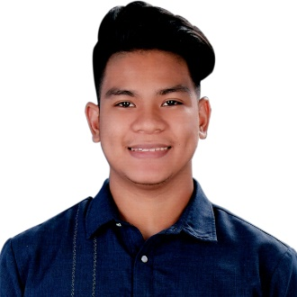

Jerome Armario Alcantara

0053 Pulong Buhangin • Santa Maria Bulacan, 3022 • jeromealcantara2200.ja@gmail.com • 09360737522

Education

Immaculate Conception I – College of Arts and Technology Bonifacio Street, Santa Maria, 3022 Bulacan
Bachelor of Science in Information Systems May 2018

Experience
Toyota Marilao Lot 1505, MacArthur Hwy, Marilao, 3019
Programmer / IT Officer May 2022 – Present
- Responsible for creating and maintaining the company's software and website.
- Supplies team members with technical assistance.
- Conduct software and online application training and orientation for the deployed company software.

Immaculate Conception Polytechnic Marian Rd, Poblacion, Santa Maria, 3022 Bulacan
Part time instructor August 2021 – May 2022
- In charge of imparting ICT education.
- Utilizing office software, prepare and deliver modules, grades, and reports.

Immaculate Conception Academy ICA Compound, Marian Rd, Santa Maria, 3022 Bulacan
Teacher June 2019 - May 2022
- Responsible for computer education.
- Image manipulation skills
- C# programming language
- Python programming language
- Organize the installation and upkeep of the machines in the computer lab.
- Using office software, create and deliver assignments, grades, and reports.
- Is charge of network hardware and software configuration setup and maintenance
- Create a visual design for school programs and events.

Alarmnet Inc. USSC Building. 711 EDSA, cor New York St, Cubao, Quezon City, 1109 Metro Manila
Technical Support / Programmer May 2018 – June 2019
- Accountable for troubleshooting and keeping track of the systems utilized by the business to operate.
- Create innovative software that will improve and benefit business transaction processes.
- Oversee the installation and upkeep of computers used for operations.

Skills

Technical: Office applications, setting up computer hardware and software, computer programming in C# and Php,
graphic design.

