Joliffe M. Molinyawe
Address: #219 Purok 4 Barangay Majada Out Calamba City
Contact number: 0995 995-8045
Email address: Joliffemolinyawe01@gmail.com

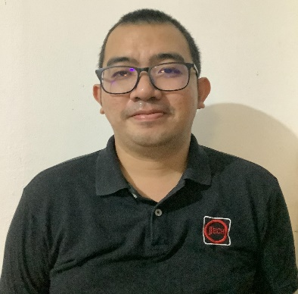
Friendly Computer Service/ IT Staff for 16 years. Seeking proven skills in problem solving and communication to provide expert service in Computer related concern.

Work Experience

2006- 2009 IT Staff
Luxor Systems Corporation
- Service provider of San Miguel Corporation for IT related concern
- Hardware, trouble shooting
- Knowledgeable In replacing defective computer parts
- Knowledgeable in assembling computer
- Knowledgeable in trouble shooting of laptop/PC
- Software maintenance
- Knowledgeable in installation of software
- Knowledgeable in installation of antivirus
- Knowledgeable in installation of MS office

2009- 2022 IT Staff
JTech Systems Corporation
Service provider of San Miguel Corporation for IT related concern
- Hardware, trouble shooting
- Knowledgeable In replacing defective computer parts
- Knowledgeable in assembling computer
- Knowledgeable in trouble shooting of laptop/PC
- Software maintenance
- Knowledgeable in installation of software
- Knowledgeable in installation of antivirus
- Knowledgeable in installation of MS office

Educational Attainment

2003 – 2004 Rizal College of Laguna
Calamba Laguna
Course: Computer Mechanics
Vocational Graduate

2001- 2002 Colegio de San Juan de Letran
Calamba Laguna
Course: Business Management
Undergraduate

Skills
- Hardware, trouble shooting
- Knowledgeable In replacing defective computer parts
- Knowledgeable in assembling computer
- Knowledgeable in trouble shooting of laptop/PC
- Software maintenance
- Knowledgeable in installation of software
- Knowledgeable in installation of antivirus
- Knowledgeable in installation of MS office
- Knowledgeable in MS words, MS Office, Excel
- Knowledgeable in cloud software
- Knowledgeable in MS PowerPoint
- Fast learner
- Team player

Personal Particulars:

Date of Birth: June 13, 1984
Gender: Male
Status: Married
Nationality: Filipino

----------------------------
Joliffe M. Molinyawe

