.  Contact  Skills  - Patient care plans  - Patient care  - Healthcare operations  - Mobility support  - Dressing wound  - Health checking  - Pulse and temperature checks  - Patient relationship building  - Bed Making  - Removing of Suture  - Transporting patient |  | Meets job demands and deadlines through diligent work-ethic and dedication to quality. Energetic healthcare worker dedicated to efficient and productive collaboration between care teams, patients, and families. Proven background establishing strong rapport with patients in hospital and health centers environment to extend immediate assistance and patients need.  Experience  August 03,2022 – Present  Davao del Norte Hospital – Carmen District  - Obtained current medical information, weight, height, and vital signs to aid care planning.  - Measured and recorded patient temperatures, pulse, respirations and weight throughout hospital stay  - Administering drugs  - Dressing wounds  - Removing of Suture  - Monitored patient health, behavioral and physical changes, promptly reporting concerns to ward supervisor  - Transporting patients  March 2022 to April 2022 (On the Job Training)  Somoso General Hospital, Panabo City, Davao del Norte, Philippines  - Monitored patient health, behavioral and physical changes, promptly reporting concerns to ward supervisor.  - Built strong, trusting relationships with patients by providing continuous support and delivering best possible care.  - Measured and recorded patient temperatures, pulse, respirations and weight throughout hospital stay.  - Conducted frequent health checks to measure effectiveness of treatment or recovery plans.  - Documented care plans, hospital actions, and patient activities in line with best practices.  - Obtained current medical information, weight, height, and vital signs to aid care planning.  February 2022- May 2020  Customer Service Representative iQor Philippines, Davao City, Philippines  - Guaranteed first-class customer service, enthusiastically anticipating and catering to customer needs and requirements.  - Addressed customer service enquiries quickly and accurately.  - Maximized customer satisfaction by resolving service issues promptly.  - Assisted customers with product-related questions, feedback, and complaints.  - Provided customer support in English  August 2019 to Current  Financial Adviser Manulife Philippines, Davao City, Philippines  - Consulted with clients to assess and meet short- and long-term financial goals.  - Articulated value of various financial products, including stocks, bonds, mutual funds, and insurance policies educated clients on benefits of individual products.  - Developed and deepened relationships with new and existing clients.  - Customized customer experiences to build brand loyalty.  - Developed expertise and knowledge for consistent delivery of outstanding quality services.  - Delivered exceptional service to each customer by listening to concerns and answering questions.  March 2008 to December 2017  Medical Sales Representative Terramedic Incorporated, Laguna, Manila, Philippines  - Closely monitored competitor activity, remaining ahead of market trends and demands across medical sales pitches.  - Analyzed data and market conditions and adjusted sales pitches.  - Increased sales and revenue growth through sales of projections and monitoring.  - Assessed client needs and sold appropriate products.  - Demonstrated impeccable sales skills to negotiate profitable deals with clinical, pharmaceutical and technical teams.  - Provided accurate medical sales forecasting, consistently delivering against revenue targets.  - Used excellent sales techniques to increase customer interest in medical products.  - Scheduled appointments with pharmacists, doctors and other medical professionals to promote new products and deliver presentations.  - Identified new leads by attending networking events and conducting online research.  Education  Degree in Bachelor of Arts, 2002  University of the Immaculate Conception, Davao City, Philippines  Certificate in Healthcare Service, NC 2, 2022  North Davao Colleges, Panabo City
  Grace Martizano 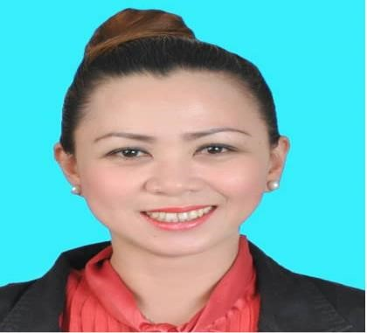
   |  | DAVAO DEL NORTE, Region XI
   |  | +639472204240
   |  | morenograce143@gmail.com
.

