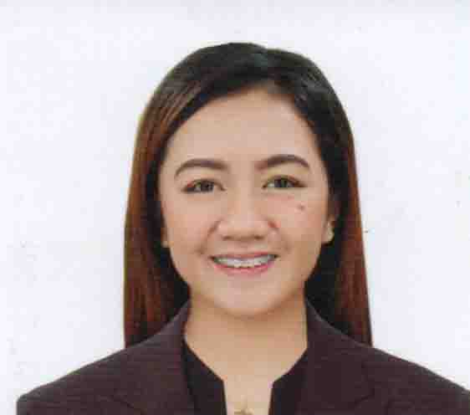

PRINCESS CHARLOTTE A. AGUINALDO, RPh
Brgy.Parado, Dingras, Ilocos Norte
Contact No.: 09496147191
Email address: rphcharlotteaguinaldo@gmail.com

Objectives:

To obtain a position as a Pharmacists, that will effectively apply the vital and significance of my knowledge and expertise, training and abilities, offering opportunity for personal growth and development as well as to reach the best of my abilities in the contribution for the success of the health of the patient.

Personal Particulars:

Age | : | 24 y/o
Date of Birth | : | November 9,1997
Gender | : | Female
Civil Status | : | Single
Nationality | : | Filipino

Educational Background:

Tertiary | : | Mariano Marcos State University  Bachelor of Science in Pharmacy  Brgy. 16 Quiling Sur, City of Batac, Ilocos Norte  2014-2018
Secondary | : | Lt.EFMNHS Dingras National High School  Poblacion Campus  Brgy. Madamba, Dingras, Ilocos Sur  2010-2014
Elementary | : | Medina-Parado Elementary School  Brgy.Parado, Dingras, Ilocos Norte
2004-2010

Experiences

Community Pharmacy internship (200 hours): The Generics Pharmacy, Laoag, I.N.
June- July 2016
- Patient counselling
- Drug dispensing
Hospital Pharmacy Internship (200 hours): Mariano Marcos Memorial Hospital & Medical Clinic, Batac, I.N.
June- June 2017
- Patient counselling
- Prescription reading
- In-patient dispensing
- Out-patient dispensing
- Oncology drug compounding
- Charting patient medication
- Making paper tablets
Manufacturing Internship (200 hours): New Myrex Laboratory Inc., Sta. Maria, Bulacan July- July 2017
- Quality control analyst
- Warehouse personnel
- Product inspector
Major Pharmacy Internship (360 hours): Mercury Drugstore 606 Washington, Batac, I.N
June- August 2018
- Assisting in the inventories
- Patient counselling
- Making paper tablets

Store Supervisor Pharmacist (June 24,2019-May 31, 2022): Watsons Personal Care Store Inc South Superhighway cor. Finlandia St. San Isidro Makati City
- Patient counselling
- Drug checking and dispensing
- Inventory Controller
- Promotion of Public Health

Strengths and Skills:

- Tolerant and flexible, adjust to different situation
- Self-motivated and maintain high level of energy
- Self-sufficient and independent in handling individual task
- Competent in working in group or a team
- Computer literate
- Trustworthy
- Excellent in written and verbal communication skills
- Ability to Multi task with Accuracy
- Excellent leadership and counseling skills

Character References:

Mrs. Aileen O. Camangeg
Chairperson
DEPARTMENT OF PHARMACY MMSU
City of Batac, Ilocos Norte Philippines
09175581028

Ms. Julie Ann D. Balicat
Pharmacist
Mercury Drugstore Washington
City of Batac, Ilocos Norte, Philippines
09757937127

Ms. Cheryll Lei B. Cator
Area Manager, Pharmacist
Mercury Drugstore Washington
City of Batac, Ilocos Norte, Philippines
09359123696

I hereby certify that the above information are true and correct above my knowledge.

PRINCESS CHARLOTTE A. AGUINALDO, RPh

