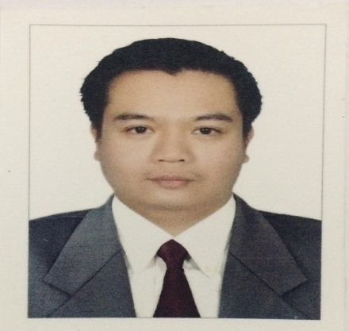
Ryan N. Gabay
Current Address : #334 Brgy.Pao,Manaoag, Pangasinan, Philippines
Mobile No. : 0907-147-5651 / 0936-784-9752
Email address : ryan.gabay@yahoo.com

Date of Birth : January 5, 1981 Nationality : Filipino
Weight : 79 kgs Height : 5’7

OBJECTIVES:
To be able to attain changelling job,enchance my capabilities and grow within the company. To utilize my knowledge
and skills that offers growth and advancement opportunities.

EDUCATIONAL ATTAINTMENT:

1998 to 2002 Lyceum Northwestern University
Bachelor of Science in Computer Science

1994 to 1998 Manaoag National High School

1988 to 1994 Manaoag Central Elementary School

WORK EXPERIENCE:
Jan. 05, 2018-Aug.31, 2019 : FOOD ATTENDANT (WAITER)
ANGELCON PROPERTIES Hotel Consuelo Resort & Chinese Restaurant
(Alvear St.,Corner Maramba Blvd.Lingayen,Pangasinan
Job Description
- Provide the perfect service experience for every Guest
- Ensure the Guest feels important and welcome in the restaurant
- Ensure hot food is hot and cold food is cold
- Adhere to timing standards for products and services
- Look for ways to consolidate service and increase table turns
- Present menu, answer questions and make suggestions regarding food and beverage
- Serve the Guest in an accommodating manner
- Must know all food liquor, beer, wine and retail offered
- Apply positive suggestive sales approach to guide Guests

Apr. 21, 2015 – Sept. 10, 2017 : WAITER
FilfillahRestaurant(Al Khobar, Kingdom of Saudi Arabia)
Job Description
- Prepare Tables for Meals, including the complete set up of linens, silverware and glassware.
- Perfume light food preparation duties including brad, salad preparation, appetizers and desert presentation.
- Greet guest. In a professional manner and provide education about the food and beverage
- Menu’s how menu items are prepared, the ingredient use and the different cooking methods.
- Inform the customers of daily specials.
- Check food and beverage of quality and presentation before serving the guest.
- Serve food and beverage to guests.
- Receive guest payments and process transactions.
- Clear and clean tables promptly according to proper sanitation standards.
- Complete side duties as required including, polishing silver ware, restaurant set up, and filling condiments.

May 2012 to July 2014 : WAITER
Holliday Inn Hotel and Restaurant (Olaya/Aldana/Medan/KSA)
Job Description
      - Providing excellent wait service to ensure satisfaction.
      - Taking customer orders and delivering food and beverages.
      - Making menu recommendations, answering questions and sharing additional information with restaurant patrons.

May, 2013 to November, 2013 : WAITER
Best Western (Orchid Hotel)
Job Description
- Present menus to patrons and answer questions about menu items, making recommendations upon request.
- Prepare tables for meals, including setting up items such as linens, silverware, and glassware.
- Serve food or beverages to customers, and prepare or serve specialty dishes at tables as required.

March 2003-Dec. 2003 : WAITER
Pizza Hut,Incorporated (Baguio City)
Job Description :
- Providing excellent wait service to ensure satisfaction
- Taking customer orders and delivering food and beverages
- Making menu recommendations, answering questions and sharing additional information with restaurant patrons

SKILLS:
Good Communication Skills
Knows Basic Arabic Language
Computer Applications

TRAINING AND SEMINARS:

October 09, 2018 Basic Training

October 11, 2018 Ship Security Awareness Training and Seafarers with Designated Security Duties
April 24, 2018 National Certificate II (NCII)-Food and Beverages Services

REFERENCES:

Ze-Alexis P. Dumaguing
2nd-Engineer-Instructor
Far East Maritime Foundation,Inc.
Bo.Imelda,Naguilan,La Union
09482942856

Edgardo Flora
Security Officer
ID#076821
MSWesterndam
09202734077

Ms.Teresita N. Fajardo
Operations Manager
Alvear St.,Corner Maramba Blvd.
Lingayen,Pangasinan
Tel No. (075)-529-1669 / 529-1719

I hereby certify that above information and details are true and correct

_________________
Applicant Signature

