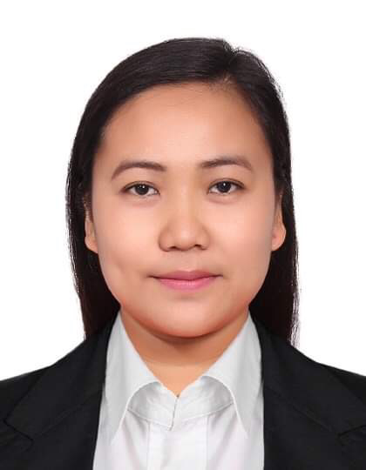
Judith S. Sumaoang
0988 Camartinezan Malacampa Camiling, Tarlac. Philippines
E-mail: sumaoangjudith@yahoo.com
Mobile:+63-9266117037
:+63-9679735301
______________________________________________

Desired Position
Receptionist front office desk, Cashier , Administrative or office staff
Career Objectives
To seek a responsible and challenging position within a reputed organization and to invest my skills, qualification and experience to the optimum level to produce best result for the organization, which would help my career development.

Work Experience

Receptionist front office desk Concord Residence
Ras Al Khaimah, UAE
October 2009 – May 2020

Job Qualifications:

- Monitors and responsible for ensuring that the reservations team achieves or exceeds monthly sales targets. This individual will also ensure that our guests enjoy exceptional customer service and memorable experiences when visiting our properties. Reservation Associate's performance.

- Monitors the daily workloads of team members and makes adjustments to ensure adequate coverage and that correct procedures are followed. Identifies system and workflow improvements to enhance the team's efficiency.

- Handles the requests from guests, companies and travel agents via phone and other platforms. Needs to ensure booking information are input accurately into the reservation system, and maintain and update room availability on online booking platforms.

- Acquisition of cashier change fund and accountable forms from supervisor/cashier cash booth

- Answer multi-line phone system and direct calls and provides prompt solutions and resolutions to customer concerns.

- Sending emails to a company prospective clients and dealing with a good service

Job Descriptions:

- Performs check-in and check-out.
- Handles telephone calls and in-house guest complaints and requests.
- Handles walk-in reservation.
- Answer multi-line phone system and direct calls to the correct employee and guest or take a message.
- Responsible for a data entry and light typing include filing, faxing, copying, scheduling appointments, handling calendars, reservations and various office duties as required.
- Provide information and assisting walked-in clients or customers, anticipating their needs and deal with a professional manner.

Training Attended with Certificates

Philippine National Bank
PNB building Rizal Street Camiling ,Tarlac Philippines

Emirates Computer Information Technology Modem
Al Shafar Tower Dubai, United Arab of Emirates

General Resources Authority
Government of Ras al Khaimah, United Arab of Emirates

Munhwa Korean Language Center Corp
3rd Floor RL building Zamora Street San Roque Tarlac Philippines

Personal Background

- Born December 29,1987
- Single and Filipino citizen
- Can speak English
- With excellent communication skills
- Can learn new knowledge / skills quickly and easily
- Computer Literate (familiar with Microsoft excel and word), and have knowledge of auditing process.

Educational Attainment

Tertiary : Tarlac Agricultural University
Camiling, Tarlac City, Philippines
April 03, 2009
Course / Degree : Bachelor of Science in Business Administration
Major in Business management

I hereby acknowledge that all above mentioned information I supplied are true and based on my experiences.

Judith S. Sumaoang
Applicant

