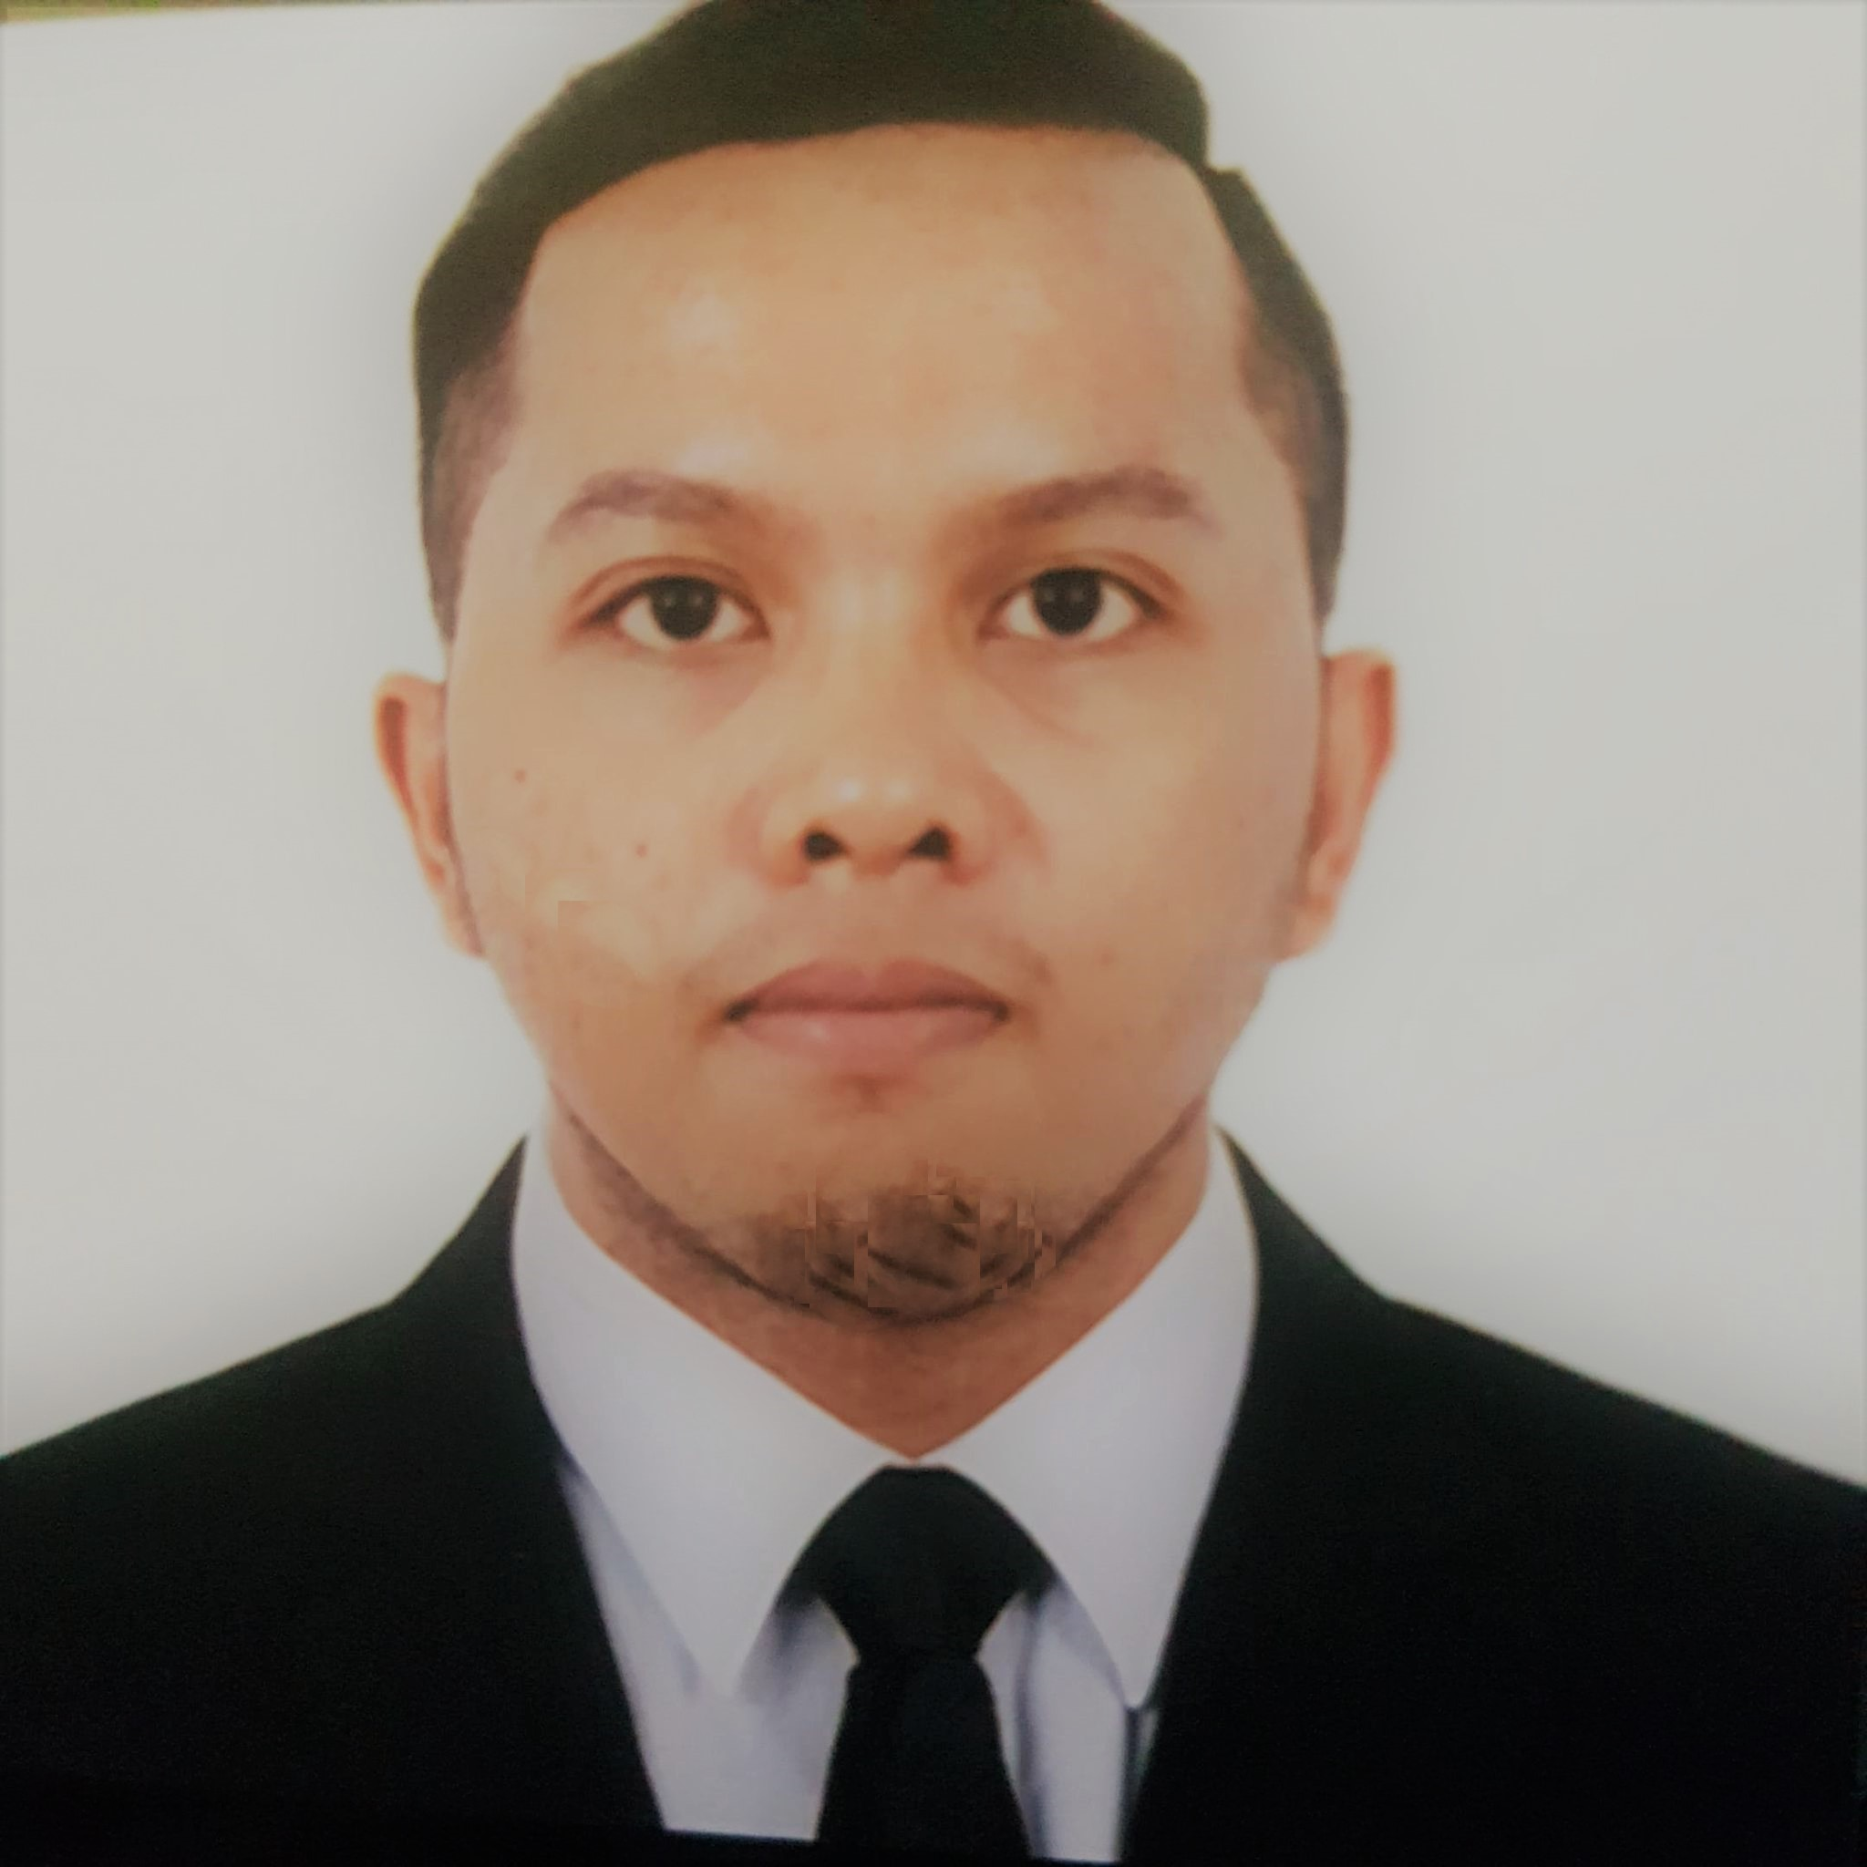
TRISTAN TROY P. RUDA
Purok-6 A Balanghai Libertad Butuan City Agusan Del Norte Philippines

Truda1107@yahoo.com
+639514103462

CARREER OBJECTIVE
To obtain a position that challenges me and provides me the opportunity to reach my full potential professionally and personally utilizing my abilities and experiences in your organization that is progressive intellectually and technically and one in which practices collaborative, leadership, integrity and honesty.

PERSONAL INFORMATION

Date of Birth: April 13, 1994
Place of Birth: Butuan City
Age: 27
Civil Status: Single
Citizenship: Filipino
Religion: Roman Catholic
Height: 5’6”
Weight: 65kg

EDUCATIONAL ATTAINMENT
Tertiary: Mindanao State Univeristy University
Marawi City
BS in Hotel and Restaurant Management
School Year 2010-2015

Secondary: Agusan National High School
A.D. Curato St. Butuan City
School Year 2006-2010

Elementary: Butuan Central Elementary School
A.D. Curato St. Butuan City
School Year 2000-2006

WORK EXPERIENCE

Company Name Inclusive Date Position

Customer Service representative Nov 2020 – July 202 Chat support/ billing and upselling
Repair and ticket specialist

Royal Caribbean Int. 2015-2020 ( 5years ) Commis 2/ Assistant Cook
Cafe attendant / Room Service Attendant

Dotties Place 2014-2015 (6 months ) Houskeeping Attendant

Pearl View Hotel 2014 ( 6 months ) Front Desk Assistant (OJT- days)

SKILLS

- Can cook different kind of cuisines
- Can Speak English, Tagalog, Visaya
- Able to communicate effectively within the team
- Can work in a fast pace environment and able to multitask
- Computer literate in proficient at MS Excel, MS Word, MS PowerPoint

REFERENCES:

Capriata Benedict Albert T. Ong M.D
Executive Chef Operation Manager of Dotties Place
Fr_executivechef@rccl.com +639089840963
305.539.6000

Hazzard John Raymon S. Lee
F&B Director Hotel Manager of Dotties Place
Fr_f&bdirector@rccl.com +639096335241
305.539.6000

Mary Teves
F&B Training manager
Mj_f&btrainingmanager@rccl.com
305.539.6000.
Marco Perez
HR Manager
Mj_hrmanager@rccl.com
305.539.600

Tristan Troy P. RUDA
P-6 A Balanghai Libertad, Butuan City, Agusan Del Norte Philippines
+639514103462
Truda1107@yahoo.com

Nov 1 , 2021

Dear Sir / Maam,

Good day!

I would like to express my interest in applying to any position available in your company.

I believe that my work experience as well as my degree in Bachelor of Hotel and Restaurant Management from Mindanao State University has prepared me for any position that is available. As an experienced worker, I was equipped with the necessary knowledge and skills to give above and beyond to your company and provide excellent customer service.

My experienced in Royal Caribbean intl as a Commis 2/ Assistant Cook and a Cafe attendant / Room Service Attendant, I learned so many things, More importantly, I had the opportunity to work with professionals and different nationality who taught me how to easily grasp complex situation and equipped with knowlege and skills that helps me to continue to grow as an individual and also how to roll with the punches in order to achieve my goals in life.

With this application letter, attached herewith is my resume for your perusal. Thank you for taking time to review my application and I am looking forward to your reply so that we can further discuss my application.

God Bless!

Best Regards,

Tristan Troy P. RUDA
Applicant

