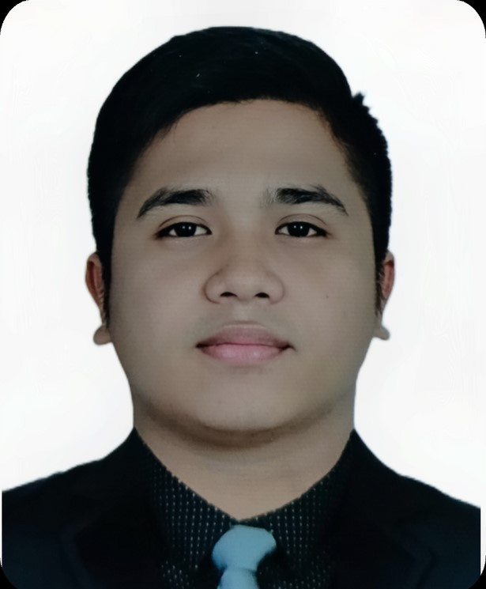
FRAN JOSHUA
MOJICA
OBJECTIVES  Dedicated and compassionate provider of elder care. Companionship and comfort for senior citizen residents | CONTACT  09317356270  franjoshua555@gmail.com
of assisted living and memory care communities. Patient, personable and professional in responding to resident need, with gentle touch and caring attitude centred on treating all with dignity and respect.  EDUCATION  VMA COLLEGE  Senior High Graduate of STEM  2016-2018  RIVERSIDE COLLEGE  Caregiver  2021-2022  LANGUAGES  - English  - Filipino  - Hebrew | WORK EXPERIENCE  - MCDONALD  Service Crew: 2016-2018  - OLD SITTER  - 2018-2021  - Responsible for daily care of patient that has Parkinson's Disease age of 83  - Managing daily activities (Exercise, Lesson Etc.)  - Handled daily feeding on special dietary needs  - PERSONAL EXPERIENCE  - Assisted my grandmother (who has Stage 4 Cervical Cancer eating, bathing, and Draining Catheter Bag)  SKILLS  - CPR certified  - First Aid certified  - Patient and Friendly  - Personal Care (bathing, toileting, transferring.)  REFERENCES  - Kgd. Carlos Anjao  Brgy. Kagawad  - Kgd. Sharon Sinining  Brgy. Kagawad.  - Kgd. Joemarie Panisa  Brgy. Leader of Mayor Albee  - Paviola Santander  Brgy. Leader of Mayor Albee

