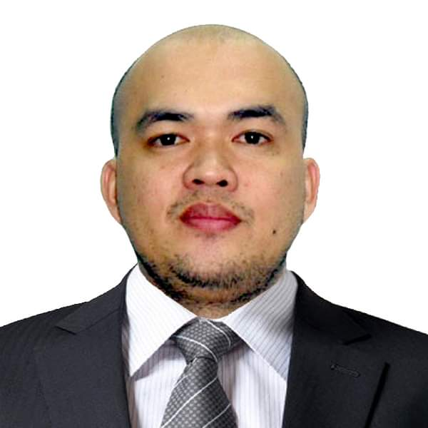
MICHAEL HENSON BASCO

Home Address: #7 Jinshan East 3rd Street, Jinshan Li
East District, Hsinchu City 300 Taiwan ROC
Email address: kaelmykbasco@gmail.com
Mobile Number: 0938435450

Objective: To obtain a position of responsibilities that utilizes my skills, experience, and keen to work in an environment where I can enrich my knowledge.

PERSONAL INFORMATION
Age : 39
Sex : Male
Birthday : August 14, 1982
Birthplace. : Concepcion, Tarlac
Nationality. : Filipino
Status : Married

EDUCATION
Tertiary : Electronics and Communication Technology
Rizal Technological University, Mandaluyong City, Philippines
2000-2005
Secondary : Angono Private High School
Angono, Rizal
1996-2000
Primary : San Vicente Elementary School
Angono, Rizal
1990-1996

PROFESSIONAL EXPERIENCE
LITE ON SEMICON TAIWAN
Preventive Maintenance Technician
July 2022-Present

Responsibilities

-Performs investigation, analysis, troubleshooting, calibration and validation for each reported
equipment tester and handler issues.
-Dealing with emergencies, unplanned problems and repair of tester and handler.
-Analyze abnormal product output visually and manual test product for double confirmation of equipment, tester or program issues and make report to product engineering.
-Participate on brainstorming / meeting activities.
-Performs actual preventive maintenance duties.
-Carrying out routine scheduled maintenance work and responding to equipment faults and conduct actual repair.
-Monitor and measure machine level of cooling water and Fluor inert liquid to sustain the power of the machine.
-Provide daily and weekly maintenance report and update checklist such as for Chiller, Motor driver, power supply and other components.
-Installation of new parts and making sure equipment is working correctly.

BATANG 9TEAS MILKTEA & SNACKHOUSE
OWNER (Supervisor)
#31 Brgy. San Vicente Angono, Rizal Philippines
2019-2022

Responsibilities
- Manage overall store operations.
- Organize and maintain inventory of the supplies
- Supervise and coordinate activities of employees.
- Resolve problem that arise such as customer complains and supply shortage
- Hire & Train applicants willing to apply.

JOPMAN CORPORATION
MIS / Admin Assistant
1927 San Marcelino St. Malate Manila
November 2011 - September 2019

Responsibilities

- Handles Company computer system hardware and software.
- Making Book reports after employers interview
- Assisting Admin in Documentation works and computer related problems
- Assisting applicants from 1st process up to documentations.

TAIWAN ROC
KING YUAN ELECTRONICS CO. LTD.
MFT-Junior Test Equipment Engineer
Test Devision/Production Dept./Equipment Eng’g Section
Zhonghua Road, Zhunan Township, Miaoli County 350, TAIWAN, R.O.C
June 2008 – September 2011

Machine Handled

- ADVANTEST MEMORY TESTER (T5365, T5371,T5381, T5382,T5385)
- ADVANTEST HANDLER (M6741A, M6751A,M6771,M6541,M6542)

Responsibilities

- Performs investigation, analysis, troubleshooting, calibration and validation for each reported equipment tester and handler issues.
- Dealing with emergencies, unplanned problems and repair of tester and handler.
- Analyze abnormal product output visually and manual test product for double confirmation of equipment, tester or program issues and make report to product engineering.
- Participate on brainstorming / meeting activities.
- Performs actual preventive maintenance duties.
- Carrying out routine scheduled maintenance work and responding to equipment faults and conduct actual repair.
- Monitor and measure machine level of cooling water and Fluor inert liquid to sustain the power of the machine.
- Provide daily and weekly maintenance report and update checklist such as for Chiller, Motor driver, power supply and other components.
- Perform machine set up for new customer requirements and scheduled customer request.
- Installation of new parts and making sure equipment is working correctly.
- Set-up or do teach markings on VITROX software. (Tape and Reels).
- Production online monitoring, repair and maintenance.

AMERTRON INCORPORATED
Line Technician
Km Cervantes St, West Service Rd., South Superhighway Parañaque City, Philippines
June 15, 2005 to 2008
Responsibilities

- Do machine troubleshooting
- Schedule and perform preventive maintenance
- Production online monitoring, repair and maintenance.

AMKOR TECHNOLOGY PHILIPPINES INC.
OJT ( PRODUCTION TECHNICIAN)
FRONTLINE WIREBOND STATION

Responsibilities

- Perform machine set up prior to the customers specs and product request.
- Production online monitoring, repair and maintenance.
SPECIAL SKILLS
- Good diagnostic and problem-solving skills
- Relevant with technical knowledge
- Confidence to respond positively when under pressure
- Computer literate
- Creative with effective interpersonal skills and organizational abilities

CHARACTER REFERENCES
Available Upon Request

I hereby certify that the above information is true and correct to the best of my knowledge and belief.

Michael H. Basco
Applicant

