CURRICULUM VITAE
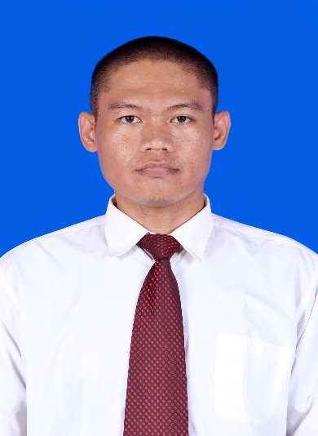
PERSONAL DATA
Name : Sukirno
Sex : Male
Place/Date of Birth : Cilacap/May 07, 1984
Religion : Islam
Marital Status : Single
Height/Weight : 170cm/65kg
Address : Jl. KH Syarbini No.16 RT 005/003 Kec. Adipala Kab. Cilacap
Phone/Email : 081228558106/sukirno84@gmail.com

EDUCATION BACKGROUND
Elementary School SD Negeri Welahan 3 Cilacap Graduated 1997
Junior High School SLTP Negeri 1 Binangun Cilacap Graduated 2000
Senior High School SMK Tamtama Kroya Cilacap Graduated 2004
Cruiseship Training Kharisma Yogyakarta Hotel School Graduated 2005

JOB TRAINING
- February 2006 – August 2006
Housekeeping Department at Puri Artha Hotel Yogyakarta

WORKING EXPERIENCES
- June 2005 – August 2005 Goedang Music Discoutic Yogyakarta as Bar Waiter
Responsible for serving the guest, taking order, cleanliness of the area, ect
- March 2007 – March 2008 Harmony Inn Hotel Bandung as Roomboy & Waiter
Responsible for the cleanliness of the guest room, public area, guest request, and room service.
- October 2008 – March 2011 Galeri Ciumbuleuit Hotel & Apartment as Room Attendant
Responsible for the cleanliness of the guest room, corridor, pantry, guest request, ect.
- March 2011 – March 2012 Hilton Hotel Bandung as Room Attendant
Responsible for the cleanliness of the guest room, corridor, pantry, ect.
- January 2013 – November 2013 Holland America Line as Housekeeping Attendant
Responsible for the cleanliness of the public area, public toilet, crew area, sanitize public area, deep clean, handling luggage, ect
- March 2014 – February 2015 Holland America Line as Housekeeping Attendant
Responsible for the cleanlines of the public area, public toilet, crew area, sanitize public area, deep clean, handling luggage, ect.
- September 2016 – July 2017 Plataran Komodo Resort & Spa as Villa Attendant
Responsible for the cleanliness of the guest area, public area, guest request, handling guest complain, ect.
- June 2018 – October 2018 MV Orient Queen as Crew Steward
Responsible for the cleanliness of the crew area, public area, and handling some officers cabin.

