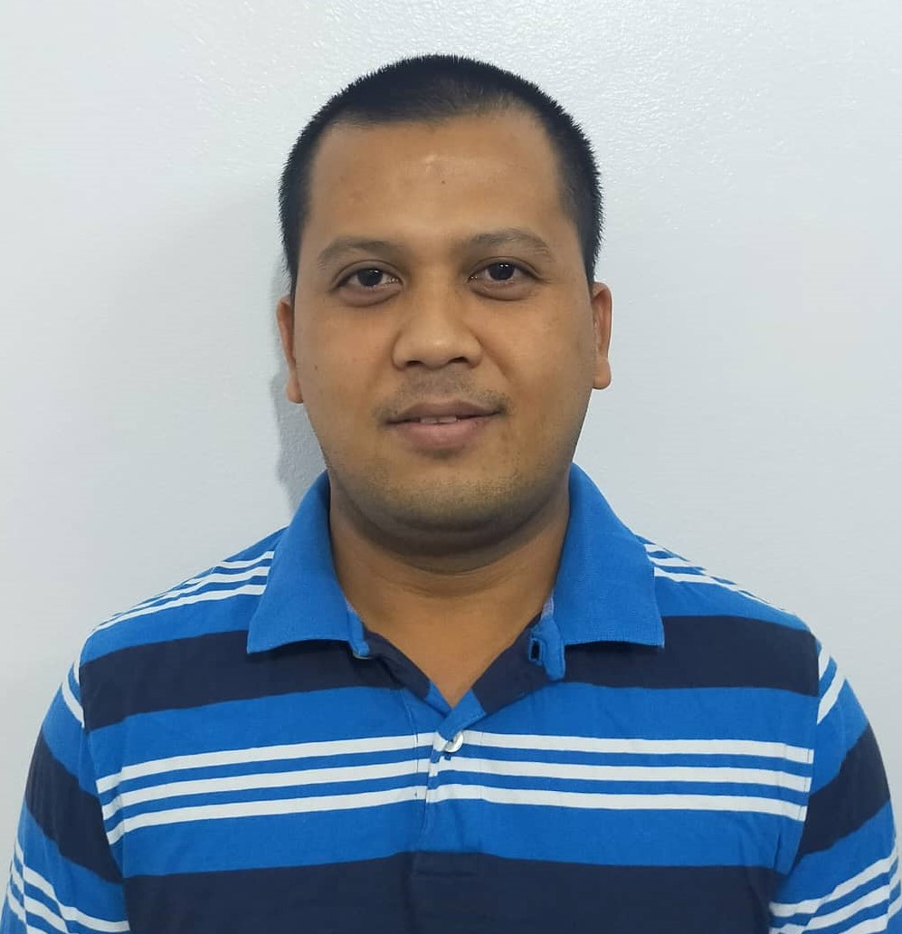

Kenneth Jhon C. Rosete
Current Address: Jeddah Kingdom OF Saudi Arabia
Philippine Address: Blk 17 lot 31 Valle Verde subdivision Langkaan 2 Dasmarinas Cavite.
Mobile #: +966509868932
Email Address: kennethjhon_rosete@yahoo.com

Objectives:
To be employed and be a part of the company’s growth and development by applying my knowledge on the real essence of work and to help my family uplift our present life and economic.

Qualifications:

- 14 years of experience as a CNC Lathe, CNC milling machine and general machinist.
- Outstanding technical personnel with accomplished experience in setting up, and operating CNC lathe and CNC milling machine.
- Ability to read, follow and develop operating instruction and procedures.
- Good knowledge of computer and CAD Cam programming.
- Remarkable ability to read blueprints and drawings; and to use inspection and measuring instruments.
- Outstanding ability to trouble shoot complex of manual programming.
- Able to edit program, set up, G code and M code, and programming in Fanuc, Heidenhain and siemens control.
- Skilled in CNC Vertical Lathe, CNC Horizontal Lathe, CNC vertical machining Center, CNC EDM sink, Lathe Machine, Milling machine, drilling machine.

Work Experience

- Company: New Products Industries Co. Ltd
Industry: Manufactures Plastic Pipes and Fittings
Address: C6FJ+HHP, Industrial Area, Jeddah 22426 Kingdom of Saudi Arabia
Position: CNC OPERATOR/PROGRAMMER in CNC Department
Date: December 5,2021 - UP TO PRESENT

Duties and Responsibilities
- Operates CNC Milling/CNC Lathe Machine and use overhead crane when loading and unloading of material in machine if needed.
- Draw a 2d,3d design and programming in master cam software.
- Always clean machines before and after operations.
- Performs daily checking of machine before operations.
- Prepares standards and work instructions on hand before operation.
- Makes an adjustment in offset settings to meet quality of parts depends on tolerances.
- Checks and update job card to be made.
- Reports any problems during operations.
- Follow-up safety practices.
- Set up the part to be Machining.
- Operates CNC Machine to produce required mold parts.

- Company: AIC-Arabian International Company
Industry: Fabrication and structural Manufacturing
Address: Bahara Jeddah Kingdom of Saudi Arabia
Position: CNC OPERATOR/PROGRAMMER
Date: JULY 3, 2014 – November 30,2021

Duties and Responsibilities
- Operates CNC Milling/lathe machine and use overhead crane when loading and unloading of material in machine if needed.
- Draw in Auto cad a 2d design and programming in master cam software.
- Always clean machines before and after operations.
- Performs daily checking of machine before operations.
- Prepares standards and work instructions on hand before operation.
- Makes an adjustment like offset settings to meet quality of parts.
- Checks cutting list to be made.
- Reports any problems during operations.
- Follow-up safety practices.
- Operates CNC Machine to produce required quantities.

- Company: SMI-Saudi Mechanical Industries
Industry: Manufacturing of Cast iron, bronze and pipes
Address: 2nd Industrial Riyadh Kingdom of Saudi Arabia
Position: CNC Lathe Machinist
Date: January 21, 2012 to March 2, 2014

Duties and Responsibilities

- Operated CNC milling and lathe machines and use overhead crane when loading and unloading of material in machine if needed.
- Always cleaned machines before and after operations.
Performed daily checking of machine before operations.
- Prepared standards and work instructions on hand before operation.
- Made an adjustment like offset settings to meet quality of parts.
- Prepared and assured that the measuring tools are calibrated.
- Understand and read working standards before start operations.
- Performed inspection of the process as indicated by standards to meet quality of parts.
- Checked the machine parameters.
- Operated the machine to produce the required quantities.
- Reported any problem during operations.
- Recorded the time and hand over to the leaders.
- Followed safety practice and housekeeping.
- Participated 5S activities.

- Company: Arabian Gulf Manufacturer LTD.
Industry: Manufacturing Wide range of plastic products
Address: Industrial Jeddah Kingdom of Saudi Arabia
Position: CNC PROGRAMMER/MACHINIST
Date: September 15, 2009 to October 25, 2011

Duties and Responsibilities

- Operated CNC Vertical machining machines, conventional milling, lathe machine, surface grinder, shaper and make quality of parts.
- Draw in Auto cad a 2d design and programming in master cam software.
- Cleaned jigs, tools, machine before and after operations.
- Ensured that the process jigs are in good condition before using.
- Ensured that machines are in good condition before using.
- Ensured that measuring tools are calibrated or verified.
- Performed daily checking of machines before operation.
- Prepared standards and works instructions on hand before starting operation
- Read and understand working standards before operation.
- Performed standards set-up of processing jigs.
- Performed process inspections as indicated on standards to assure quality of parts.
- Made adjustment of machine settings offset settings as needed to meet the quality of parts.
- Performed data recording of inspected parts as directed by standards.
- Ensured parts quality on handling and transporting packing materials are clean and appropriate.
- Completed fill-up forms and other sheets necessary in the process.
- Encoded process result to system on time.
- Immediate reporting to leaders or superiors in the observance of abnormalities on the process, and machine and standards.
- Suggested to leaders for improvements.
- Performed schedule maintenance as authorize by leaders.
- Performed basic machine repairs as authorize by leaders.
- Participated in 5S activities and all improvements activities.

- Company: Supercast Foundry and Machinery Corporation
Industry: Manufacturing of metal casting
Address: Lingunan Valenzuela Manila Philippines
Position: CNC Lathe Operator
Date: April 14, 2009 to September 9, 2009

Duties and Responsibilities

- Always cleaned machines before and after operations.
- Performed daily checking of machine before operations.
- Prepared standards and work instructions on hand before operation.
- Made an adjustment like offset settings to meet quality of parts.
- Prepared and assured that the measuring tools are calibrated.
- Understand and read working standards before start operations.
- Performed inspection of the process as indicated by standards to meet quality of parts.
- Checked the machine parameters.
- Operated the machine to produce the required quantities.
- Reported any problem during operations.
- Recorded the time and hand overs to the leaders.
- Follow-up safety practice and housekeeping.
- Participated 5S activities.

- Company: United Metal Smelting & Mfg. Corp.
Industry: Manufacturing of floor machines
Address: 34-E Caina drive Balong bato Quezon City Philippines
Position: Lathe machinist
Date: March 13 2006-April 4 2009

Duties and Responsibilities

- Operated Lathe machine, milling machine, shaper machine and knowledgeable in tolerances and set up fixtures.

Machines /Tools/Equipments Used:

- CNC Vertical Machining Center (XYZ 828d-Siemens Control)
CNC Vertical Machining Center (Hartford-Fanuc Control)
CNC Vertical Machining Center (Mori Seiki-Fanuc Control-SV-503)
CNC Vertical Machining Center (Heidenhain TNC-407)
CNC Vertical Machining Center (Mynx-650/60 Fanuc Control)

- CNC Horizontal CNC Lathe (SL-65/SL-303/RL-253-Fanuc control/ Mori-Seiki)
- CNC Vertical Lathe (Doosan-Puma VT450/PumaVT750/PumaVT900)
- CNC EDM Sink (Sodik-AD35L)
- Conventional milling machine
- Conventional lathe machine
- Conventional shaper machine
- Cylindrical grinding machine
- Surface grinding machine

Seminar/ Training / Achievements

CNC MILLING PROGRAMMING
MFI Technological Institute
January 18 to February 15, 2009

CNC MACHINING
Technical education and skills development authority (TESDA)
March 2-27, 2009
BASIC CAD/CAM Programming ( Mastercam )
MFI Technological Institute
March 16 to April 13, 2014

Licenses and Certification Information

License/Certification License/Certification No. Date Issued

- CNC MACHINING PGS00035 March 27 2009
- BASIC CAD/CAM 14-B2-18132-09-025326 April 13 2014
- CNC MILLING PROGRAMMING 09-B1-8897-09-025326 February 15 2009

Educational Information

Tertiary: Access Computer Technical College
Caloocan, Philippines
Computer Technician
2008-2009

Vocational: Don Bosco Technical College
Mandaluyong, Philippines
Fitter Machinist
2004-2006

Secondary: Magsikap National High School
Occidental Mindoro, Philippines
2000-2004

Primary: Magsikap Elementary School
Occidental Mindoro, Philippines
1994-2000

Personal Information

Birth Date: December 22, 1987
Birth Place: Occidental Mindoro
Age: 34
Height: 165 cm
Weight: 65kg
Gender: Male
Civil Status: Married
Citizenship: Filipino

