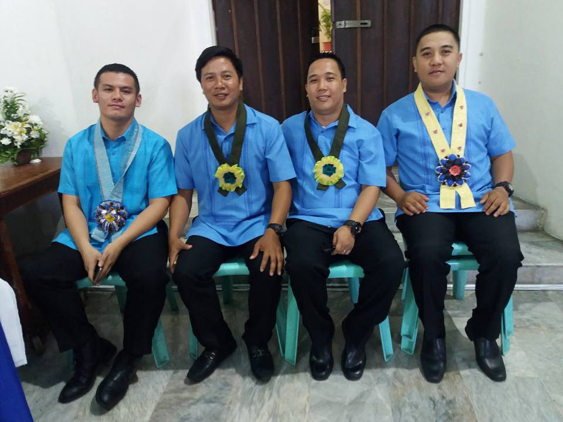
REGIE S. DELA CRUZ
Brgy. # 15, Vintar, Ilocos Norte
Contact #: 09062077193

- POSITION APPLIED FOR

Any qualified position suit to my knowledge and experience

- OBJECTIVES
- To obtain a responsible job in this company which will enable me to apply and make use of my knowledge.
- To obtain a position that will enable me utilize my strong organizational skills, educational background and ability to work well with others.

- PERSONAL INFORMATION
Age: 38 years old
Place of Birth: Vintar, Ilocos Norte
Date of Birth: March 18, 1984
Civil Status: Married
Religion: Roman Catholic
Nationality: Filipino
Height: 5’7”
Weight: 74kg

- EDUCATIONAL BACKGROUND
College: MARIANO MARCOS STATE UNIVERSITY
BACHELOR OF SCIENCE ARICULTURE ENGINEERING

CAGAYAN STATE UNIVERSITY
BACHELOR IN ELEMENTARY EDUCATION

MASTERAL GRADUATES OF SAINT PAUL UNIVERSITY
MACDDS (MASTER OF ARTS AND CURRICULUMN DESIGN
DEVELOPMENT SUPERVISION)

Secondary: SARRAT NATIONAL HIGHSCHOOL
SARRAT, ILOCOS NORTE

Elementary: VISAYA ELEMENTARY SCHOOL
VINTAR, ILOCOS NORTE

- JOB EXPERIENCE
CONSTRUCTION WORKER SAFETY OFFICER
HEAD TEACHER FARMER
TEACHER

- CHARACTER REFERENCE

Divina Sevilla Mrs. Ofelia Melchora M. Sumalin
Guidance Councelor School Head of Holy Spirit Academy

