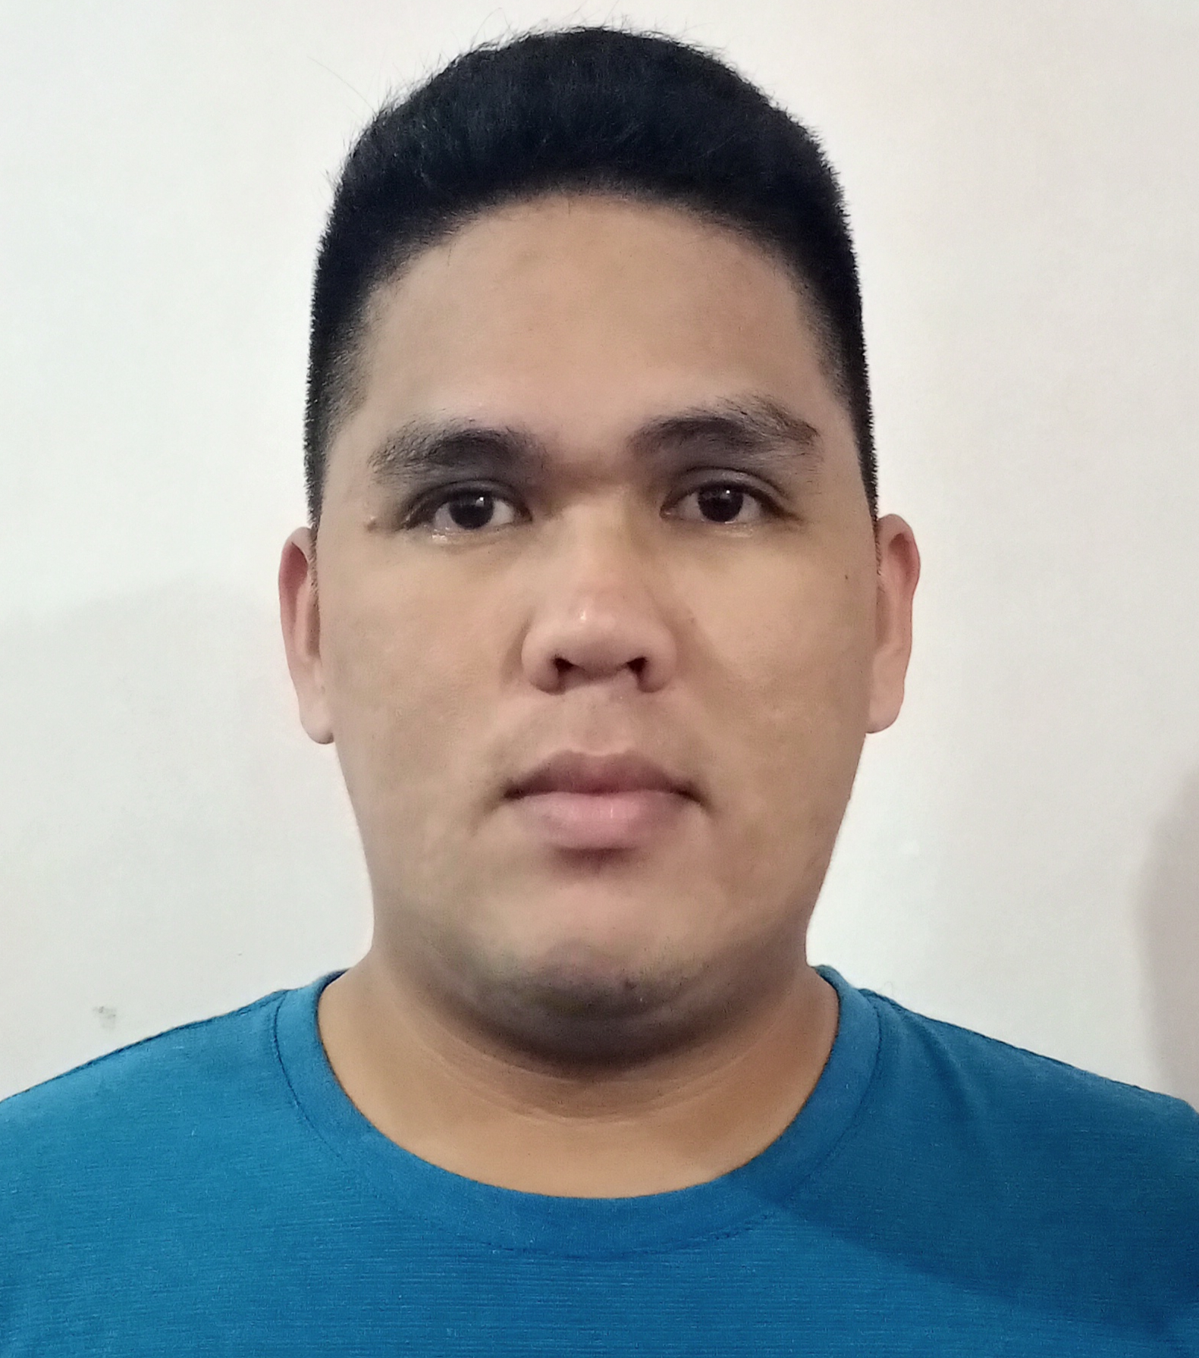
ANDREW C. POLEGA
Permanent address:Brgy. Himbubulo Este, Guinayangan Quezon
Contact no. 09060966730
Present Address: block 14 Lot 12 Asia-1, Canlubang Laguna
Email address: Andrewpolega7@gmail.com

Career Objective
Seeking a challenging career with a progressive organization that’s
Provides an opportunity to capitalize my welding skill and abilities
In the field

RELEVANT SKILLS
(MIG'GMAW,SMAW)

PERSONAL DATA

Age : 27 years old
Date of birth : October 07, 1994
Place of birth : Guinayangan, Quezon
Sex : Male
Civil status : Single
Height : 5’9
Weight : 60 kg
Citizenship : Filipino
Religion : Roman Catholic

EDUCATIONAL BACKGROUND

VOCATIONAL:
SHIELD METAL ARC WELDING ( NC ll/ NC lll )
LUCENA MANPOWER SKILLS TRAINING CENTER
Lucena City, Quezon
2019
SECONDARY:
GUINAYANGAN NATIONAL HIGH SCHOOL
Guinayangan, Quezon
2013-2014
PRIMARY:
GUINAYANGAN ELEMENTARY SCHOOL
Guinayangan, Quezon
2008-2009

JOB EXPERIENCE

TEAM ENERGY POWER PLANT
SECURITY GUARD
NOVEMBER 2014 - AUGUST 2015

ZEST-O CORPORATION
MAINTENANCE
SEPTEMBER 2015 - FEBRUARY 2016

LKS AGENCY
SECURITY GUARD
SEPTEMBER - DECEMBER 2017

SEVILLA'S CATERING
PRIVATE SECURITY
JANUARY 2018 - MAY 2021

ROBERTS AIPMC
WELDER
JULY 2021 – Present

