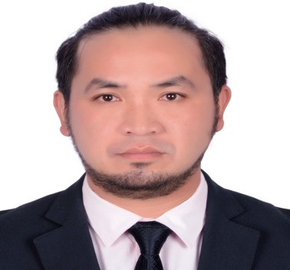
Ruel Tordillos Martija
Lipa City Batangas, Philippines
Mob. # +639369911033
r.martija@yahoo.com

OBJECTIVES:

- To provide excellent service and to have a good level of employment experience.
- Seeking a position in a facility where my extensive professional and practical experience will be fully utilized.

TECHNICAL SKILLS:

- Can operate any types of computer system.
- Knowledgeable in computer system repair, assembly, installation and configuration.
- MS Word, Excel, PowerPoint, SAP.

CAREER HISTORY:

Material Management-

ZTE Philippines
Hummingcomm Corporation
DITO Philippines (Principal)
Feb. 1, 2021 – April 30, 2021

Job Description:

- Coordinate shipment from ZTE custom broker agent.
- Plan shipment schedule through laydown availability and equipment available.
- Receiving Inbound shipment by arranging manpower from our logistic patner.
- Encoding of all inbound shipment on our data base and report to our Logistics head for information.
- Receiving of Material Request from sub contractor through our data base and inform our logistic partner for preparation.
- Inspect all prepared material from requisition and approved for outbound of materials.
- Encoding of all outbound item to our data base.
- Prepare daily report and submit to our superior.
- Conduct actual weekly inventory and match to system inventory.

Material Controller E&I –

DAESUN ELECTRICAL & COMMUNICATION
Hyundai-Samsung Joint Venture
Principal: Emirate Nuclear Energy Corporation (ENEC)
Al Barakah UAE
October 8, 2018 – October 8, 2019

Job Description:

- Receiving of material from shipment and store in Main Contractor warehouse for temporary storage and for preparation for inspection.
- Receiving and proper storage of all instrument item.
- Proper handling of valued material such as Man Machine Interface System panels.
- Ensuring the quantity of material is correct as per packing list and actual count
- Separation of material as per their quality class.
- Preparation of preventive maintenance record of the instrument that was already calibrated and to be transfer to site for installation.
- Update maintenance record of all instruments install at site using the Nuclear Power Construction Management System (NPCMS) SAP Application.
- Conduct monthly inventory of all material in the warehouse.
- Prepare Purchase order for local supply materials
- Review all quotation from supplier for purchasing of materials use for support to construction

Material Controller E&I –

Al-Hasoun Sejong Electro-Mechanical
Hyundai-Samsung Joint Venture
Principal: Emirate Nuclear Energy Corporation (ENEC)
Al Barakah UAE
September 2014 – September 2018

Job Description:

- Receiving of material from shipment and store in Main Contractor warehouse for temporary storage and for preparation for inspection.

- Receiving and proper storage of all instrument item.
- Proper handling of valued material such as Man Machine Interface System panels.
- Ensuring the quantity of material is correct as per packing list and actual count
- Separation of material as per their quality class.
- Preparation of preventive maintenance record of the instrument that was already calibrated and to be transfer to site for installation.
- Update maintenance record of all instruments install at site using the Nuclear Power Construction Management System (NPCMS) SAP Application.
- Conduct monthly inventory of all material in the warehouse

Material Controller (Piping,Mech. and E&I)–

DANIELI CONSTRUCTON INTERNATIONAL S.P.A.
Hadeed Long Product Expansion Project ( SABIC Affiliate)
Al-Jubail City, KSA
July , 2010 – March 2014

Job Description:

- Inspects materials on arrival on the site in terms of quantities and their conformity with specifications and technical drawings.
- Ensures the availability of adequate means for handling materials.
- Ensures the storage and preservation of material, in accordance with the methods of classification, marking and traceability.
- Ensures segregation of nonconforming material, nothing any losses or damage in a report.
- Keeping the situation of available material and incoming material up-to-date and provide assistance for feasibility analysis.
- Keep up-to-date the stock Record card/Data Base System
- Verify the test certificate number and heat cast number.
- Preparing the materials requested by the sub-contractors
- Issuing daily receiving report to the Material Manager.

Maintenance Clerk & Maintenance Technician –

PHILINAK INDUSTRIES INC.
Malvar,Batangas
October 4, 2005 to July 17, 2010

Job Description:

- Prepare Maintenance Standard Operating Procedure.
- Prepare monthly preventive and predictive maintenance schedule.
- Conduct preventive maintenance.
- Conduct mold maintenance as per schedule.
- Facilitate any activity related to safety standard.
- Set up mold on machines.
- Operate Machine through Automatic work condition.
- Repair and troubleshoot machine like injection machine, Chiller and Dryer
- Conduct preventive maintenance in all machine as per schedule.
Warehouse Operator –

K&K Molding Inc.
Malvar, Batangas
February 2005 to July 2005

Job Description:

- Preparation of material base on the Purchased Order of costumer for daily delivery.
- Receiving of material from production and proper storage of materials base on First In First Out policy.
- Coordinate with purchasing department the material to be deliver to costumer for preparation of delivery notes.
- Conduct 5’S(Housekeeping) before and after the work.
Machine and Equipment Technician –

Epson Precision Phil. Inc.
Lipa City, Batangas
April 2004 to October 2004

Job Description:

- Monitoring of machines at the start of shift base on the checklist.
- Repair and calibrate tools and jigs to be use by production lines.
- Support to production line during trouble and system failure of machine
- Prepare daily report base on the daily activity.

EDUCATIONAL ATTAINMENT:

College - Batangas State University
BS Industrial Engineering
Brgy.Marawoy Lipa City
2004

SCHOOL AFFILATION:

- Member of Junior Philippine Institute of Industrial Engineers (JPIIE).
- Vice President of Association of General Engineering Student (AGES).
- Former member of University Baseball and Softball Team.

TRAINING AND SEMINARS:

- Safety seminars at site for all activities like Material Handling, Confined space, Lifting, working at height etc..
- Indoctrination.
- Leadership Training.

PERSONAL INFORMATION:

Age : | 36 yrs. Old
Birthday : | May 22, 1983
Weight : | 75 kg
Height : | 176cm
Mother : | Milagros Luces Martija (deceased)
Father : | Rodolfo Tolentino Martija (deceased)
Religon : | Roman Catholic

REFERENCES:

Mr. Marco Sandrin
Project Manager
SAIPEM (UAE)

Jesus Ocdamia
Production Manager
Philinak Industries

Byeong Chul Han
Construction Manager
Al-Hasoun Sejong Electro Mechanical LLC (UAE)

**I hereby certify that the given information above is true and correct to the best of my knowledge and belief**

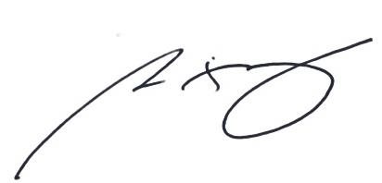

____________________
Ruel Martija

