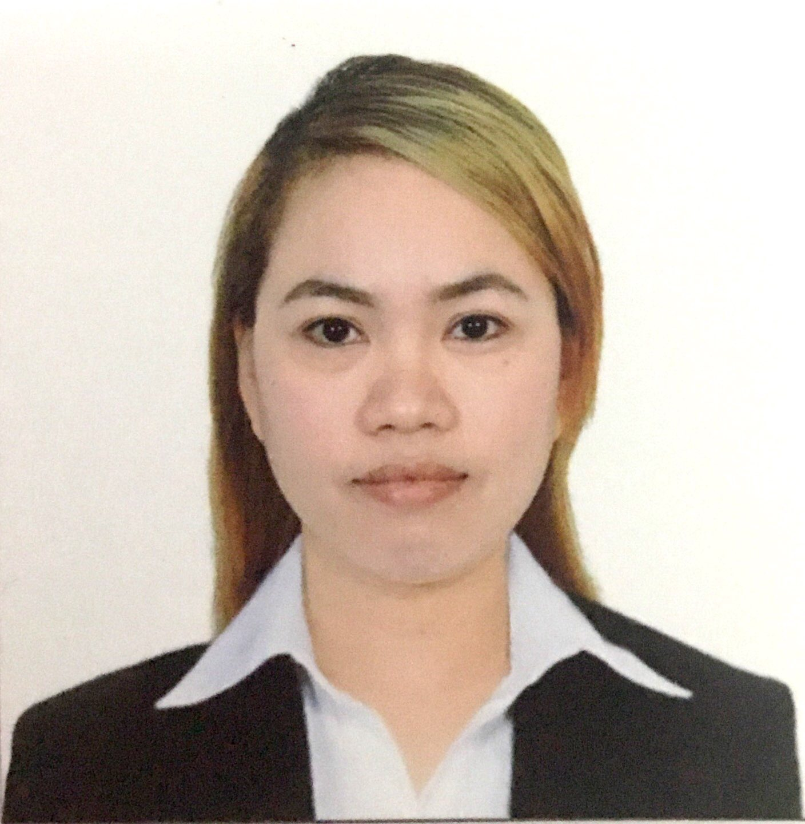
JENNA MHARIE REYES-BALDOVINO
Present Address: 178 Hope St. Saint Catherine Village
Brgy San Isidro, Sucat, Paranaque, Philippines
Permanent Address: 31 Gen. Malvar St. Barangay 4
Pasuquin, Ilocos Norte, Philippines
Mobile Number: (+63) 998-3803428 (+63) 945-7349576
E-mail Address: jennamhariereyes@gmail.com
Birthdate: January 7, 1986

OBJECTIVE:
Seeking a challenging position in a competitive area where I can fully utilize my extensive nursing profession and practical experiences
PROFESSIONAL EXPERIENCE

Name of Hospital : Immam Abdulrahman Bin Faisal University Hospital
(formerly King Fahad University Hospital)
Full Address : Immam Abdulrahman Bin Faisal University Hospital
(formerly King Fahad University Hospital)
Aqrabiyah, Al– Khobar, Kingdom of Saudi Arabia

Brief Description of Hospital:

King Fahd Hospital of the University is a tertiary regional referral teaching hospital 10 Km South of the University of Dammam where it is affiliated. It has a 440 Bed capacity with tertiary health care services as well as teaching and training facilities for undergraduates, medical and paramedical professional and post-graduate trainees. As a recognized teaching and training hospital, the hospital facilities and services have been progressively enlarged and modified to meet the continuing changes and growing educational and clinical needs of the community. At present, the hospital has the following services, Intensive Care, Coronary Care, Neonatal Intensive Care, Burn Unit, Haemodialysis and peritoneal Dialysis, endoscopy, Lithotripsy, Physiotherapy, Radiology (CT scan, MRI), Pharmacy, Diagnostic Laboratory Services, Cardiac Diagnostic Laboratory and heart surgery which started in 2009. KFUH is the first teaching and training hospital to be accredited by the Joint Commission International Accreditation (JCIA) in the region.

Position: Charge Nurse/Staff Nurse - Surgical Intensive Care Unit
(12/17/2012 – 10/04/2019)

9 Bed capacities with 3 Isolation bed, provides intensive surgical care service round the clock for patients with critical surgical condition admitted by KFHU or referred by other hospitals.

- Provides exceptional care to critically ill patients
- Assess physical and emotional needs of trauma patients
- Implements treatment accordingly
- Assess working conditions of all surgical equipment
- Accepts and supports work assignment changes
- Handles patient blood and blood products with regard to all applicable hospital safety standards
- Monitors mechanical ventilators and artificial airway equipment
- Took all appropriate steps for infection prevention and control
- Provides support and counseling to patients and family members as required
- Assigns task to all trainee nurses in correspond to their respective assignment
- Ensures compliance with all facility local and state safety requirements in all performed tasks
- Performs all task in coordination with attending physician

Name of Hospital : Almana General Hospital
Full Address : Al Ahsa, Kingdom of Saudi Arabia

Brief Description of Hospital:

A private hospital aims to provide primary and secondary health care services and tri (niche) on a high level in all medical specialties. Where they are providing care affordable for all groups in Saudi Arabia, particularly Al - Ahsa province and its surroundings. Officially, the hospital was launched in June 2001 with bed capacity at the time of up to fifty (50) beds, and twelve (12) outpatient clinics. It was clear during the short period that the needs and requirements of the population of health care were far outweighed accommodating the hospital. He quickly was to begin a comprehensive expansion plan, the main goal of which provide more inpatient and outpatient facilities to help meet the growing demand for medical services in the area of al - Ahsa.

Position: Charge Nurse/Staff Nurse - Surgical Intensive Care Unit
(06/22/2010 – 08/17/2012)

16 Bed Capacity that has multicultural staff catering to middle eastern patients admitted in the hospital.

- Assess, plans, implements and evaluates patient care
- Performs patient education in accordance to unit standards for all patient types and age groups
- Monitors telemetry and responds to codes
- Administer medications and intravenous fluids
- Assist physician with procedures and treatment protocols
- Grooms and bathe patient and provide assistance with general care
- Resolves issues utilizing the nursing issues
- Assigns task to all trainee nurses in correspond to their respective assignment
- Ensures compliance with all facility local and state safety requirements in all performed tasks
- Performs all task in coordination with attending physician

CASES HANDLED – ONE SUMMARY FROM ALL EMPLOYMENT EXPERIENCES

- Trauma
- Sepsis
- Shock
- Stroke
- Post Operative Cases
- Heart Failure
- Lung Failure
- Aneurysm

EQUIPMENT HANDLED - ONE SUMMARY FROM ALL EMPLOYMENT EXPERIENCES

- Hospira Plum IV set
- GE Cardiac Monitor
- Prismaflex Machine for CRRT
- Edward LifeSciences Vigileo Machine
- EV1000 Clinical Platform
- Omnicell Pharmacy Central Automation System
- IV Alaris tri-site Thermometer
- Siemens Rapid Point Blood Gas Analyzer
- Puritan Bennet 840 Ventilator
- Pulse oximeter (Nellcor)
- Phillips Heartstart Defibrillator
- Bronchoscope
- Feeding Pumps (Covidien,Freego)
- Glucometer (Accu Check)
- Pneumotic Machines (Kendall)
- ECG Machine
- Doppler Ultrasounds
- Defibrilator

EDUCATION

COLLEGE
Diploma : Bachelor of Science in Nursing
University : Northern Christian College
Full Address : Laoag City, Ilocos Norte, Philippines
Period Attended : 06/2004 – 03/2008
Date of Graduation : 03/2008

Diploma : Bachelor of Science in Physical Therapy
University : Mariano Marcos State University
Full Address : Batac, Ilocos Norte, Philippines
Period Attended : 06/2003 – 03/2004
Date of Graduation : Undergraduate

SECONDARY
School : Ilocos Norte College of Arts and Trades
Full Address : Laoag City, Philippines
Period Attended : 06/1999 – 03/2003

ELEMENTARY
School : Pasuquin Central Elementary School
Full Address : Pasuquin, Ilocos Norte, Philippines
Period Attended : 06/1993 – 03/1999

LICENSING/CERTIFICATION

Philippine Nursing License
PRC ID No.: 0549336

Saudi Council Passer
Professional Registration No. 11-L-N-0030481

ORGANIZATIONAL AFFILIATIONS

Name: Philippines’ Nurses Association

TRAINING/SEMINARS

Title: Basic Life Support
Date Completed: September 20, 2018
Expiration Date : September 20, 2020

Title: Tracheostomy Care
Date: June 2015

Title: Mechanical Ventilation
Date: January 2016

SKILLS AND CAPABILITIES
- Works well even under pressure, eagerly assists co-workers
- Can effectively deal with all types of people and nationality
- Experience in assisting and doing bedside insertion of invasive lines
- Open in acquiring more knowledge from the health care team
- Can easily adjust to different working environment
- Determinate and dedicated to give quality health care to a client
CHARACTER REFERENCES
Available upon request

