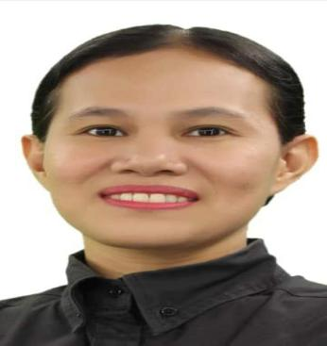
CECILIA B. BOMBITA
Block 21 Lot 9 Saint Joseph 10 Langgam San Pedro Laguna
Cezbombita@gmail.com
0995-2268-189 / 0932-3586-833
OBJECTIVE:
I am seeking competitive and challenging environment where I can serve the organization/company a very enjoyable career for myself.
SUMMARY:
Organized and friendly Restaurant shift manager with excellent organizational skills and years of experience in customer relation, sales, inventory, stocking, production process, cleaning and maintaining store compliance.
EDUCATIONAL ATTAINMENT:
College: Our Lady of Assumption College of Laguna Inc.
Course: Bachelor of Science in Business Administration
Marketing Management S.Y. 2015-2017
Tertiary: University of Makati
Course: Political Science S.Y. 2002-2004
Secondary: Bacoor National School S.Y. 1997-2002
Primary: Molino Elementary School S.Y. 0991-1997

PERSONAL INFORMATION:
Weight: 50kg
Status: Married
Date of birth: July 28, 1983
Place of birth: Lapaz, Leyte

WORKING EXPERIENCE:
COMPANY NAME: BURGER KING
ADDRESS: Jollibee Plaza Ortigas Pasig City
DATE HIRED: April 16, 2018 – up to present
POSITION: Assistant Restaurant Manager
JOB DESCRIPTION: Supervising store operations, scheduling manager, receiving stocks, handling customer feedback, implementing standard operating procedure.

COMPANY NAME: BURGER KING (5 years experience)
ADDRESS: Alabang Town Center, Muntinlupa city
DATE HIRED: October 2013 - January 2018
POSITION: Team Member
JOB DESCRIPTION: Production Controller, inventory daily weekly and monthly, receive stocks, preparing diff kinds of burgers.

COMPANY NAME: Jollibee (5 years experience)
ADDRESS: Alabang, muntinlupa city
DATE HIRED: May 2007 – May 2012
POSITION: Team Member
JOB DESCRIPTION: Production Controller, inventory daily, receive stocks, preparing diff kinds of burgers, pasta, and etc.
COMPANY NAME: Kenny Rogers
ADDRESS: Roxas Boulevard
DATE HIRED: March 1, 2004 – September 1, 2004
POSITION: Team Member

AWARDS WITH CERTIFICATE:
Best crew trainer March 15, 2007 Best in Pantry area March 15, 2007
Work Olympics June 7-13, 2007 Best crew trainer July 26, 2007
Ms. Food Safety July 26, 2007 Sparkling Bee July 26, 2007
Best in back up July 26, 2007 Best in cleanliness Dec. 7, 2007
Best in Pantry area Dec. 7, 2007 Ms. Clean as you go Dec. 7, 2007
Best crew trainer March 8, 2008 Ms. Clean as you go March 8, 2008
Best in Pantry area March 8, 2008 Best in Pantry area July 27, 2008
Ms TLC July 27, 2008 Ms. Clean as you go July 27, 2008
Ms. Elwagas July 27, 2008 Ms. Elwagas Sept.10, 2008
Respect for individual Sept 10, 2010

CHARACTER REFERENCE:
Glaiza Fabiosa Burger King Manager 0945-4624-605
Neslyn Luzon Burger King Area Manager 0998-5809-091

I hereby certify that the above information is true and correct to the best of my knowledge and belief.

____________________
Cecilia B. Bombita
Applicant Signature

