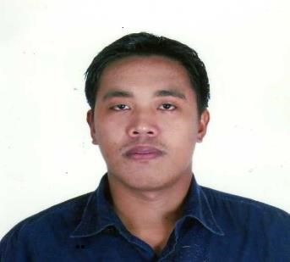
CELESTINO F. VISPERAS

Satwa, Dubai, U.A.E.
M: 0557023047
E: visperascelestino@gmail.com

PERSONAL & PROFESSIONAL PROFILE

- Overall 9 years working experience (2 years in Riyadh.KSA).
- Possess very good command in English Language (written and spoken).
- 2 years experience as Maintenance Facility
- (CCTV Installer/Welder/Electrician in Riyadh, KSA.
- 8.5 years experience as Maintenance Electrician/Welder in Philippines.
- Ability to multi task and work well under pressure with
- minimal or no supervision.
- Proficient in MS Office Applications.
- Proven competence, sincerity, dedication, flexible, results oriented and
- hard working qualities.
- Undergraduate of BS Auto Mechanic.
- Born on October 23, 1982.
- Understand and speak Arabic.

OBJECTIVE

To obtain a position that challenges me and provides me the
Opportunity to reach my full potential professionally and
Personally, utilizing my abilities and years of experience in your
organization that is progressive intellectually and
technically and one in which practices collaborative
leadership, integrity and honesty.

PROFESSIONAL EXPERIENCE

COFFEE PLANET LLC.
- Warehouse Assistant
UNASCO Building, Al Quoz 4
PO Box 73042, Dubai, UAE
Present-Jan 18, 2016

GOODS IN, STORAGE & STOCK CONTROL, GOODS OUT

- Pack, stock, organize and rearrange products in warehouse.
- Recording and damaged, missing or faulty goods.
- Keep neat and clean warehouse premises.
- Moving the goods, to the correct area in the warehouse ,
either manually or using mechanical handling equipment.
- Organize and maintain records of inventories up to date.
- Monitor and manage inventory control.
- Manage and handle shipping, loading and unloading of
products.
- Operate forklifts and pallet jacks.
- Handle and operate necessary tools and accessories in
maintaining and
- Provide assistance or direction to other technicians,
warehouse, or sales personnel
- Integrate best practices in handling warehouse materials.

MAALEM DUBAI
- Worked as Maintenance CCTV Installer/Electrician/Welder
Al Imam Abdullah Bin Saud Exit 9 Riyadh, KSA.
March 2013-May 2015

- Install CCTV camera and paradox GM console security system.
- Responsible for the installation of wires, switch lights, outlets, and breakers.
- Assemble 400watts street lights with ignitor trans, and photo control.
- Assemble Crystal Treya.
- Fabricate steel window/gate like grills and parleins.

EDUCATIONAL BACKGROUND

Undergraduate of BS Auto Mechanic Eulogio “Amang “ Rodriguez Institute of Science and Technology(EARIST

