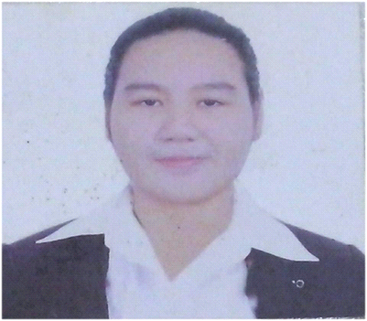

KARLA MARIE D. AMANCIO
B1 Lot18 Unit B Carnation St TS Cruz Subdivision
Almanza Dos Las Piñas
09197346294
karlaitchiro@gmail.com

EDUCATIONAL ATTAINMENT:

- Bachelor of Science in Psychology
University of San Jose-Recoletos
Magallanes Street, Cebu City
2011-2015

- Saint Alphonsus Catholic School
Poblacion, Lapu-Lapu City
2007-20011

- Saint Alphonsus Catholic School
Poblacion, Lapu-Lapu City
2000-2007

Achievements:

S.A.C.R.E.D (delegate)
(Student Alliance for a Christian and Real Education Under Democracy)
2012-2015

Consistent Player CAS Women’s Volleyball Team
University of San Jose-Recoletos
2011-2015

Class Officer
Saint Alphonsus Catholic School
(grade 1- 4th year HS)
Honor Student
Saint Alphonsus Catholic School
2007-2008

Trainings and Seminars:

- Clinical Aspect of Bullying
Research Congress 2013
Center of Performing Arts, University of San Jose-Recoletos
February 13, 2013

- Career Assessment Seminar for CAS Sophomores
Audio Visual Room, University of San Jose-Recoletos
July 28, 2012

- “Filling Gaps, Chaining Linkages”
Position: Facilitator
Date: March 16, 2014

- Psychological Assessment & the Law Nullity of Marriage in the Philippines
Center of Performing Arts, University of San Jose-Recoletos
October 6, 2012

- 2ND SACRED Summer Camp(Student Alliance for a Christian and Real Education Under Democracy)
University of San Jose-Recoletos
May 23-26, 2012

Working Experiences:

- Industrial Internship (Human Resource)
Mariner’s Court ,Pier 1 Cebu

- Social Psychology Internship
Dr. Caridad C. Labe Education CenterEx (CCL CenterEx)

- Clinical Psychology Internship
Vicente Sotto Memorial Medical Center

- Social Worker/ Enumerator (Field Work)
Department of Social Welfare and Development (DSWD) - Field Office 7

- Customer Service Representative (Amazon)
Concentrix Cebu-Mactan Newtown
October (2017)- June (2018)

- Customer Service Representative (METRO by T-Mobile)
IQOR Sta. Rosa Laguna
October (2018)- March (2019)

- Optum (OGS Alabang)
Northgate Cyberzone Filinvest
May 01, 2019- 2021 September

- Exl Philippines
Northgate Cyberzone Filinvest
September 27,2021- May 16, 2022

References:

- Mr. Roberto Ferrer
Team Leader
Concentrix Cebu-Mactan Newtown
09177732939

- Zhony Reyes
Secretary of former Mayor Arthur Alonte
City of Binan Laguna
09185689232

- Mr. Rex Argate
College of Law Professor
University of Cebu
09229440302

