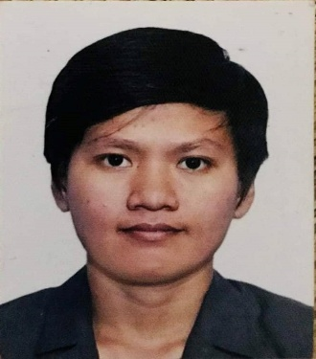
Rachelle M. Solmerin
Address: Purok 4, Eden, San Manuel, Isabela, Philippines
Email-Address: ellechar1711@gmail.com

OBJECTIVE | Seeking a challenging opportunity where I will be able to utilize my strong organizational skills, education, and ability to work well with people, which will allow me to grow personally and professionally.

WORK  EXPERIENCE | July 31, 2018-Present  MOTOISHISEIKA CORPORATION  Fukuoka Ken Kurume Shi Kitano Machi Nakagawa 418-2 Japan  Job Description: Cultivation Agriculture/Farmer  Responsibilities:  - Differentiation of fertilizer measurement and fertilization design  - Differentiation of fertilizer measurement and fertilization of seeds  - Handling Materials  - Seeding irrigation and growth diagnosis of crops  - Forage and manure cultivation  - Cultivation for seeds raising crops  - Rice cultivation  - Observational work such as monitoring of earth acid degree & etc.  - Planting, Harvesting, Vegetable growing& Upland Field Cropping  September 15, 2014 – September 14, 2017  PANRAM INTERNATIONAL CORPORATION  Gongjan S. Rd, Qidu Dist. Keelung City, Taiwan R.O.C  Job Description: Production Operator  Responsibilities:  - Assembly Testing  - Burn in Scanning  - Operating Auto SPD Machine  - Operating Module Testing  December 12, 2013 – June 3, 2014  JAE PHILIPPINES INCORPORATION  Gateway Business Park, Brgy. Javalera Gen. Trias, Cavite  Responsibilities:  - Operating Emboss Packaging Machine

EDUCATION  TERTIARY  SECONDARY  PRIMARY | 2009-2013  Isabela State University  Roxas, Isabela  Bachelor of Science in Agri-Business  Major in Management  2005 – 2009  Callang National High School  San Manuel, Isabela  1999 – 2005  Eden Elementary School  Eden, San Manuel Isabela

ADDITIONAL  SKILLS | Ability to work under pressure, self-motivation, easy fast learner & hardworking.
REFERENCES | YOUKO MOTOISHI  CEO  MOTOISHISEIKA CORPORATION  Kurume Shi Fukuoka Japan  CHIH SIANG LIN  Line Leader  Panram International Corporation  Keelung Taiwan

