

ESTHER S. RUMBAOA
#27-A PungtoBacarra, Ilocos Norte
Contact No. +639074664403
Email Address: estherrumbaoa18@yahoo.com

OBJECTIVE
To work in an organization that could give me the opportunities to gain knowledge, enhance my skills furthermore, to give myself the chance to experience a working environment that could provide improvement of my abilities.

PERSONAL PROFILE
Age : 31
Height : 5’6
Birthday : June 18, 1991
Birthplace : Bacarra, Ilocos Norte
Civil Status : Single
Religion : Iglesia Ni Cristo
Citizenship : Filipino
Languages and Dialects Spoken: English, Filipino, Ilocano,Kapampangan

EDUCATIONAL BACKGROUND

Level | School | Inclusive Date
Tertiary | Northwestern University;  College of Business Education Laoag City;  Course: BS in Tourism | 2009-2013
Secondary | Cadaratan National Highschool  Brgy. 30 Cadaratan, Ilocos Norte | 2005-2008
Elementary | Cadaratan Elementary School  Brgy.30 Cadaratan, Ilocos Norte | 2001-2006

EMPLOYMENT HISTORY & WORK EXPERIENCES

On-the-Job Training
Negros Navigation/Actual Ship board
Front Office/Reservation/Receptionist
Room Attendant
April 2010

Laoag International Airport
Ground stewardess
October 2012 –Jan 2013

DSJ Travel & Tours
-Reservation & Airline Ticketing Officer
-Tourist Visa and Visa assistance
-International & Domestic Tour package
Room 102 Cruces Bldg
Brgy. 8 LaoagCity, Ilocos Norte
April 8 2013-June 2017

JJLRC Travel Adventures
-Reservation & Airline Ticketing Officer
-Tourist Visa and Visa assistance
-International & Domestic Tour package
Brgy. 1 Sta Rita Bacarra, Ilocos Norte
July 30 2017-June 2022

SKILLS and ABILITIES
- Good communication skills
- Flexible personality
- Work under minimal instructions
- Computer literate
- Oriented in Abacus system/Sambre
- Good moral character
- Dedicated and Hardworking individual

ACHIEVEMENTS
BS- TOURISM Graduate
Northwestern University
Laoag City, Ilocos Norte
April 5, 2013

Character References

Ms. Caroline S. Sicat
Senior Manager Finance Deputy
Team Head Phoenix Semiconductor Philippines Corp.
Clark Freeport Zone Pampanga
09175509041

Ms. Louelyn B. Tabili
Tourism Adviser
Northwestern University
LaoagCity, IlocosNorte
09153060186

I hereby certify that the above information is true and correct to the best of my knowledge and ability.

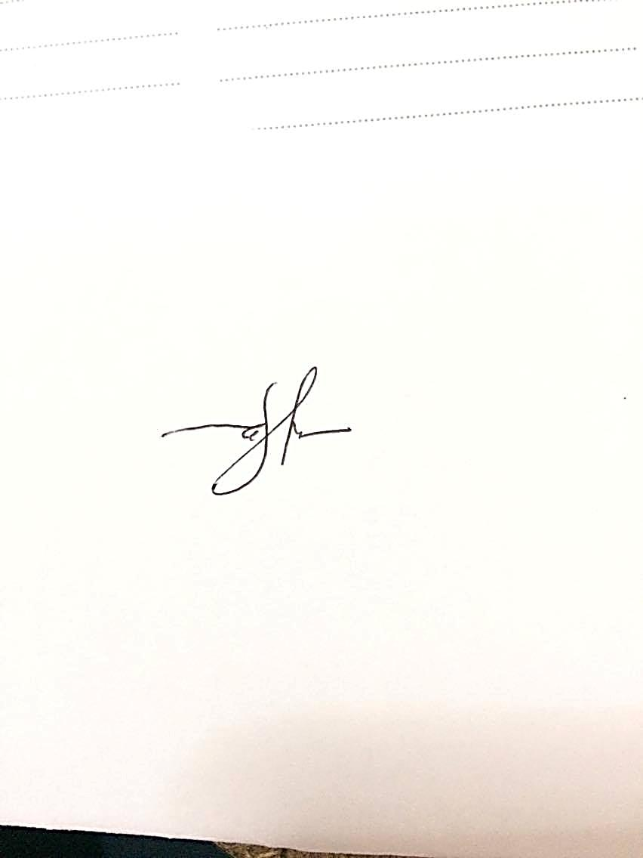

ESTHER S. RUMBAOA
Job Applicant

