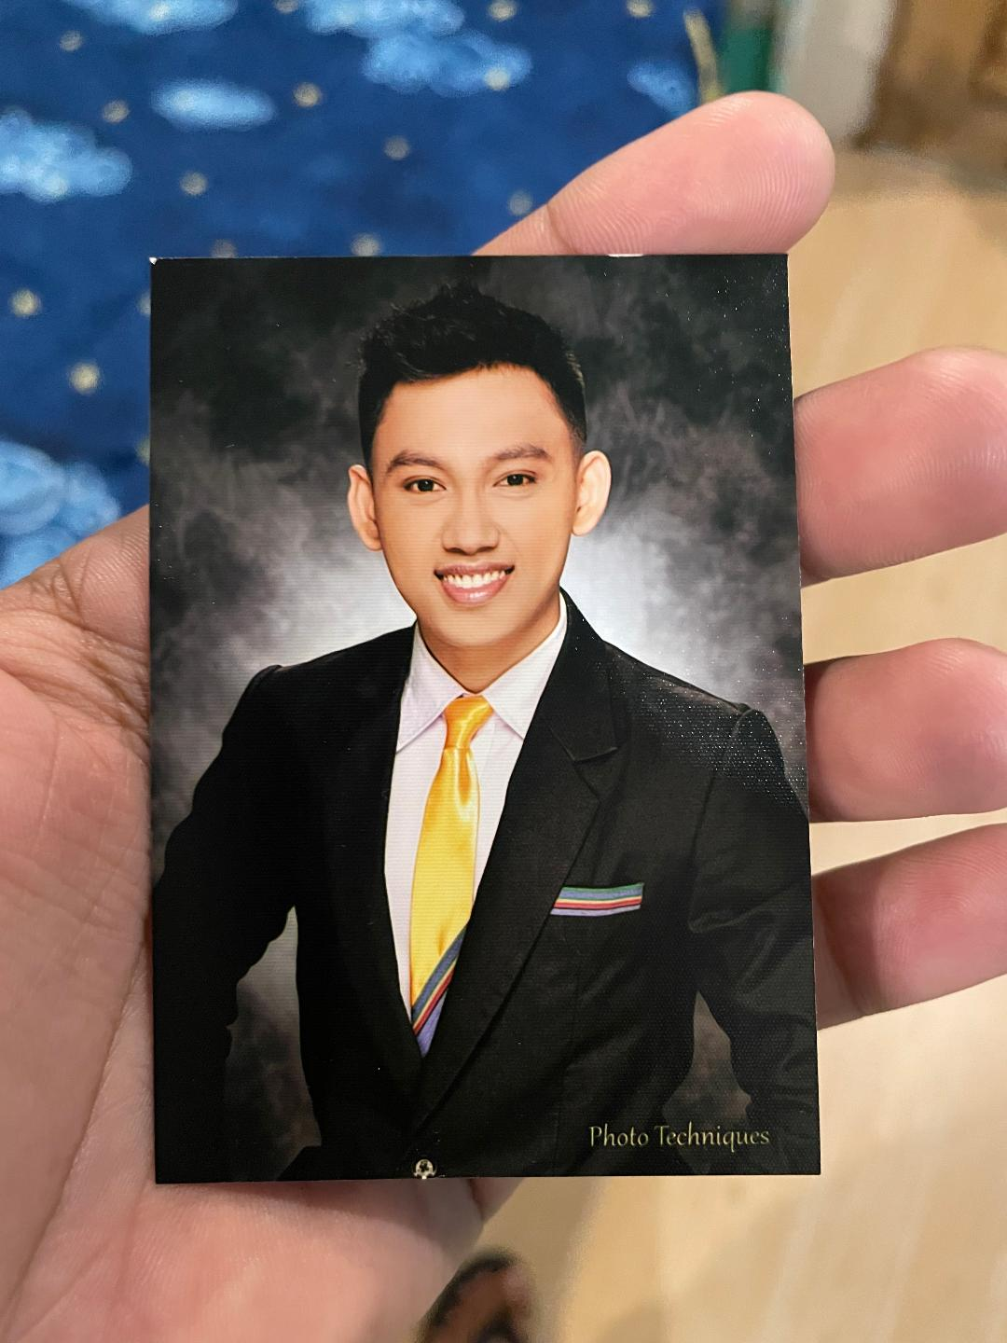Jehvico L. Santos
#408 Malued District, Dagupan City, Pangasinan, Philippines 2400
0933-817-3161, jehvicosantos@yahoo.com

OBJECTIVE
To share my skills and abilities in a challenging surroundings to further explore and become accustomed in different fields, and realize my potential in becoming an accessory to the development of the organization with inspiring performance.

WORK EXPERIENCE
Assistant Manager – Operations (August 2019 – Present)
Moreenz Curtain
Dagupan City, Pangasinan 2400

- Manage a team of 5 professional fabric sewers and cutters
- Develop strategies in maintaining best quality products
- Accomplish made to order curtains, bedsheets and pillowcases ahead of time
- Ensure continuous production to satisfy the demand of the market

Assistant Manager – Operations (August 2019 – Present)
D.A.GSPEED Motorparts and Accessories
Dagupan City, Pangasinan 2400

- Manage a team of 4 professional saleslady and motorcycle mechanics
- Maintaining quality service rendered to customers
- Upselling products and engaging in motorcycle events
- Generate more revenue by attracting wholesalers

ACADEMIC BACKGROUND
Saint Louis University – Maryheights Campus, Baguio City 2600
Bachelor of Science in Hospitality and Tourism Management
Major in Hotel, Resort and Restaurant Management
Minor in Travel and Tours Management
CERTIFICATIONS
TESDA NATIONAL CERTIFICATE II

Housekeeping
Certificate number: 17141102015018

Food and Beverage Services
Certificate number: 17141102015035

SKILLS
- Adaptability
- Industrious
- Self-Motivation
- Punctuality
- Team Player
- Computer program literate

CHARACTER REFERENCES

D.A.GSPEED Motorparts and Accessories
Vivian Luna Lopez – Proprietor
0920-920-4895

Moreenz Curtain
Vivian Luna Lopez – Proprietor
0920-920-4895

Jonathan Cabrera – Motorcycle Chief Mechanic
0933-864-9470

