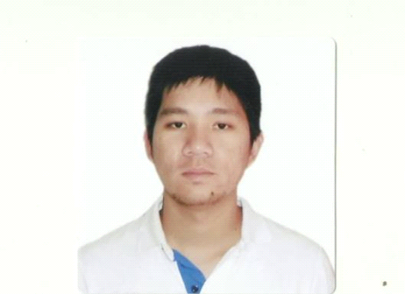

RESUME

Ronald R. Maranan
ronald08maranan@yahoo.com
Contact No. : 09179719076/09276447786
Professional Profile
An extremely hard working, committed and highly self-motivated individual with a proven track record within the provision of an exceptional customer service at all times, whilst adhering to set deadlines, targets and business objectives. Works well on own initiative with a high level of self-responsibility and plays an instrumental role within a successful and productive team. Possesses excellent cashiering, organization, time management, problem solving and interpersonal skills, using communicative abilities to build, develop and maintain beneficial relationships at all levels. Thrives in a fast-paced working environment.

Career Objective:

I am looking to secure a challenging and rewarding new role, where I can apply the skills, knowledge and expertise I have gained throughout my studies and successful career to date.

Work Experiences:

Eaton Philippines
Sto. Tomas (LISP III)
Maintenance Technician
January 2017- Up to Present

IM DIGITAL PHILS.INC.
Sto. Tomas (FPIP)
Maintenance Technician
February 2014 – October 2015:

PHILIPPINE MANUFACTURING co. of MURATA
First Philippine Industrial Park
Machine Engineer
April 2013 – September 2013

Optis Philippines Inc.
Gen. Trias Cavite (Gateway)
Equipment Engineer
August 17, 2010 - March 25, 2013

EATON PHILIPPINES:

Duties and Resposibities;

• Operates, maintains & calibrates electronics and electro-mechanical equipment
• Performs major and minor repairs on the machine if possible where applicable
• Troubleshoot and resolve electronic and electrical malfunction
• Conduct studies on efficiency of methods, material and equipment
- Performs related work as assigned
- Follows all SOP and work protocol implemented by organization
- Prepares a detail report with respect of completed task

IM DIGITAL INC.

Duties and Responsibilities:

- Production Equipment Installation, (Electrical and Mechanical).
- Operation of Industrial Computer controlled equipment.
- Perform scheduled maintenance and service works on manufacturing machinery.
- Troubleshooting of faults and recalibrating instruments.
- Documenting weekly report in regards with the machines and equipment status inside production area.
- Ensure safety during work. Strict compliance to safety procedures. Target for zero accident in work area.
- Report to Supervisor Engineer on any abnormality encountered.
- Keeping an Up to date inventory of mechanical tools.
- Assisting Trainee Technician.
- Completing all Duties according to applicable safety measures and published procedure.

PHILIPPINE MANUFACTURING co. of MURATA

Duties and Responsibilities:

- Perform scheduled maintenance and service works on manufacturing machinery, such as a Plating Machine,
- Documenting weekly report in regards with the machines and equipment status inside production area.
- Repairing or replacing defective equipment parts.
- Responding immediately to machinery breakdowns.
- Assisting with Mechanical and Electrical Installation.
- Operation of Industrial Computer controlled equipment.
- Keeping an Up to date inventory of mechanical tools.

OPTIS PHILIPPINES INC.

DUTIES AND REPONSIBILITIES:

- Ensures 100% working condition on all equipment’s prior to daily production.
- Troubleshoots and resolves problems concerning the operation and performance of machines.
- Generates equipment downtime reports, updates equipment check sheets and control charts.
- Knowledgeable in repairing conveyor.
- Knowledge troubleshooting in automatic machine.
- Ensure safety during work. Strict compliance to safety procedures. Target for zero accident in work area.
- Making weekly report about the machines and equipment’s in production area.
- Report to the Supervisor Engineer on any abnormality encounter.

SKILLS and COMPTENCIES:

  - Sense of Responsibility
  - Excellent skills in communication and collaboration
  - Hardworking
  - Computer Literate
  - Functional and Technical Skill

EDUCATION BACKGROUND:

2003-2009 Polytechnic University Bachelor of Science in
Of the Philippines Electrical Engineering

Character References:

Nick De Vera Michael Ang Ian Penaflor
Asst. Manager Asst. Supervisor Asst. Supervisor
IM Digital Inc. IM Digital Inc. IM Digital Inc.
09175913219 09464207536 091644761886

