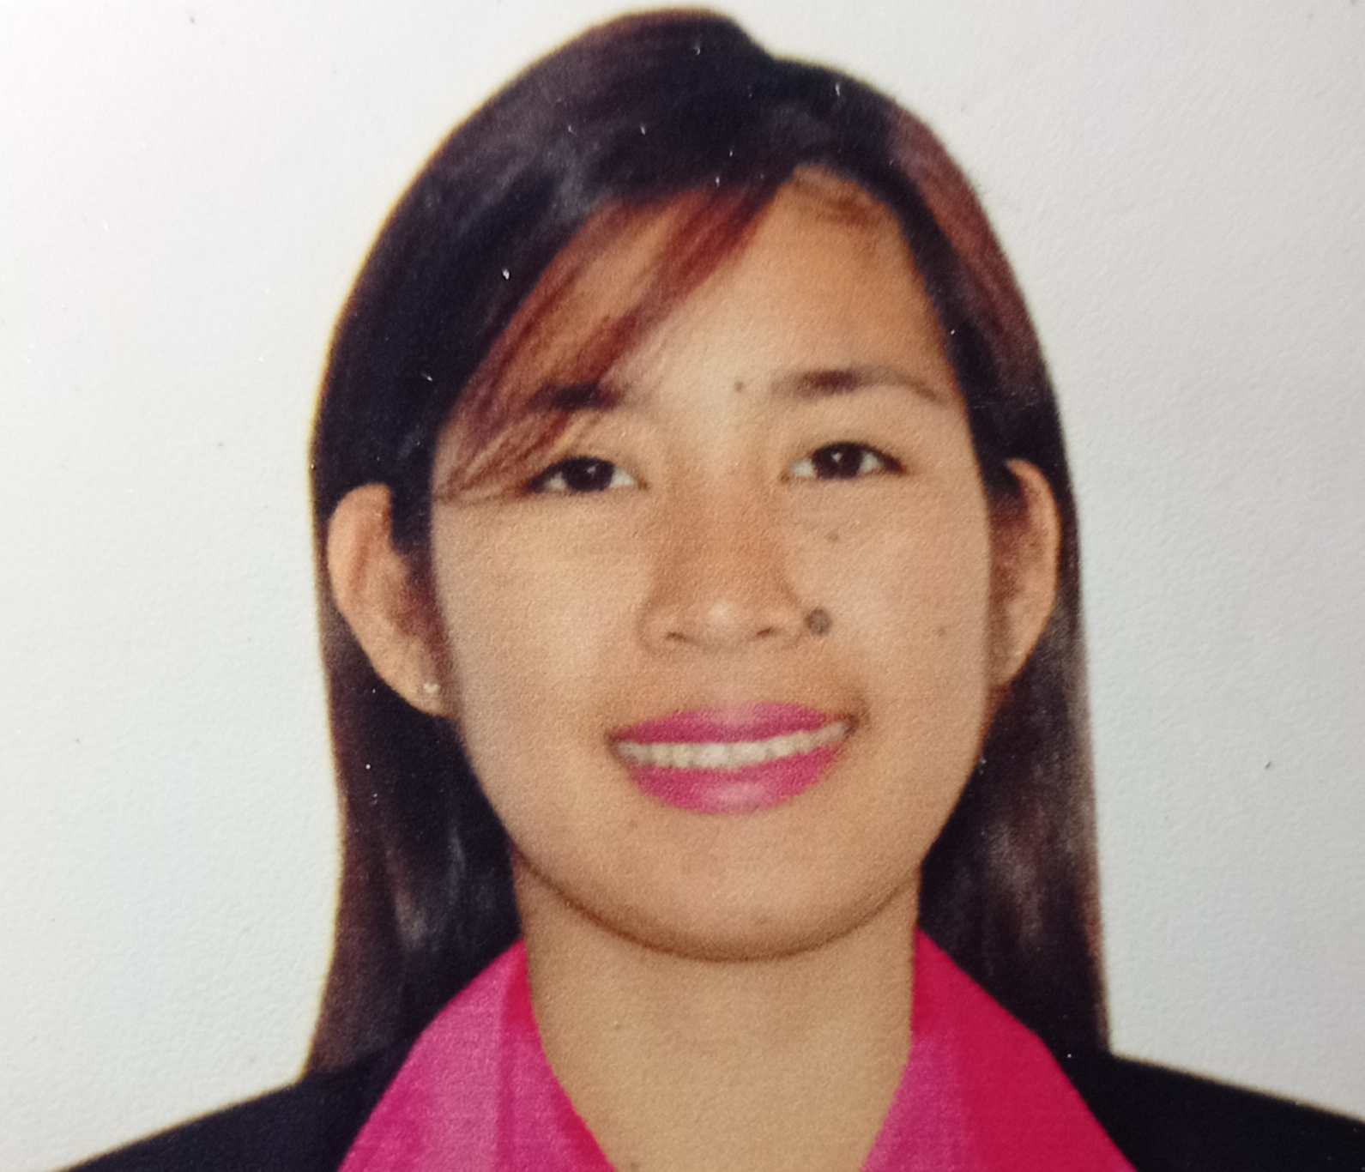
Danica Arandia Colegio
Calumpang East,San Luis,Batangas
09128814543/09367652911
Ysikielxia@gmail.com

OBJECTIVE:
- To be part of your company, to improve my skills and to have a stimulating job.

QUALIFICATION:
- I am hardworking,persistent, fast learner,flexible,and willing to gain and improve my skills,can handle pressure.
WORK EXPERIENCE:

- PKI Manufacturing Technology Inc.
Fpip,Sto.tomas,Batangas
May 06,2013-January 02,2014

- Furukawa Automotive Systems Lima Philippines Inc.
Blk 2,Lot 3, Ph.2A JP Rizal Avenue , Lima Technology Center, Lipa City, Batangas
Production Operator
January 02,2014- August 2021

- Alorica
2nd Floor, SM City Lipa, Ayala Highway, Lipa, 4217 Batangas
Customer Service Representative
Oct.26,2021

SEMINAR/TRAINING ATTENDED:

- WAVE Leadership Training
Furukawa Automotive Systems Lima Philippines Inc.
Blk 2,Lot 3, Ph.2A JP Rizal Avenue, Lima Technology Center, Lipa City, Batangas
February 26,2018

- Expert Training
Furukawa Automotive Systems Lima Philippines Inc.
Blk 2,Lot 3, Ph.2A JP Rizal Avenue, Lima Technology Center, Lipa City, Batangas
December 2018

- Junior Staff Training
Furukawa Automotive Systems Lima Philippines Inc.
Blk 2,Lot 3, Ph.2A JP Rizal Avenue, Lima Technology Center, Lipa City, Batangas
December 2018

EDUCATION:

Primary:
Calumpang East Elementary School
Calumpang East, San Luis , Batangas
1999-2004

Secondary:
San Luis Academy
Calumpang, San Luis ,Batangas
2004-2008

Tertiary:
Kolehiyo ng Lungsod ng Lipa
Bachelor of Science in Computer Science
Talisay Lipa Batangas
2008-2010(Undergrad)

Vocational:
Danis Technical Training Center INC.
Computer Science-PC Operation
Tanauan,Batangas
June 02,2019

PERSONAL INFORMATION:

Age: 28
Birthdate: December 07,1993
Birthplace: Calumpang East, San Luis, Batangas
Civil Status: Married
Citizenship: Filipino
Religion: Roman Catholic
Height: 5’
Weight: 42 kls
Language: English and Filipino
Nationality: Filipino

CHARACTER REFERENCES:

- Gerlie Arbuega
Supervisor
Furukawa Automotive Systems Lima Philippines

- Jonar Cabrera
Brgy. Captain
Calumpang East, San Luis, Batangas

I hereby certified that the above informations are true and relevant to the best of my knowledge and belief.

Danica A. Colegio
Applicant

