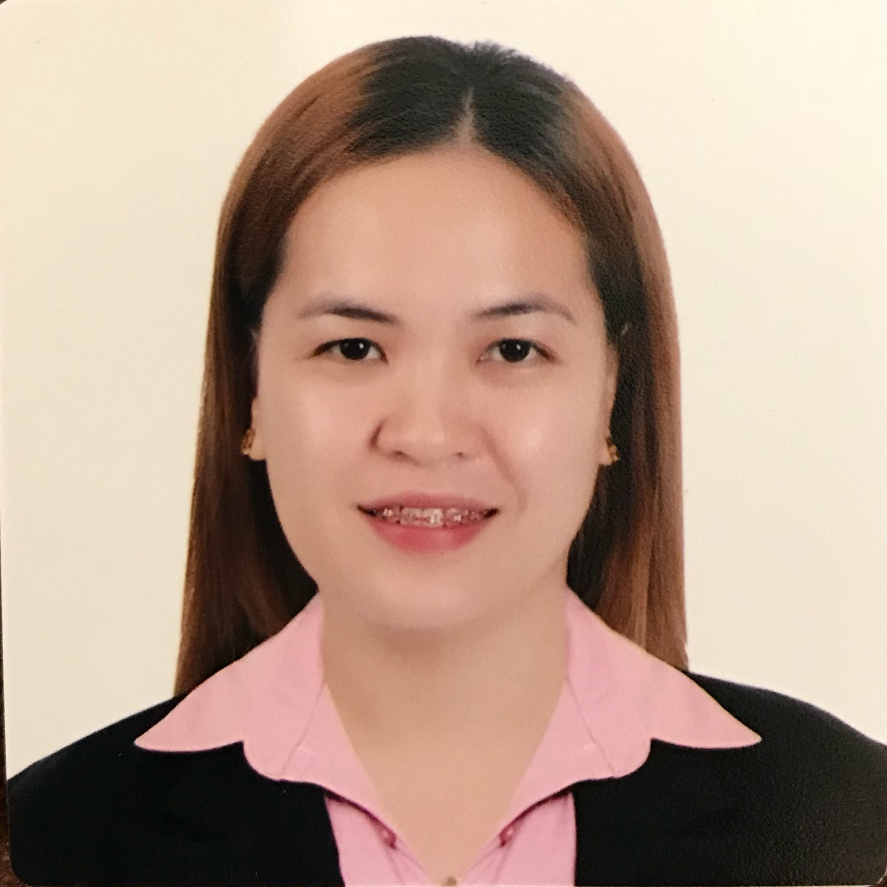
MYLA ESPIRITU MAG-ISA, RN
182 Luna St. Balatong B. Pulilan, Bulacan
Mobile: +63925-7240104
mylaemagisa@hotmail.com

OBJECTIVE: To obtain a position as Company Nurse

JOB DESCRIPTION:

- Provides nursing services to ill and injured employees including application of first-aid procedure.

- Performs basic nursing functions which include monitoring and tracking of vital signs, issuance of over-the-counter medicines and treatment of wounds.

- Prepares patient evaluation and refers patients to the Company Physician for proper medical attention.

- Escorts patients to nearby clinics and hospitals for proper medical treatment.

- Ensures efficient and coordinated clinic flow by coordinating and planning clinic activities; communicates patient’s needs; makes referrals.

- Delivers direct patient care; assesses patients physical, psychosocial and/or emotional needs; provides patient and family teaching; triages patients and informs physician of patient status; responds to phone messages from patients and informs physicians as needed; orders supplies; stocks and maintains patient’s rooms; sterilizes instruments.

- Administers medications as assigned; serves as a resource person for knowledge of medication uses, side effects, and dosage; checks for proper medication order; documents medications; obtains required consent forms to administer immunizations; notifies pharmacies of physician approved prescriptions; reviews drug samples to insure they have not exceeded the expiration date; labels sample drugs and educates patients of medication administration.

- Performs other duties as assigned.

WORK EXPERIENCE:

Private Duty Nurse June 2019 – June 2021
Abdulla A. Ghani Abdulghani
Al Saad, Doha, Qatar

Company Nurse June 2016 – June 2018
White Medical Care
Salwa Road, Doha, Qatar

Hotel Nurse March 2011 – June 2016
Century Park Hotel
Malate, Manila

Staff Nurse March 2009 – March 2011
Mary the Queen Maternity and General Hospital Plaridel, Bulacan

SEMINARS ATTENDED:

January 02, 2017 Immediate Life Support (ILS) Provider
European Resuscitation Council

October 30, 2006 The Philippine National Red Cross
Basic Life Support: Adult Cardiopulmonary Resuscitation Training for Lay Rescuers

October 31, 2006 First Aid Training in the Campus

November 06, 2006 Disaster Nursing

KNOWLEDGE, SKILLS, PERSONAL CHARACTERISTICS:
- Knowledge of medical terminology
- Computer Literate, internet surfing
- Ability to maintain confidentiality
- Ability to instruct/teach/tutor
- Ability to receive telephone inquiries in a tactful, helpful manner
- Ability to respond to emergency situations and unpleasant elements.
- Flexible, resourceful, patient, multi-tasking, energetic, hardworking

EDUCATION and PROFESSIONAL LICENSE:

2016 Passed – Qatar Prometric Exam

2008 Passed - Local Board Exam in Nursing

2007 Our Lady of Fatima University
Bachelor of Science in Nursing
Mc Arthur Highway, Valenzuela City

2003 St. Dominic Academy
Secondary Education
Poblacion, Pulilan, Bulacan

1999 Sta. Peregrina Elementary School
Primary Education
Balatong B. Pulilan, Bulacan

PERSONAL DATA:

AGE: 35 years old
CIVIL STATUS: Single
BIRTHDATE: November 4, 1986
BIRTHPLACE: Pulilan, Bulacan
HEIGHT: 5’4”
WEIGHT: 136lbs.
RELIGION: Roman Catholic
NATIONALITY: Filipino

PERSONAL REFERENCE:

Cindy Ngsuy-Chua, M.D.
Hotel Physician
Century Park Hotel
Malate, Manila
+63917-5224639 / 02-5288888

Maha Hannaoui
Medical Director
White Medical Care
Doha, Qatar
+97450022009

