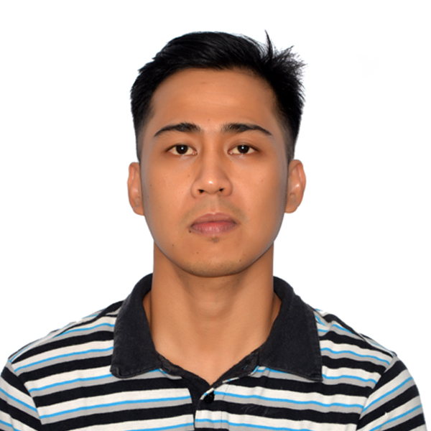

JEFF BRIAN DULAY DELA CRUZ
06-4332 Avenue Des Chûtes, Charny
Lévis Québec City, Canada
G6X 1C2
Email Address: reliahnebree@yahoo.com
Cellphone Number: 418-573-6003

Objective: To obtain Sanitation Worker position where my skills, knowledge and abilities can contribute positively to the organization's success.

SKILLS
- Knowledgeable on hazard analysis critical control points. (HACCP monthly meeting)
- Over 3 years’ experience in industrial cleaning.
- Ability to work under pressure and attention to detail
- Ability to multi-task in fast paced environment
- Excellent interpersonal, communication skills and strong organizational skills
- Open availability, flexible on schedule and can work weekends, day or night shifts.
- Willing to work in a team oriented environment.
- Strong work ethic and well-rounded skills.
- Knowledgeable in computer operation (Microsoft Windows- MS Word, MS PowerPoint,).

TEAM PLAYER FLEXIBLE SELF - MOTIVATED

RELEVANT WORK EXPERIENCE:

- Daily cleaning and sanitation of food processing and manufacturing equipment
- Experienced in preparing different meat/chicken cuts by chopping, slicing and deboning.
- Experienced in packaging and processing meat/chicken.
- Experienced in working in a variety environment including wet, humid, winter, inside or outside.
- Checked and controlled the equipment for food processing such as temperature gauge, keep the machines clean and tidy.
- Maintained work environment and equipment clean.
- Established positive working relationships with managers, supervisors and co-workers
- Established good work ethics and attendance record
- Established daily work priorities to ensure all deadlines were met on a timely basis.

EDUCATION:

July-Sept. 2012 Shielded Metal ARC Welding (SMAW) Technical Education and
Skills Development Authority (TESDA)
Cabanatuan City

2003 – 2007 Bachelor of Science in Commerce Wesleyan University-

Philippines

Cabanatuan City

1999 – 2003 High School Diploma The Good Samaritan
Colleges Cabanatuan City,
Nueva Ecija, Philippines

EMPLOYMENT HISTORY

Sanitation Worker Clean International Inc. January 2021 - present
Lévis, Québec City, Canada

JOB DESCRIPTION – Responsible for cleaning equipment, disinfect, surfaces, sanitize all components of the food production.

Food Processor Meiji Kenko Ham Co. Ltd. July 2015 - July 2018
Maker Ham, Sausages, and Bacon Mishima Shi, Shizuoka, Japan

JOB DESCRIPTION – Take on a variety of tasks to ensure the highest food and ingredient quality. Required to measure out ingredient components and properly mix ingredients to create the right formula. Also operate different pieces of equipment to get the final product right.

Credit Department/Appraiser GM Bank of Luzon, Inc. July 2013 – Apr 2015
Cabanatuan City, Nueva Ecija

JOB DESCRIPTION – Conducts Asset Appraisal procedure such as:
- Inspect physical condition of the asset.
- Checks model, serial number, motor vehicle number and other identifying marks against invoice and other required documents.
- Canvasses price from the other dealers/suppliers.
- Checks fair market value of property/assets; and prepare approval report.
- Conducts and prepares ocular inspection reports of leased assets.
- Conducts and prepares report on background/neighbourhood checking on company’s principal signatories/owners.

Free Lancer Independent Buy and Sell Cars/Motorcycle April 2011 –July 2013
Cabanatuan City, Nueva Ecija

JOB DESCRIPTION – Sealing the car deals after negotiating the price, overcoming objections, completing purchase or sales contracts, explaining the process of provisions, offering and explaining financing options, warranties and services, collecting payments, and delivering cars.

Credit Investigator Numax Micro-Finance Lending Jan 2009 – Mar 2011
Cabanatuan City, Nueva Ecija

JOB DESCRIPTION - verify the information of the client and investigate the client’s credit and income history to discover the whether the client qualifies for a loan.
- Gather information such as credit reports, tax forms, and financial statement.
- Guide the client’s through the loan process.

I hereby certify that the above information are true and correct to the best of my knowledge and belief.

JEFF BRIAN D. DELA CRUZ

