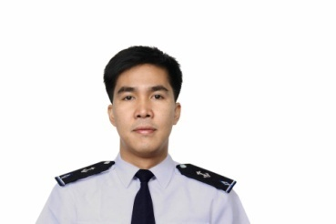
CHARLIE PAPELERA JUSI
- Assistant Security Manager- December 2021 up to present
HIJO Resources corporation,
Dr. 5 & 6, Tropicana Bldg. Km. 7, JP Laurel Ave.,Lanang Davao City 8000,
Hijo Compound, Barangay Madaum Tagum City,8100

- EHS and Security Officer – January 2017- September 2021
RJS Industrial Construction Development Corporation,
KM. 18 Crossing Eliong Road, Tibungco, Davao City, 8000 Davao del Sur

- Security Manager/Chief Security Officer- October 2017 -March 2018
Enterprise Bank Incorporated,
CSSO Building KM.5 Buhangin Road Davao City

- Private Contractor Armed Security Personnel –June 2015 – February 2016
Alphard Maritime Group
B1 & B2, 6th Floor, Gundecha Onclave,
Sakinaka, Andheri (East), Mumbai, India - 400072.

- Maritime Security Professional –March 2014- December 2014
SecuriState Pte Ltd.
20 Sin Ming Lane Midview City, #05-66 Singapore 573968
Email: info@securistate.com Phone number: +65 6684 5650 / 5652 Fax number: +65 6684 5651

- Maritime Security Operator-Sept 2013- February 2014
MA CREW INC PTE LTD (MCI) / Titanium Security International,
The Vertex 33 Ubi Avenue 3 #07-33 Singapore 408868,(+65 6634 1183)

- Team Leader/Member Security TM no.233-October 2011–Sept 2012
Gulf of Aden Group Transit Ltd.( GOAGT),
1 John Lopez Street. Floriana FRN 1400 Malta
Skills Proficiency:
- Knows how to Operate and Drive Vehicle AT / MT
- Computer literate
- Customer Services
- Insurgents / conflict Capable Readiness
- Strategical planning

Certifications & Clearances
- Drivers Licenses No.M06-98-01017577
- With Valid United States R-C1/D Visa. (Expired)
- Passport (Expired)
- BOSH Certified
- Safety Officer Certified
- ICS Certified

Personal Details:
` Status: Married
Place of Birth: Makilala North Cotabato
DoB: November 12,1978
Place of Res: Km.14 RJS Bldg. Brgy. Panacan Davao City
Contact No. +639154631325, Email: charliejusi@gmail.com
STRENGTHS:
- God fearing
- My Family
- Hardworking and Very Flexible kind of person
- Easy to adapt and understand things and instructional operations.
- Humble and down to earth
- Friendly and Approachable person
- Self-Motivated
- Worked Professionally
Summary:
A highly professional, hardworking, flexible, motivated self-disciplined and adaptable individual that performs well under pressure with a wide variety of experience in Safety and Security details.

