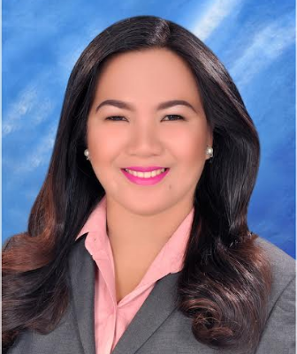
IJY LAYOSA TURA
Buagsong, Cordova, Cebu
+639952273369
Ijylayusatura10812@gmail.com

PERSONAL PROFILE

An ESL Teacher with more than three years of teaching experience both online and offline. Fully knowledgeable on how to handle young, teenager, adult and elderly students, aspiring to be part of your company.

SPECIAL SKILLS
-  Good Communication skills
-  Knowledgeable in Microsoft Application
-  A good team member and flexible at any given situation
-  Can work under pressure

WORK EXPERIENCE

RGE CORPORATION, Apas Lahug, Cebu May 2018-Present
ESL Teacher (May 2018-Present)

-  Assist English learners in developing their four macro skills.
-  Identify suitable books for each student.
-  Conducts lesson with efficiency

MCIA Departure Area , Pusk Lapu-Lapu City
Service Crew (December 2014- June 2015)

- Provide customer needs
- Assemble the products

EDUCATION ATTAINMENT
TERTIARY PRIMARY

Bachelor of Secondary Education Buagsong Elementary School
Cordova Public College Buagsong Cordova Cebu
Gabi Cordova Cebu 2006-2007
2017-2018

SECONDARY

Cordova National High School
Day-as Cordova Cebu
2010-2011

