CURRICULUM VITAE
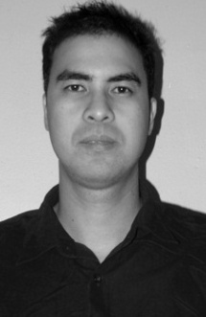

POBLEO FAJARDO BELMONTE

B6 L16-C Libra St. Pamplona Park Subdivision

Pamplona 2 Las Piṅas City, Metro Manila

Mobile No. 09184329839

Email Address: pobleo12@yahoo.com

CAREER GOAL

To contribute to an organization’s success through the use of my skills and experienced. Initiate positive work attitude, team work, desire for progress and professional growth development and warmth attainment for excellence.

PERSONAL DATA

Date of Birth : 10 November 1977
Place of Birth : Baao, Camarines Sur
Nationality : Filipino
Gender : Male
Height : 5’10
Weight : 73 Kgs

EDUCATIONAL BACKGROUND

Bachelor of Science in Commerce Primary
Major in Banking and Finance St. Monica Academy
Far Eastern University Baao, Camarines Sur
Morayta, Manila S/y 1985-1991

S/y 1995-2000

Secondary

St. Monica Academy

Baao, Camarines Sur

S/y 1991-1995

TRAININGS AND SEMINAR ATTENDED

Basic Aviation Security Course
Basic Aviation Security Screeners Course Aviation Security Refresher Training
Philippine National Police-Aviation Security Group Civil Aviation Security Bureau-OTS
Pildera 2, Pasay City Legazpi City Airport
09 June 2006 – 13 July 2006 17-19 May 2011

Basic Safety Course (SOLAS) On-The-Job Training
Mariners Training Institute Great Pacific Life Assurance Corp.
Baras Canaman, Camarines Sur Buendia, Makati City
14-20 February 2011 S/y 1999-2000

WORKING EXPERIENCES

Aviation Security Screening Officer
Intelligence Agent
Office for Transportation Security-DOTC

Ninoy Aquino International Airport 1 2 3

22 May 2006- Present

CHARACTER REFERENCES

Atty. Miguel FF. Oraa Ms. Pura B. Saavedra
Legal Planning and Research Bureau Intelligence Officer 2
Office for Transportation Security Office for Transportation Security

