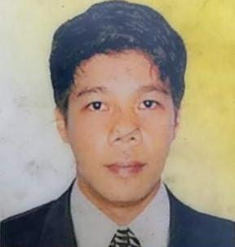

CANDAME CHRISTIAN U.
ADDRESS: #13C Road 2 Purok 6B Lower Bicutan Taguig City
EMAIL ADDRESSS: christiancandame.cc@gmail.com
CONTACT NO: 09282235528

PERSONAL INFORMATION
*Marital Status: Single
*Nationality: Filipino
*Height: 5’1
*Date of Birth: September 27, 1993
*Parents: Mother- Rosalina Candame

*Objective
To share my capabilities and wisdom together with my
Experience.

EDUCATIONAL BACKGROUND
*Inter Global College
B.S. Marine Transportation (2010-2013)
*Talipan National HighSchool
Quezon Province (2005-2009)
*Bukal Elementary School
Quezon Province (1999-2005)

SPECIAL SKILLS
*Electrical
*Rewinder

JOB EXPERIENCE
ALC Industrial and Commercial Development Corporation
*Electrician/Rewinder
(Start of May 21, 2014- presently working)

CHARACTER REFERRENCE
*ALBER SANTOS
Aircon Technician
09168710650
*RUSSEL DURIA
Assist. Manager
09168710650

I Hereby Certify that above mentioned are true and correct.

Christian U. Candame
Applicant

