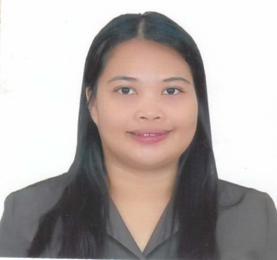
Arriane Idrissalam Valdez
Sta Ines Cabiao Nueva Ecija
Cp # 09163360792
Email: arrianevaldez.otlc@gmail.com

Work Experience:
ESL Teacher
Freelancer
Acadsoc
Feb 2020 to present

Customer Service Representative
Teletech Pampanga
Tmobile USA
March 2015 to April 2018

Customer Service Representative
Sutherland Global Services
Bonifacio Global City
EBAY North America and Canada
Feb 2013 to January 2015

Call Center Agent
(Senior Representative)
T-Mobile USA
NCO Teleservices ( EGS)
Mezza Residence
Aurora Blvd
Quezon City
April 2011 – Feb 2012

Retention Specialist
Sales
T-Mobile USA
NCO Teleservices (EGS)
ClarkField Pampanga
2008-201

TERTIARY:

Bachelor of Secondary Education
major in Social Studies
Divina Pastora College
Gapan Nueva ecija
SY June-Oct 2018

BS Business Administration
Major in E marketing
ABE International College
Cabanatuan City
Nueva Ecija
SY 2003 to 2007
SECONDARY:
Cabiao National High School
Cabiao Nueva Ecija
SY 1998-2003

Trainings and Seminar:

Managerial Housekeeping
NC3 –Tesda
Gapan City College
April 2018
Personal Information
Gender : Female
Address: Sta Rita Cabiao Nueva Ecija
Language: English & Filipino
Civil Status: Married

I hereby certify that the above information are true and correct to the best of my knowledge and belief.

ARRIANE M. IDRISSALAM VALDEZ
APPLICANT

