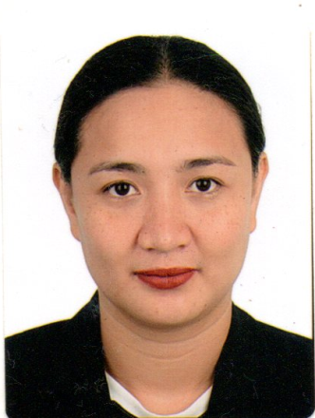
Rizalie G. Villadar
Registered Nurse
Licensed #: 0612699
Board Rating: 79%
Mobile phone:+639295105730

JOB SEARCH  OBJECTIVE | Nurse 1  To work in a Hospital with commitment to productivity and employee growth
JOB EXPERIENCES | Nurse 1  Saint Anthony Mother and Child Hospital  September 17, 2019 – Present  Area of Exposure:  Emergency Room  Nurse 1  Cebu Provincial Hospital- Carcar  February 16, 2017 – June 30, 2019  Area Of Exposure:  Emergency Room  Delivery Room  Operating Room  Surgical ward  Medical Ward  Pediatric and Obstetrics Ward  Ambulance Nurse  Cebu City Emergency Medical Service  April 1, 2016 – December 31, 2016  Clinic Nurse  MO Dermatologic Laser and Surgery Center  May 1, 2014 – March 30, 2016  RN HEALS  Vicente Sotto Memorial Medical Center  January 1, 2013 – December 31, 2013  Area Of Exposure:  Emergency Room  Delivery Room  Operating Room  Female and Pediatric Medical Surgical Ward  Nurse Trainee  Saint Anthony Mother and Child Hospital  July 1, 2010 – January 31, 2011  Area Of Exposure:  Emergency Room  Delivery Room  Out- Patient Department  Pediatric and Obstetric Ward
HIGHLIGHTS | - Capable for multi-tasking functions under pressure  - Sense of responsibility  - Ability to deal with different personalities  - Good team player with interpersonal skills  - Diligent and capable of meeting reporting deadlines  - A good team player and self starter
TRAININGS & SEMINARS  EDUCATION | Basic Life Support and Advanced Cardiac Life Support  Philippine Heart Association  July 1-2, 2021  Lactation Management Education Training  Saint Anthony Mother and Child Hospital  May 31, 2021- June 4, 2021  Basic Life Support –AED  Academy of Emergency Sciences – Cebu  Jan 7, 2019  UNIVERSITY OF CEBU- BANILAD, Cebu City, Philippines 6000  Bachelor of Science in Nursing  April 2009
PERSONAL INFORMATION | Civil Status : Married  Age : 33  Birthday : December 30, 1988
REFERENCES | Dr. Marilou Ong  Internal Medicine, Dermatology  Mobile Phone: +639173218104  Dr. Rio Dela Peña  General Surgery  Mobile Phone: +639770944371

