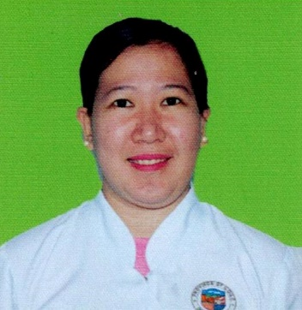
Brittany B. Pradel

OBJECTIVE
Pursuing opportunity which will allow me to grow professionally, while effectively utilizing my versatile skill set to help promote your health care goals.

SUMMARY OF QUALIFICATIONS
Extremely motivated and passionate in whatever I choose to do. Strong interpersonal and communication skills and know how to handle and deal with different kinds of people and circumstances effective working independently and in cooperation with others.
______________________________________________________________________________
Birth March 3, 1987
Address Azucena Street, Barangay Poblacion
Concepcion, Iloilo Philippines
Phone Number +639454396116
Email brittanybanias_pradel@yahoo.com

EDUCATION
2004 – 2009 Riverside College
Bachelor of Science in Nursing
Bacolod City, Philippines

2000 – 2004 Eucharistic King Academy
Secondary Education
Sara, Iloilo Philippines

1995 – 2000 St. Mary the Anawim of God Institute
Elementary Education
Concepcion, Iloilo Philippines

WORK EXPRIENCE
2018 – Present NURSE 1
Sara District Hospital
Sara, Iloilo Philippines

2013 – 2018 Contractual Nurse
Sara District Hospital
Sara, Iloilo

2011-2012 RHU Nurse
Concepcion Rural Health Unit
Concepcion, Iloilo

SKILLS

- Can be assign in any area like Emergency Rooms, Labor and Delivery and Surgical Medical Ward.
- Dependable, responsible contributor committed to excellence and success.

