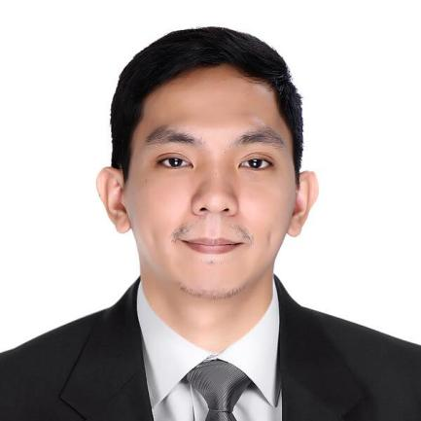

ARLI JOSEPH ABARIENTOS PATIO

19- D R.Valenzuela St., Marulas Valenzuela City
May 16, 1991
Mobile: 09954843606
arlijosephpatio@yahoo.com
PERSONAL PROFILE
I am a mature, positive and hardworking individual, who always strives to achieve the highest standard possible, at any given task. I possess good communication skills, and I have the ability and experience to relate to a wide range of people. I enjoy learning new things, I can work very well under pressure and I have the sales experience to handle customer complaints and solving problematic situations.
OBJECTIVE
To be a part of company that indulges professional growth which provides challenging and rewarding career while allowing me to utilize my knowledge and skills.
EDUCATIONAL BACKGROUND
Tertiary Education:
- STI-College Caloocan
Bachelor of Science in Information Technology
June 2011- October 2015
WORK EXPERIENCE
WNS Global Services Philippines, Inc.
(Eastwood City, Libis Quezon City)
- January 2016 to April 2017
- Associate – Operations (Sales)
- Expedia – Travel Account

Malayan Bank Savings and Mortgage Bank
(Makati Head Office)
- June 2017 to July 2018
- Risk Management Assistant
- In-Charge of Operational Risk Management (OKRI, CIV Limit, OPS Risk report)
- In-Charge of Business Continuity Management (Risk Event Monitoring Report, BCMC Monitoring)
- In-Charge of Information Security (IT Operations Monitoring and Incident Report)

24-7 Intouch PH Inc.
(Cyberpark Tower 1, 60 General Aguinaldo Ave, Cubao, Quezon City)
- November 2019 to February 2020
- Customer Happiness Associate
- Operations - Instacart Account
IBEX Global Solutions Philippines, Inc.
(7F Shaw IT Center, Shaw Blvd cor Nueve de Pebrero St. Brgy. Addition Hills, Mandaluyong City)
- March 29, 2021 to March 9, 2022
- Agent Inbound - Customer Service II
- Operations - FedEx Account

SKILLS

- Application on Microsoft Office(Word,Power Point, Excel)
- Familiarity with programming in Visual Basic 6, VB.net, HTML and SQL
- Computer hardware and software installation and troubleshooting.
- Flexible to adapt to new software applications
- Good communication skills
- Good Problem-solving skills

SEMINARS
Seminar Title | Seminar Date | Venue
BCMAP Forum on Mitigating Crisis Due to Data Information Leak (Crisis Communication Management, Data Sanitization and Erasure) | 06 December 2017 | Somerset Millennium Legaspi Village , Makati City
Special Briefing on the Updated Cyber Security Guidelines from the BSP with Mr. MhelPlabasan | 29 November 2017 | 11F UCPB Executive Office, Makati Avenue ,Makati City
Information Security Forum on a New Approach in Cybersecurity , by IBM Phils and Questronics | 23 November 2017 | Shangri-La, Makati
Web Security-Enabling Business and Machine Learning Applications in Information Security | 31 August 2017 | UCPB Executive Office, Makati Avenue ,Makati City
BCMAP Forum on Circular 951 – Business Continuity Management | 18 July 2017 | BSP, Malate, Manila
Cascading of Alignment Meeting Information | 11 July 2017 | Malayan Bank Head Office, Benavidez cor. Trasierra, Legaspi Village, Makati City
Lecture on Completed Staff Work (CSW) | 10 July 2017 | Malayan Bank Head Office, Benavidez cor. Trasierra, Legaspi Village, Makati City

CHARACTER REFERENCE
Ramesees Vargas Jose Armin Villamin
Assistant Manager – Ops Risk Management Officer
WNS Global Services Philippines, Inc. Malayan Bank Savings and Mortgage Bank
09428274275 09195134066

Mark Adriel Del Callar
Lead Associate - Ops
24-7 Intouch PH Inc.
09057357146

