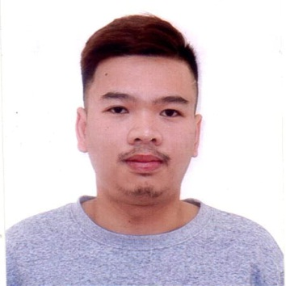

ERISH TRISTAN SALVADOR TIAMZON
499 Rosal Street San Isidro Village Bacolor Pampanga
Contact Info. 0945-283-3296
Email Add: erishtristan15@gmail.com

OBJECTIVE:

To seek for a position where I can contribute my knowledge and skills with great sense of responsibility, dedication and hard work.

PERSONAL INFORMATION:

Date of Birth : October 15, 1994
Place of Birth : JBL City of San Fernando Pampanga
Civil Status : Single
Sex : Male
Age : 27 Years Old
Height : 5’9’’
Weight : 70 kg.
Citizenship : Filipino
Religion : Roman Catholic
Dialects Spoken : English, Tagalog

EDUCATIONAL ATTAINMENT:

Secondary : Harvardian High School
SY.2010-2011

Primary : San Isidro Elementary School
SY. 2006-2007

WORK EXPERIENCE:

Company: Night Shift Disco and Music Lounge
Address: Ortigas Avenue Extension Cainta Rizal
Position: Waiter
Date: March 2012 – June 2014

Description of Duties and Responsibility
- Assisting customer
- Greet customers, record orders, and serve food with a consistently positive and helpful attitude, including answering questions about the menu.
- Ensure restaurant cleanliness daily by clearing tables, returning trays to the kitchen, sweeping and mopping floors, washing and sanitizing kitchen utensils, and servicing restrooms.
- Handle guests’ concerns and complaints professionally and calmly to resolve problems according to restaurant policy

Company: Darwin Precision Incorporation
Address: Taichung Taiwan
Position: Machine Operator, Electric Forklift operator and technical assistant
Date: August 2018 – August 2021 (Finish Contract)

General Skills
- Electrical, mechanical skills
- Communication Skills
- Quick Learner
- Excellent people relation skills

CHARACTER REFERENCE:

SUPERVISOR
Reynalyn Mendoza
0997-382-8432

I hereby certify that the above information is true and correct to the best of my knowledge and belief.
ERISH TRISTAN TIAMZON
Applicant Signature

