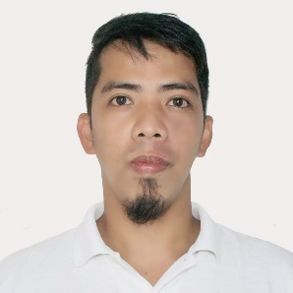
ERICKSON TAN ULANG (Chief Cook)

1137 San Pedro St. Brgy. San Roque Cardona, Rizal 1950 Philippines
Contact No. +63 9998280128
Email: ulangericksontan23@yahoo.com

Personal Statement

I’m a Chief Cook in an international sailing merchant ship with a multi-nationality crew onboard. A committed and responsible Cook who is able to consistently carry out my duties in a professional and positive manner. I can handle multiple tasks without losing my focus on the main priorities. I ‘am innovative and have the ability to make the necessary changes needed to improve a working environment and kitchen team’s performance. As a creative person I can drive a business forward by combining a modern dining experience with traditional values. I ’am looking now for a suitable position with a company that offers a truly unique environment to work in. along with excellent career development opportunities.

Culinary Expertise: Scandinavian & Mediterranean Cuisine, Asian Cuisine, Western Cuisine and
Baking Bread/Pastries.

Sea Base Employment History

- Company: UTKILEN AS. / TSM SHIPPING INC.
- Position: CHIEF COOK September 2019 – Up to present

- Company: EPSILON MARITIME SERVICES INC.
- Position: CHIEF COOK December 2013 – June 2019

Duties and Responsibilities:

- Responsible for the whole operation in the galley/kitchen.
- Directs and participate in the preparation and serving of meal breakfast, lunch and dinner.
- Determine timing and sequence of operation required to meet serving times.
- Inspect galley/kitchen and equipment for cleanliness and oversees proper storage and preparation of food.
- Ordering provisions in convenient port/country.

- Ensuring proper control of victualing matters onboard ship
- Making a weekly menu cycle plan.

Sea Base Employment History

- Company: V-SHIP POMI MARITIME SERVICES INC.
- Position: Kitchen and Dining Steward (2012 – 2013)

- Company: WALLEM MARITIME SERVICES INC.
- Position: Kitchen and Dining Steward (2011– 2012) (Feb.2009 – Nov. 2009)

- Company: HOLLAND AMERICA LINE – Unite Philippine Line Inc.,
- Position: Kitchen Assistant (Assistant Cook) (2010 – 2011)

Land Base Employment History

- Company: LOREAL PHIL.
- Position: Data Encoder (2006 – 2008)

- Company: CROWNE PLAZA HOTEL
- Position: Kitchen Steward (2005 – 2006)

- Company: JOLLIBEE FOOD CORP.
- Position: Dinning Attendant (2004 – 2005)

EDUCATION

RIZAL MARINE TECHNOCOMPUTER COLLEGE – Tanay, Rizal Phil.
Course: 2 years Associate Marine Transportation – 2001 to 2003

REFERENCES:

Available upon request

