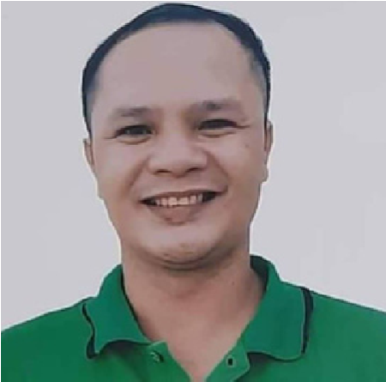
Derbe P. Duhaylungsod
WELDER / FABRICATOR
derbeduhaylungsod@gmail.com
Davao City, Philippines
+639814452109

Career Objectives:
______________________________________________________________________________________
Taking up the responsibilities as 6G welder and structural metal arc welder (SMAW), steel fabricator, and repairman where I can make effective using my knowledge and skills in a highly and efficient manner.

Duties and Responsibilities:
- Knowledge of safety precautions and risks associated with tasks.
- Able to mark and repair welded joints.
- Able to interpret blueprints, drawings, work orders, and sketches to fabricate, and install products and the parts correctly.
- Knowledge to operate magnetic drill machine and oxygen-acetylene automatic cutting machine.
- Welding, cutting, and general repairs of piping and structure both in the oil field (Rig) and in workshops.
- Highly dedicated and capable welder and fabricator with a superb work ethic and excellent eye for detail.
- Able to operate a forklift to transfer materials needed for repair of fabrication, Flexible in schedule ability to include weekends, third shifts, and emergency situations.
Work Experience

Welder / Fabricator of Heavy Equipment - July 15, 2017 - May 18, 2022
KTS Transport Services | Khalid Obaid Darwesh Al-Rashidi General Contracting Est. (KTS)
Activities involved:
- Refurbishment of land rigs works over rigs and gas exploration of Saudi Aramco Nabors Drilling in Saudi Arabia (SANAD).
- Plan-lay-out install test, and repair mast and substructure installation and structural components in accordance with all applicable plans. Specification codes, and industry standards.
- Welding, fit-up, and fabrication of low-pressure pine lines in mud tank, water tank, diesel tank, and cement tank fit-up and welding of high-pressure piping from mud pumps, ground manifold to vertical standpipe manifold fit-up and welding of choke manifold and gas buster.
- Repair modification and installation of different platforms and basic structures of the rig. High expertise in skid layout, cable tray, staircase, handrail fabrication, and welding in coordination with the rig crew while rigging up in a location.
- Extensive rig welding experience, maintenance repair tasks, and strong familiarity with hand power tools operation and excellent with safe practices in welding techniques.

KTS Transport Services
Khalid Obaid Dawesh Al-Rashidi General Contracting Est. (KTS)
Workshop: Welder Fabricator of Heavy Equipment
- Welder maintenance of heavy equipment Payloader, low bed trailer, flatbed, Hydraulic low bed, Diesel tanker, Water tanker, and other different trucks. Weld steel components with welding equipment as specified by layouts engineering drawing work orders or verbal instructions.
- Inspect under chassis cracks and defect clean and reweld using the correct procedure on welding.
- Willingness to cross-train and perform the work of other job tasks in addition to primary assigned job
- Fabricate and weld the safety barriers of trucks and trailers.
- Align components using calipers right angels and clamp pieces.

Alrashid Abetong Co. LTD Riyadh, Kingdom of Saudi Arabia
SMAW Welder | July 2, 2014 - July 16, 2016
Duties and Responsibilities:
- Manufacturers of concrete products include precast columns, beams, slabs, stairs, and panels.
- Fabricate and weld side form for precast weld using oxygen-acetylene and smaw welding.
- Works from shop drawing, blueprints, sketches work orders, and verbal instructions from supervisor and foreman.
- Performing any combination of duties to assist workers in welding brazing and cutting activities.
- Read and understands blueprints for the selection of materials, measurements, and weld types and perform to a specified tolerance.

Seminar and Training Attended:
- Basic H2s safety and SCBA training
- Welder/welding operator performance qualification test.

Education History
Vocational: Endonela Institute of Technology Foundation Inc.
Shielded Metal Arc Welding (SMAW) - May 2009
College: Serapio Basalo Memorial Foundation
Bachelor of Science in Education - 2009 College Level

High School: Holy Cross of Magsaysay Davao Del Sur March 1994 – 1995

Elementary: Magsaysay Elementary School | March 1989 - 1990

Character Reference:
Vernie C. Andan
Diesel Dispatcher/ Supervisor
KTS Transport and Services
Kingdom of Saudi Arabia
+966555075910
Jesus Abao
Sr. Welder Supervisor
Saudi Aramco Nabors Drilling
+966506017213
Amancio Lincuna
Sr. Welder
Saudi Aramco Nabors Drilling
+966503052756

