ANGEL BACTAD RODIN III
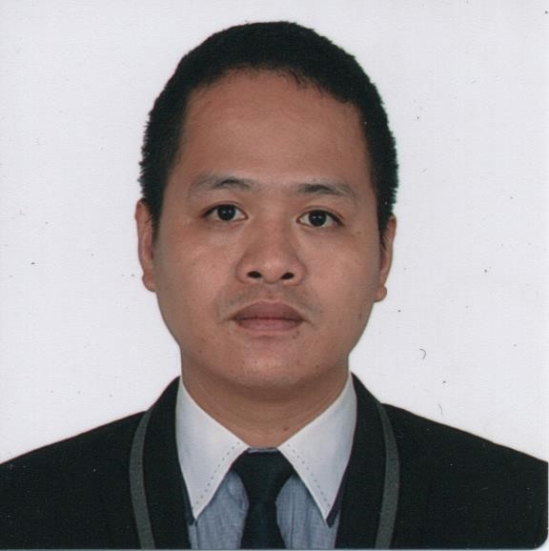
Purok 5, Brgy. San Rafael, San Felipe, Zambales, Philippines 2204
(63) 9995105494
seanderon127@yahoo.com
______________________________________________________________________________

OBJECTIVE

To be part of an institution/company that will further improve and enhance my skills, provide me with work experience that will broaden my horizon to cope up with any kind of job available to me.

WORK EXPERIENCE

March 24, 2022 – November 24, 2022 | Assistant Waiter
 | MSC Divina (Company: MSC Shipmanagement Ltd.)
March 24. 2019 – October 30. 2019 | Assistant Waiter
 | M/S Norwegian Pearl (Company: Norwegian Cruise Line)
June 24. 2018 – January 01. 2019 | Assistant Waiter
 | M/S Artania (Company: Sea Chef Cruises Ltd.)
September 13.2017 – April 08. 2018 | Assistant Waiter
 | M/S Albatros (Company: Sea Chef Cruises Ltd.)
August 30. 2016 – January 07. 2017 | Assistant Waiter
 | M/V Minerva (Company: Sea Chef Cruises Ltd.)
September 22. 2015 – June 10. 2016 | Assistant Waiter
 | M/V Minerva (Company: Sea Chef Cruises Ltd.)
April 11. 2015 – July 07. 2015 | Assistant Waiter
 | M/V Minerva (Company: Sea Chef Cruises Ltd.)
- Ensures the assigned station is properly setup with the required amounts of china, glassware, silverware and mis-en-place prior to start of service
- Assist with achieving department guest satisfaction targets and food and beverage revenues by following established service strategies and optimizing up-sell opportunities.
- Complies with sequence of service for food and beverage, and follows the lead/instruction of the waiters to ensure timeless of service to guests.
- Resolves any service and/or product deficiencies that may occur, to ensure satisfaction of service with guests in assigned station.
- Ensures that assigned station is properly cleaned and set-up at the end of the meal period and that all assigned side-work is complete.
- Performs other jobs as assigned, to include but not limited to manning non-cooking buffet action stations (i.e., carving station and dessert station).
- Must be familiar with the Safety and Environmental Protection Policy and the SEMS, and carry out the policies and procedures appropriate for his/her position.
- Deliver food and beverage orders to guest’s staterooms as per company procedure as well as assisting with private parties and functions.
- Field guest phone orders and handle according to established procedures.
- Clear service trays from staterooms, corridors and pantries in a timely manner.
- Buffet Room Service and Specialty restaurant as assign by management.

October 28. 2014 – November 04. 2015 | Dining Utility
 | M/V Minerva (Company: Sea Chef Cruises Ltd.)
- Responsible for providing support to the Main Dining Rooms, Buffet and Crew Mess during service and ensuring cleanliness of these areas at the completion of service.
- Responsible for beverage and table maintenance in an assigned station of the Buffet as directed by management.
- Performs other related duties as assigned or as directed. The omission of specific duties does not preclude the supervisor from assigning duties that are logically related to the position.

July 30. 2014 – August 23. 2014 | Utility Deck Steward
 | M/V Minerva (Company: Sea Chef Cruises Ltd.)
- Maintains the deck areas clean & tidy, with all furniture neatly arranged & in place if not in use.
- Distributes clean towels to guests on the deck & at the gangway during port days.
- Assists with & performs other beverage services, support tasks & guest services.
- Safe storage of all deck equipment, such as tables, chairs, umbrellas & cushions according to safety regulations.
- Sanitation of the assigned areas & amenities at all times, in accordance with Public Health rules and regulations.
- Workstation is properly stocked, set & prepared to meet the daily business demands.
- Maintains an attentive & proactive approach, offering assistance to guests in need.
- Performs other related duties as assigned or as directed.
November 19. 2013 – July 30. 2014 | Dining Utility
 | M/V Minerva (Company: Sea Chef Cruises Ltd.)
- Responsible for providing support to the Main Dining Rooms, Buffet and Crew Mess during service and ensuring cleanliness of these areas at the completion of service.
- Responsible for beverage and table maintenance in an assigned station of the Buffet as directed by management.
- Performs other related duties as assigned or as directed. The omission of specific duties does not preclude the supervisor from assigning duties that are logically related to the position.

December29. 2012 – October 16. 2013 | Server/Cashier
 | Tokyo Bubble Tea Subic
- Provide excellent customer services
- Greet customers and present menus
- Take and serve food/drinks orders
- Up-sell when appropriate
- Arrange table settings and keep tables clean and tidy at all times
- Deliver checks and collect payments
- Cooperate and communicate with all serving and kitchen staff
- Adhere to all relevant health department rules/regulations and all customer service guidelines
April 09. 2005 – April 12.2007 | Production Operator
 | Far Eastern Textile Ltd. Taiwan ROC
- Ensure production standards are met, finalize products, and prepare them for shipping.
- Set up and operate machines that make products from fibers.
- Carding and combing machines clean and align natural fibers.
- Performs other related duties as assigned or as directed.

TRAININGS AND SKILLS

Ship Security Awareness Training and Seafarers Oct. 04.2021
With Designated Security Duties

Basic Training Sept. 22, 2021

Crowd Management, Passenger Safety and Safety April 28.2018
Training for Personnel Providing Direct Services to
Passengers in Passenger Spaces

Passenger Ship Crisis Management and Human January 17, 2020
Behavior Training

EDUCATION

- COLUMBAN COLLEGE
Bachelor of Science in Hotel and Restaurant Management (Undergrad)
Olongapo City
June 2001 – March 2003

- ZAMBALES CENTRAL INSTITUTE
San Felipe, Zambales
March 2000

- SAN RAFAEL ELEMENTARY SCHOOL
San Felipe, Zambales
March 1996

TRAVEL DOCUMENTS

- PASSPORT
Issued Date: April 17, 2018
Valid Until: April 16, 2028

- SEAMAN’S BOOK
Date of Issue: March 02, 2017
Valid Until: February 28, 2027

- US C1/D VISA
Issue Date: May 04, 2018
Valid Until: May 01, 2023

PERSONAL DATA

Date of Birth : June 15, 1983
Civil Status : Married
Citizenship : Filipino
Height : 5’11” in.
Weight : 192 lbs.

I hereby attest that the above information is true and correct.

ANGEL B. RODIN III

