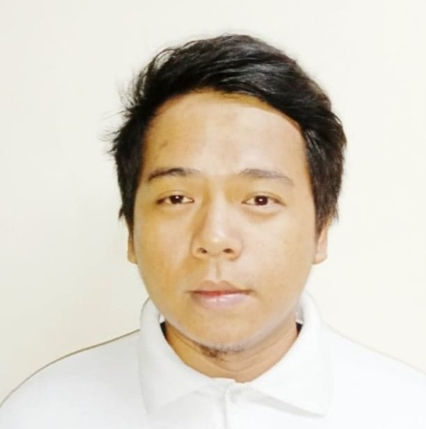
Cordero, John Michael D.
Home address: Blk. 279 Lot 01 Orchids St. Zone 6 South Signal Village, Taguig City
Phone number: 09954515855
Email: jmc010492@yahoo.com
Skype:
Facebook Name: Michael Cordero

Objective:
To obtain a position from which my skills and dedication to work qualify for the job using my skills and past experiences in a way that is mutually beneficial to the customer, myself and my employer and allow for future growth and advancement.

Educational Attainment:
Magsaysay Institute of Hospitality and Culinary Arts (MIHCA)
Chino Roses Ave. corner Antonio Arnaiz Ave. Makati. Metro Manila
Professional Culinary Arts June 15, 2015 – Nov. 28, 2018
Work Experience:
Cabutihan trading inc, / Arvin’s meat shop
Butcher (2009 to Present)
Responsibilities:
- Cutting pork, beef, chicken and fish into major part, for retail purposes or special request of customer.
- Ensuring all orders are planned day before.
- Cutting pork into bits depend on dish (restaurants).
- Boneless milk fish
- Collecting slashes
- Receiving and restocking the meat shop needs.

GREENSUN Hotel (Part time)
BUTCHER CHEF
Chino Roces Ave ext. Makati city March 12, 2018 – Jan.04, 2020
Responsibilities:
- I am in charge of all boneless meat pork chicken and fish.
- Prepare mise en place for early line cook.
- Preparing EM or employees meal.
- Maintaining order and applying FIFO in walking chiller and freezer,
cutting meat into portion by executive chef’s order.
- Carving lechon (grilled whole pork) for every event.

References:
Arvin Manalo
Owner / manager at CT Inc. Arvin’s Meat shop
092557170207

