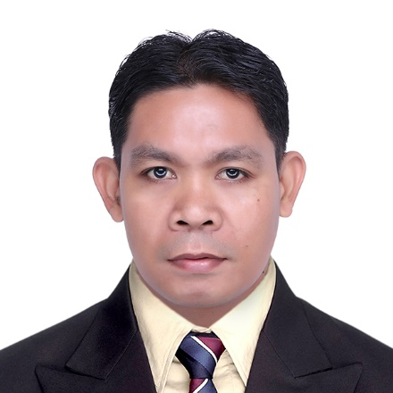
CHAVEZ, JEREMIE SOBREDO
Block 17, Lot 22, Brio drive, Amaia Scapes Cavite,
Santiago, General Trias, Cavite 4106
Contact Number: 0945 352 5585
E-mail: chavezjeremie@gmail.com

Date of Birth: December 19, 1984
Age: 37
Civil Status: Married
Sex: Male
Language Spoken: English, Tagalog
Citizenship: Filipino
EDUCATIONAL ATTAINMENT:
Tertiary: Automotive Mechanics (Light Duty)
Passi Trade School, City of Passi, Iloilo
(2003-2005)
Secondary: Salngan National High School
Salngan, Passi City Iloilo
(1999-2003)
Primary: Salngan National High School
Salngan, Passi City Iloilo
Year graduated (1999)

ON THE JOB TRAINING:
Motor Pool Section, Office of the City Mayor Passi City Iloilo

EMPLOYMENT HISTORY:
YONGHWA OF PHILIPPINES INC.
Lot 6, Block 9 Road B St Tejeros Convention,
PEZA Rosario Cavite
CNC Machine Operator
July 13, 2021 to January 5, 2022

TUNG FONG INDUSTRIAL CO., INC.
Lot 10 & 12, Block 19 Phase 3 PEZA
Rosario Cavite
CNC Lathe Machine Line Leader and Welder
Jan 30, 2007 to March 15, 2021

SKILLS:
- Machine Operator (Press Machine, Lathe Machine & Bevelling)
- Welder
- Self-motivated and desirable to work on a team environment.
- Adaptability and Flexibility
REFERENCES:

Joven L. Lacaba
Production Operator
House Technology Industries
09482038941

Richard S. Palma
Grinding Machine Line Leader
Tung Fong Industrial Co., Inc
09082009383

I hereby certify that the above information is true and correct with all the best of my knowledge.
____________________________________
Jeremie S. Chavez
Applicant

