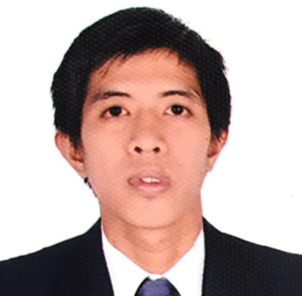
GENER MERCADO CONTRERAS

Permanent Address:

Purok 7 Majada Out, Calamba City

Laguna, Philippines 4027

Mobile : +639613209511

Email : contreras.gener29@gmail.com

POSITION DESIRE : PRODUCTION OPERATOR/ WELDER

CAREER OBJECTIVE

To be able to join in a reputable company where in my skills and expertise will contribute to the progress of the company.
SKILLS

- Machine Operation
- Welding
JOB EXPERIENCES

Company
Shindengen Philippines Corp.

Carmelray I, Canlubang, Calamba City

POSITION: MACHINE OPERATOR (July 2007 – July 2015)

- Performed machine process operation, set up machine prior processing the product.
- Do some troubleshoot for some minor error encountered
- Follow regulations, safety guidelines and company procedures at all times.
- Kept work areas clean and neat.

Mitsubishi Heavy Industries Marine Structure Co., Ltd.

180 koyagi-machi Nagasaki-ken Nagasaki-shi

POSITION: WELDER (April 2016– April 2019)

- Tack weld or weld component and assemblies using gas, arc or welding equipment.
- Assemblies may be clamped or involve holding jigs to control dimensional requirements.
- Operate various hand tools, power hand and machine tools to make finish adjustments to products.
- Use a variety of precision measuring devices to set up and adjust work and verify conformance of work to specifications.
- Performs other duties or responsibilities as requested or required.
- Maintains a safe and clean work environment.

PERSONAL PROFILE
Nickname: Gener
Sex: Male
Date of Birth: March 29, 1990
Place of Birth: Calamba City, Laguna
Civil Status: Married
Citizenship: Filipino
Religion: Roman Catholic
Height: 5’6 1/2
Weight: 110 lbs.
Language Spoken: English/Tagalog/Nihongo
Spouse Name: Helbe D. Contreras
Father’s Name: Gerardo B. Contreras
Mother’s Name: Hilaria M. Contreras
EDUCATIONAL BACKGROUND
July 10, 2015 – Sept. 11, 2015 : Short Course Certificate
Course: Basic Japanese Language (Japanese Language Proficiency Test N4)
Brgy. Punta, Calamba City, Laguna

2002-2006 : Secondary
Majada In National High School
Majada In, Calamba City, Laguna

1996-2002 : Primary
Majada Out, Elementary School
Majada Out, Calamba City, Laguna

LIST OF REFERENCES:

Rowell Fajardo
Brgy. Chairman
Majada Out, Calamba City, Laguna

Paul Manuel
Engineering Section Manager
Shindengen Phil. Corp.
Carmelray 1, Canlubang, Calamba City, Laguna

This is to certify that the above information is true and correct to the best of my knowledge and ability.

Signed:

GENER MERCADO CONTRERAS

