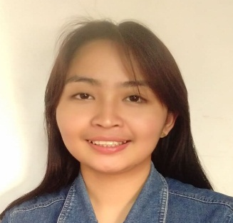
Katherine L. Gonzales
Brgy Dahican Catanauan Quezon
Philippines /
KUWAIT CITY
Contact Number: 09653878681/+96598570017
Email add. gonzaleskatherine628@gmail.com

Objectives:

TO OBTAIN ANY POSITION FROM YOUR COMPANY, WOULD ALLOW ME TO SHARE MY KNOWLEDGE, SKILL AND EXPERIENCE.

Personal Data:

Birth place : Catanauan, Quezon
Birth date : January 01, 1992
Age : 30
Religion : Roman Catholic
Father : Danilo M. Gonzales
Occupation : Soldier (Philippine Army)
Mother : Monet V.Limdico
Occupation : House Wife
Height : 5’4”
Weight : 60 kg
Civil Status : Single
Nationality : Filipino

Educational Attainment:
Tertiary :
ASSOCIATE HOTEL AND RESTAURAT MANAGEMENT
SAN ANTONIO DE PADUA COLLEGE PILA LAGUNA
S.Y. 2008-2011

Secondary : MANUEL S. ENVERGA UNIVERSITY FOUNDATION INC.
BRGY. 9 CATANAUAN QUEZON
S.Y. 2004-2008

Elementary : BRGY DAHICAN ELEMENTARY SCHOOL
S.Y.1999-2004

Work Experiences

 | Name of Company/ | Dates/year | Position
 | Nutreeze ( Healthy Food Restaurant )  Boz AAljedi Restaurant and Coffee Shop Company  Top Choice Training Institute and Assessment Center Inc.  San Jose Del Monte, Bulacan, Philippines | KUWAIT 05/2021-10/2021  KUWAIT 07/2019-04/2021  February 4,2018 - Present | - Sales Associate /kitchen helper  - WAITRESS  - Processing Officer
 | Provincial Census Catanauan Quezon, Philippines | 2017 | Enumerator
 | Nasugbo Coconut And Copra Buyer Construction Supply  Brgy 9. Catanauan Quezon Philippines | 2016 | Clerk/Casher
 | Enchanted Kingdom (340 hours)  Sta Rosa Laguna | February 18 to may 11 , 2011 | Food Handler / Food Service  Kitchen Helper
 | MAX RESTAURANT  CALAMBA LAGUNA Philippines | August 2010 to January 2011 | Kitchen Helper/Food handler/  Foodservice
 | MONTE VISTA HOT SPRING RESORT AND CONFERENCE  CALAMBA LAGUNA Philippines | MAY 24 TO JULY , 2010 | Receptionist And Assist All Guest , Housekeeping
 | Sk Chairwoman  Brgy. Dahican Catanauan Quezon, Philippines | 2008 to 2011 | Sk Chairwoman

Special Skills

- Food Serving
- Baking
- Computer Literate
- Housekeeping
- Good Listener

KATHERINE L. GONZALES
Signature

