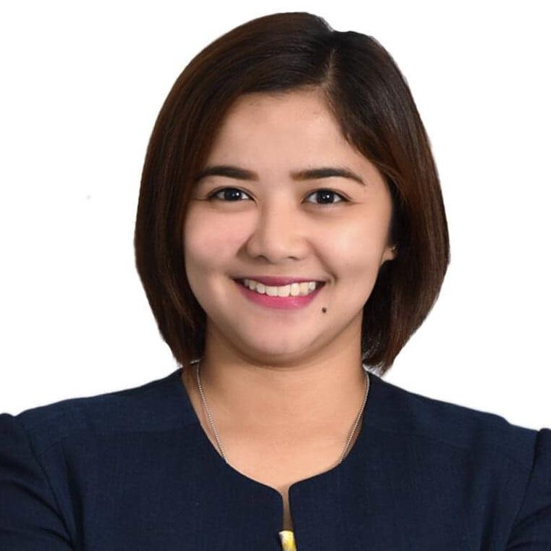
KATHLEEN Maderazo SANTOS
Residential Address: B13 L13 Silver Crest Villas Tirona Highway Brgy.Habay I Bacoor City Cavite 4102 Philippines
Contact nos.: 0916 555 9444 / 046 – 853 4262
Email: santoskathleenm@yahoo.com

Personal Information
Citizenship: Filipino Religion: Roman Catholic Status: Single with Dependents
Birthday: July 10, 1988 Age: 33 y/o Height: 5’2 cm. Weight: 60 kls.

Objective
To apply my skills, knowledge and experience gained from education and contribute towards developing and expanding business opportunities, with the chance to advance to a management role in future.
To support the financial needs of my family.

Educational Attainment
Tertiary Level Bachelor of Science in International Relations major in Diplomacy (formerly BS in Foreign Service)
Lyceum of the Philippines University – Manila
Muralla St., Intramuros, Manila (2005-2009)

Skills
- Computer literate especially in Microsoft Office, Excel and PowerPoint. Be able to type at a speed of 40-50 WPM.
- Have experience in navigating technical software such as:
  - Administrative and Finance, 2019 to present
    - Coupa, Condeco Software, SAP Concur Solutions, IBM.DCIW+, PEGA Cloud, Velocity.
  - Banking and Finance, 2012 to 2017
    - Finacle, Oracle, T24
- Can operate Telephones, Personal Computers/Laptops, Scanners, Photocopier Machine and Tele-fax/Fax Machine.
- Has a strong and pleasing personality, creative and highly motivated, with excellent communication skills, good in dealing with other people, able to do multiple tasks in a pressured environment, and can work under pressure with minimal supervision.

Work Experience

Sison Corillo Parone & Co. (client assignment: Unilever Global Services BV-PH)
Site Administrator / Finance Assistant, Accounting Supervisor (Permanent), May 1, 2021 – Present
Site Administrator / Finance Assistant, Senior Accounting Associate (Permanent), October 21, 2019 – May 1, 2021
Job description (overall):
- Responsible for the reception of all tasks and assignments given by the Company.
- Serve also team lead of SCP Personnel designated at the area
- Managing daily administrative requirements in the office
- As Team leader is responsible in assigning the tasks and given the authority to review and evaluate the performed task made by SCP Personnel.
- Act as the point of contact between the executives and internal/external clients
- First Point of Contact for Administrative Concerns for Foreign Visitors, Short-Term Assignees and International Assignees – ensuring that clients’ requirements are met in full.
- Maintain diary, arrange meetings and appointments and provide reminders
- Prepare, collate and ship proposal and other important / confidential documents
- Arranging conference calls locally and globally
- Make travel arrangements
- Take dictation and minutes and accurately enter data
- Perform general office duties such as monitoring office supplies and research advantageous deals or suppliers
- Produce reports, presentations and briefs
- Cascades General Information for the whole department via email blast
- Setting up accounts for General Information e.g.: SharePoint, Viber (Social App) Messenger Group
- Develop and carry out an efficient documentation and filing system
- Organizing and Execution of local events
- Liaising with Accounts Payable for processing invoices and issuing payments
- Completes special projects by organizing and coordinating information and requirements; planning, arranging, and meeting schedules; monitoring results.
- Provides historical reference by developing and utilizing filing and retrieval systems.
- Achieves financial objectives by anticipating requirements; submitting information for budget preparation; scheduling expenditures; monitoring costs; analyzing variances.
- Maintains continuity among corporate, division, and local work teams by documenting and communicating actions, irregularities, and continuing needs.
- Evaluate all purchase requisitions and purchase orders on a regular basis and develop implementation strategies for all programs
- Manage all communications for purchase orders with vendors and analyze all communication and resolve all purchase issues and coordinate with Finance department to process all invoices
- Maintain records of all purchase order, associate documents, and knowledge on all open order and status
- Working Closely with Finance control team for GR/IR report and analysis
- Key/Super User for Coupa (Procurement System)

Sterling Bank of Asia
Sales/Service Associate - Pool, RF-Teller 3 (Permanent) – November 3, 2014 – December 12, 2015
Job Description as SeA:
- Counterfeiting / Acknowledging of Cash Deposit and Withdrawals
- Examine Check Deposits
- Daily Cash, Checks and Media Balancing
- Making Daily Banking Operations Reports
- Attend to Clients' multiple transactions
- Achieve the tasks assigned by the Supervisor
Job Description as SA:
- Prepares / Organizes Files of Daily reports such as Accountable, Safekeeping, TD Reports, ATM Recon, AMLA Reports, CIV Reports and other reports given or assigned by supervisor
- Performs KYC before opening of Bank Accounts
- Attends to over-the-phone transactions

Philippine Business Bank
Bank Teller & Customer Service Assistance, RF-Teller 3 (Permanent) – October 16, 2012 – October 17, 2014
Job Description as Bank Teller:
- Counterfeiting / Acknowledging of Cash Deposit and Withdrawals
- Examine Check Deposits
- Daily Cash, Checks and Media Balancing
- Making Daily Banking Operations Reports
- Attend to Clients' multiple transactions
- Does tasks given by Supervisor accordingly
Job Description:
- Prepares / Organizes Files of Daily reports such as Accountable, Safekeeping, TD Reports, ATM Recon, AMLA Reports, CIV Reports, Supplies Inventory Report and other reports given or assigned by supervisor
- Performs KYC before opening of Bank Accounts
- Attends to over-the-phone transactions

KPMG Manabat Sanagustin & Co., CPAs
Executive Assistant to the Vice-Chairman for Audit, (Probationary) November 21, 2011-March 21, 2012
Job Description:
    - In-charge of all (Local and International) incoming and outgoing communications
    - Takes charge of incoming and outgoing documents and communications processing
    - Maintain an updated and systematic filing of documents, correspondences and other records
    - Prepare communications (memoranda, letters, reports, etc.)
    - Making a monthly Time and Expense Report and Liquidation Report of Utility bills such as PLDT and Globe Bills, Credit card bills
    - Make a monitoring report of each Clients such as Billings, Invoices, Clients' Company Information, etc. for the VC
    - Update the calendar of activities of the VC for his daily activities
    - Make an Expense Summary Report of the VC for Reimbursements/Refunds of official business trips, Cash Advance (for an official Executive Meetings done in MS & Co. nationwide and affiliated companies abroad)
    - Make booking travel/visa requirements of the VC for important meetings and discussions with Clients / Partners / Managers / Directors of MS & Co.
    - Basically, functions as Personal Assistant of the VC
    - Process liquidation of receipts such as transportation, meals and others for the VC

KSE – Kathleensantos Enterprises
Owner /Proprietor – November 2015 – October 2019
Business Description:
- Electronic Loading Station (at home)
- Online Selling - Lazada Seller Center / Shoppee Online Seller / FB Market Place

Seminars and Training
- Counterfeit Detection Seminar
  - Bangko Sentral ng Pilipinas - East Avenue, November 5, 2014, Ms. Aileen Manansala, BSP CARD Officer
  - Bangko Sentral ng Pilipinas - East Avenue, October 14, 2013, Ms. Nette Malabrigo & Ms. Aileen Manansala, BSP CARD Officers
- Signature and ID Verification Seminar
  - Sterling Bank of Asia – Center for Learning, January 17, 2015, Mr. Eugene Chua
  - PBB - Annex Bldg., September 18, 2013, Mr. Antonio R. Magbojos, NBI Senior Questioned Documents Examiner & Training Facilitator
- Professionalizing Banking Image
  - PBB - Annex Bldg., August 15, 2013, Ms. Abigail Arenas - De Leon
- Anti-Money Laundering Seminar
  - Sterling Bank of Asia – Center for Learning, November 2015
  - PBB - Annex Bldg., July 10, 2013, Mr. Agustin Dingle, PBB Compliance Officer
- On the Job Training in Bureau of Internal Revenues
  - BIR Manila, April 22, 2008 - May 30, 2008

Extra-Curricular Activities
- Lyceum of the Philippines University Chorale
V.P. for External Communications (2008-2009)
Executive Secretary (2005-2008)
Member (2005-2009)

Character Reference
- Ma. Kathrina Morelos-Ang
Data Specialist, Unilever Global Services BV – PH ROHQ
0998 566 9819

Kathleen M. Santos
Applicant

