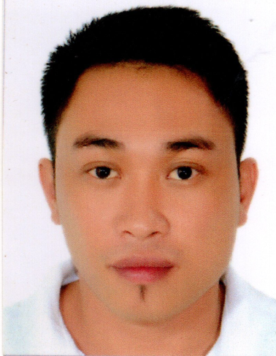
Romir Kim Cagang Perez
Permanent Address: 849-2 Bolton Extension Davao City,
Davao del Sur Philippines 8000
Date of Birth : September 02, 1985
Civil Status : Married
Nationality : Filipino
Phone Number : +639381187615
Email: kimromir@yahoo.com

Career Objective

Aspiring to obtain a position as a Meatcutter, where I can utilize my knowledge and skills, while making significant contribution to the success of the company with hardwork, dedication and honesty.

WORK EXPERIENCES

Noel & Amy Meatshop
Stall #64 Agdao Public Market, Davao City
October 15, 2017 - present

Duties and Responsibilities
- Applying proper hygiene and sanitation
- Receives and fulfills customers order
- Trims, cuts and prepare meat to display
- Maintains the cleanliness and sterilizations of knives and other tools
- Good customer posture
- Packages and display meat

Penongs Seafoods and Grill
Saint Michael St. Coca-Cola Village, Davao City
June 07, 2006 –September 30, 2017

Duties and Responsibilities
- Driving
- Update the stocks needed in stores
- Delivering Stocks
- Preparing goods stated on the purchase order
- Taking care of all vehicle maintenance, renewal of vehicles
- Doing inventory of the purchase order

Josefino P. Gonzales
Lapu-Lapu St. Tagum City, Davao del Norte
January 14, 2004 – March 20, 2016

Duties and Responsibilities
- Provide excellent customer service
- Take order and serve
- Give customer satisfaction
- Keep tables clean and tidy at all times
- Check product before it serves
- Delivered checks and collect payment

Education Background

Elementary: Rizal II Elementary School
Tagum City, Davao del Norte
Year Graduated: March 1998

Secondary: Davao National High School
Mankilam Tagum City, Davao del Norte
Year Graduated: March 2002

REFERENCES

MS. ELOISA CASAS
PENONGS HR OFFICER
+639662262792

MS.MERLY DAGATAN
PASTRY CHEF/TESDA ASSESSOR
+639328894530

HON. PRINCESS ALICAWAY
BRGY. COUNCILOR
BRGY. 1-A POBLACION DAVAO CITY
+639555176323

