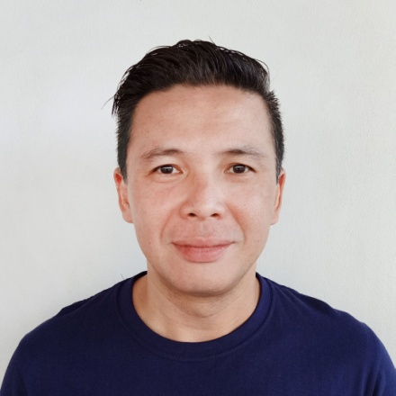
FREDERICK CO CHUA
Phase2 Block5 Lot32, Le Moubreza Subd.
San Antonio, Sto. Tomas City, Batangas
Contacts: +63 9177071017
frederick060912@yahoo.com/frederick081910@gmail.com

WORK EXPERIENCE

CHEE PUCK GROUP OF COMPANIES
Warehouse Supervisor, September 2021 to Present
- Supervises warehouse staffs.
- Checking/Keeping an inventory of all merchandise entering or exiting the warehouse.
- Ensuring that all the merchandise is safely and securely packed and labelled for shipping.

LIGHTFORCE CORPORATION
Project Sales Manager, April 2017 to October 2020
- Supervises sales personnel in all their dealings
- Supervises closed deals with regard to delivery schedule and post-sale
finalization.
- Assists with any prioritized decision-making.
- Assists the sales agents’ dealings with higher authority.
- Supervises in research and dealings with new prospects
- Supervises in meetings and monthly reports
- Reports directly to higher authority.
- Represents the company in all invites, events and exhibits
- Can do assembly when staffs are short-handed.

HERCO TRADING, INC.
Assistant to the Department Manager, March 2011 to April 2017
- Assist the Department Manager in the day-to-day activities
- Receives inquiry from clients
- Makes Purchase Order and Sales Order
- Creates Monthly Sales Report for the Dep’t Manager
- Creates Monthly Inventory Report
- Assists in all the yearly product events and program
- Heads the sales team during exhibits

A&S LAMPS, INC.
Officer-in-Charge / Sales Supervisor, February 2005 to 2011
- Supervises day-to-day activities of branches assigned to
- Do sales and inquiries of walk-in clients
- Assists in giving ideas or choices for clients
- Supervises sales and assembly personnel
- Supervises in the completion of orders from sales to deliveries.
- Makes requisition order of sold out items from warehouse.

EDUCATION
UNIVERSITY OF MANILA
Bachelor of Science in Commerce, Major in Management
June 1993 to 1997

SKILLS
- Can speak Chinese Fukien
- Computer Literate
- Knowledge in the assembly of lighting fixtures
- Can work under pressure
- Trustworthy
- Driving skills

CHARACTER REFERENCES:

- JACQUELINE DEL MUNDO
Unit 77 -200 Hillbrook Drive, Winnipeg, MB R2R 3A1 Canada
204-291-2831
SILOAM MISSION
Transition Services Case Worker

- LILIAN GARCIA
297 Harthill Way, Ottawa, ON K2J 0P3 Canada
1-416-903-6248
Retired Senior Validation Consultant

- EULALIA FENOL
250 rue Barnett Dollard-Des-Ormeaux, Quebec H9G 3C7 Canada
515-243-1390
ROYAL BANK OF CANADA
Quality Control Admin

