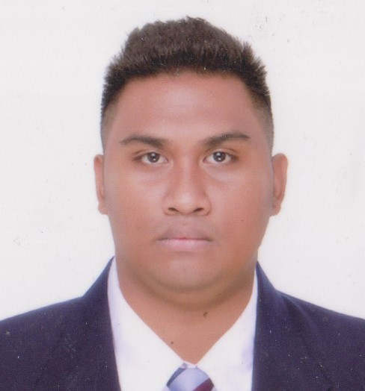
RAFAEL RODOLFO CALASICAS
F194 Guyabano St. Umali Compd. Summitville, Putatan, Muntinlupa City
Cellphone. No. +639289380149 E-mail Address: raffycalasicas@gmail.com
CAREER OBJECTIVES:
To be able to work in a highly competitive company that would challenge my skills and abilities while gaining opportunity to learn, to enhance and make use of the knowledge and skills that I possessed.
EDUCATIONAL BACKGROUND:
ELEMENTARY:
2000-2006
Elementary
F. De mesa Elementary School
Freedom Hills, Putatan
MuntinlupaCity

SECONDARY:
2006-2010
High School
Christ the King School of Muntinlupa
Jaysonville, Putatan
MuntinlupaCity
COLLEGE:
2010 - 2014
Bachelor of Science in Hotel and Restaurant Management
University of Perpetual Help DALTA System
Alabang-Zapote Road, Las Piñas
PROFESSIONAL EXPERIENCE:
Line Cook February 23, 2022 – Present
Barcino Wine and Restobar
Unit 5 Molito Lifestyle Extension, Alabang Zapote Rd, cor Madrigal Ave, Muntinlupa, Metro Manila

3rd Cook 1st Contract: August 26, 2017 – April 17, 2018
2nd Contract: July 18, 2018 – March 16, 2019
Royal Caribbean Cruises ltd. – Celebrity Cruises
1050 Caribbean Way, Miami, Florida 33132-2096
- Well trained about US Public Health regulations
- Have a knowledge about massive production

Commis II February 1, 2015 – January 30, 2017
Le Meridien Dubai Hotel and Conference Centre
Airport Road,Garhoud - Dubai - United Arab Emirates
- Maintaining high standards of hygiene
- Preparing the ingredients for senior chef
- Measuring dish ingredients and portion sizes accurately
- Dealing with deliveries and stock rotation
Certificate in Basic Food Hygiene Training – July 2, 2015 in Dubai, UAE
VOLUNTEER EXPERIENCE:
Member/Competitor June 2010- April 2014
February 27, 2014
Certificate of Appreciation – Cuisine De Patissier
University of Perpetual Help Dalta System
Alabang – Zapote Road, Las Piñas City, Philippines

July 31, 2013 – August 3, 2013
Silver Medalist – Philippine Culinary Cup
SMX Convention Center, SM Mall of Asia
Pasay City, Philippines
SKILLS:
- Mise en place (Preparing, organizing and arranging the ingredients)
- Have a knowledge in Basic food hygiene
- Dealing with deliveries and stock rotation (First In, First Out)
- Have a knowledge in Recipe making and portioning
CHARACTER REFERENCES:
Katrina Marie Costelo
Scheduler
Royal Caribbean Cruises ltd.
1050 Caribbean Way, Miami, Florida
Fax 305/603-0053

Mr. Rodante Casison
Sr. Sous Chef
Chez Charles
Ontario Tower Office 603 Business Bay Dubai, UAE
Cellphone No. +971564772180
Email Address: rodcasison@gmail.com

Mr. Anthony Tabosares
Head Chef
Barcino Wine and Restobar
Unit 5 Molito Lifestyle Extension, Alabang Zapote Rd, cor Madrigal Ave, Muntinlupa
+63 946 557 6774

This is to certify that all the above information provided on this resume is true and
Complete to the best of my knowledge.
__________________________
RAFAEL R. CALASICAS

