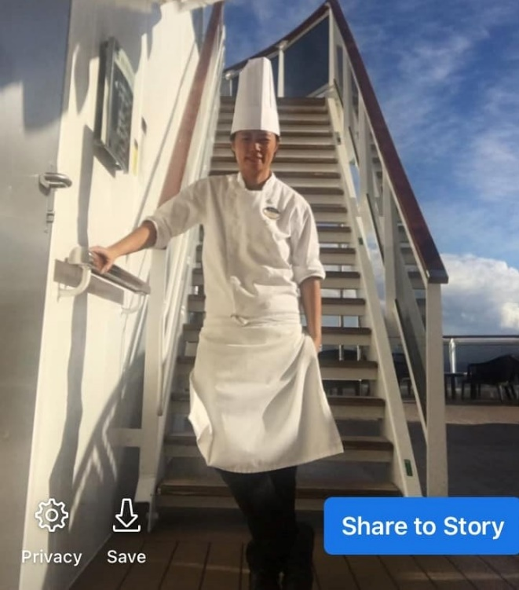

Position Applied : Cook
Name : ELENITA D. DANO
Contact # : +639563044618
FB Account : Elexus Danz
Email Address : eleen_chefdano@yahoo.com

SUMMARY : A reliable trustworthy and flexible individual who has relevant culinary experience and qualifications that you are looking for. She has extensive cooking knowledge and is more than able to abide by all legal requirements, food and hygiene regulations and food safety laws and she is able to exceed employers expectation.

SKILLS:

- Possesing a high level of personal cleanliness and comprehensive understanding of how to comply with all relevant food and safety standards.

- Ensuring that food is always ready on time and to the required standards.

- Knowledge of specialties recipes for complete meals sources soups, pastries, meat, vegetables, pizzas, salads fish and poultry dishes.

- Knowledgable in USPH United States Public Health and Safety standard.

- Highly competent in the following : Meat fish and poultry cooking and preparations of vegetables, stocks soups and sauce.

- Posses great attention to details.

- Excellent to communicate clearly, concisely and open in all interactions.

- Considerable knowledge of mathematics to create and interprete reports, budgets and forecast.

- Exceptional ability to use sound logic and judgement at all times within a high-pressure work invironment.

- Well mannered and behaving a friendly and hospitable manner to colleuges, guests and customer alike.

ACADEMIC:

Holy Name University - 1993 -1997
Bachelor of Science in Commerce Major in Marketing.

American International Culinary and Hospitality Institute Cebu - 2012

Certifiacte in International Culinary Arts

National Certificate in Commercial Cooking NC III

SFSMS / HACCP / USPH Trainings – Shangrila Group & Onboard the Vessel

Kitchen Overview (Proper Grooming Standard
Department Orientation and Trainings Onboard the Vessel.

CHEF COOK - MSC Cruise Ltd. –

MSC SEASHORE - 16 JUL 2019 – 23 DEC. 2021
MSC SEASIDE - 15 FEB 2020 - 22 MAR. 2020
MSC PREZIOZA - 15 JUN 2019 – 07 NOV. 2019

NAME OF VESSEL - MSC SEASHORE

ROLE - OMELETTE AND PASTA MAN – Buffet Station

1 Cooking Omelette during breakfast
2 Cook and prepare Pasta during lunch and dinner
3 Cook and prepare sauce for pasta both lunch and dinner
At night after Dinner is serve I Prepare Mise en 4 place for Breakfast Omelette station
5 Check my station beore leaving to ensure cleanliness and proper disposal and removal of food and proper storing and labelling
6 Maintain USPH Standard

NAME OF VESSEL - MSC SEASIDE

ROLE - COOK GARDE MANGER

1 Cook and prepare mise en place for hot appetizer
2 Cook and prepare plating for apetizer and salad in the main restaurant.

3 Do plating for the main course service and hot appetizer
5 Check my station before leaving to ensure cleanliness and proper disposal and removal of food and proper storing and labelling
6 Maintain USPH Standard

NAME OF VESSEL - MSC PREZIOZA

ROLE - SUSHI CHEF COOK JAPANESE SPECIALTY RESTAURANT

1 Prepare all mise en place – Slicing spices and vegetable
2 Cook and prepare soup and sauce like Miso Soup and cool teryaki sauce
3 Season and grill fish meat vegetables
4 Cook and prepare main course for orders
5 Make sushi and sashimi
6. Cook and prepare appetizer and dessert
7 Check my station before leaving to ensure cleanliness and proper disposal and removal of food and proper storing and labelling
8 Maintain USPH Standard

CHEF - VIKING CRUISES LTD. - May 2018 – Jan. 2019.

Responsible in the crew galley Cold / garde manger section. Cook and prepare all cold cuts salad, dressings and helping my supervisor in cooking asian cuisines for the crew and making it sure that all foods serve in a highest quality.

- Maintain standard of health & safety in the kitchen.
- Strictly adheres to all recipes methods and instructions from the supervisor.
- Maintains and organize an efficient flow of production with changes in forecast and menus.
- Consistency check temperature in foods and follows proper procedure in regards to chilling reheating and holding food.

BLUE WATER HOTEL- 01 FEB 2017 - 01 SEPT 2017
CRIMSON HOTEL – 05 DEC 2012 – 28 FEB 2013
SHANGRILAS MACTAN CEBU HOTEL AND RESORT & SPA. - April 1 2013 - 10 NOV 2013

Blue Water Hotel Cebu – ROLE Demi Chef responsible Italian restaurant
1 Make and prepare sauce and dressings
2 Preparing and making pizza dough and Cooking Pizza,
3 Cooking orders from the restaurant menu from dessert sandwiches, soup, sauce, main course salad.
5 Check my station before leaving to ensure cleanliness and proper disposal and removal of food and proper storing and labelling
6 Maintain USPH Standard

CRIMSON HOTEL RESORT AND SPA - Commis Garde Manger
1 Responsible in preparing salads and cold cuts
2 Check my station before leaving to ensure cleanliness and proper disposal and removal of food and proper storing and labelling
3 Maintain USPH Standard

SHANGRILA’S MACTAN RESORT & SPA CEBU –ROLE - COMMIS
1 Assigned in the buffet section making sushi and all japanese food and later assigned in the Banquet Department. Responsible in Handling events in the hotel. Preparing and cooking Medeterenean and Asian Cuisines. Soup, sous, main course salad and desserts.

2 Check my station before leaving to ensure cleanliness and proper disposal and removal of food and proper storing and labelling

3 Maintain USPH Standard

ADDITIONAL EXPERIENCE – Owner Proprietor Elexus Sushi – May 2020 – present
Hands on in preparing and cooking my own business during pandemic and vacation time.

COMPUTER SKILLS - Excellent in MS word and excel.
INTEREST :

- Learning new cuisines
- Food photography
- Molecular gastronomy

