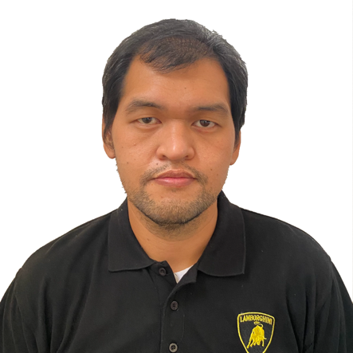
raphael p. cruz
Phase 4 Block 404 Lot 25, Neptune Street
Brgy. Loma de Gato Heritage Homes,
Marilao Bulacan, Philippines. 3019.
(+63) 905 863 8680 | raffycruz7694@gmail.com

Objective
To work in an environment which encourages me to succeed and grow professionally where I can utilize my skills and knowledge appropriately.

Work Experience

ERNSS Trucking Services
Truck Driver
May 14, 2015 - Present

Philippine Airport Ground Support Solutions
Cargo Agent
April 2014 - April 2015

Philippine Airport Ground Support Solutions
Customer Service Cargo and Operation Service Ramp
September 2013 - October 2013

Challenger Aero Air Corporation
Mechanic Helper
October 2007 - September 2011

Duties and Responsibilities / Skills

Truck Driver

Drives and operates: 10-wheeler 24 tonners, 6-wheeler 12 tonners, 6-wheeler light duty.
- Pre-inspect truck.
- Load and unload cargo.
- Follow instruction; locate and navigate location/road maps.
- Basic vehicle maintenance, complying all safe work practices, processes and policies all the time.
- Complete and verify paper works with accuracy.
Skills: Able to operate GPS, able to basic communication, knowledgeable with traffic laws, knowledgeable to basic computer skills, can troubleshoot, determine minor problems and conduct minor repairs.

Educational Background

Xavier Technical School
Automotive Technician
July 24, 2016 - October 30, 2016

Airlink International Aviation College
Bachelor of Science in Aircraft Maintenance Technology
June 05, 2005 - March 16, 2009

Saint Mary’s Academy of Sto. Niño
High School
June 2003 – March 2005

Philippine Cultural College (Annex Campus)
High School
June 2000 – March 2003

Philippine Cultural College (Annex Campus)
Elementary
June 1993 – March 2000

Reference
Dionisia Bongcayao
ERNSS Trucking Proprietor
(+63) 915 535 7048

Nickanor Bongcayao
Head of Logistics
(+63) 915 763 2257

